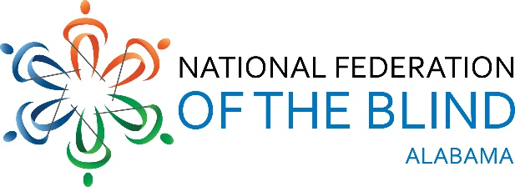
Serving Birmingham, Huntsville, Mobile, Montgomery, NFB At-Large Chapter, Talladega, & Tuscaloosa.

Dear Friends,

The National Federation of the Blind is the leading champion for the rights of blind Americans. Every day we strive to raise the expectations of blind people because low expectations create obstacles between blind people and our dreams.

Since 1942, the National Federation of the Blind of Alabama has encouraged the blind community and provided opportunities and quality services. Despite the challenging times, we still must find ways to continue enhancing opportunities for our blind Alabama citizens.

We know everyone has been impacted and do not minimize this situation. Companies and agencies have been affected in a variety of ways. We are contacting you to inquire about your ability to help our organization secure funding to further our mission. Will you consider becoming a sponsor of our virtual “Transforming Dreams into Reality” walkathon. Our goal this year is to raise $5,000. Every contribution will bring us closer to reaching our goal. The proceeds will afford us the opportunity to continue promoting independence through our key programs: B.E.L.L. Academy, educational scholarships; and annual upward mobility training conferences.

The walk will take place on October 16-17, 2020 between 7:00 AM and 7:00 PM each day. We sincerely hope you will join us in the walk and help raise awareness for our community.

Three extraordinary resources you will support through this event:
- Braille Enrichment for Literacy and Learning Academy- a two-week program providing blind children ages 4- 12 initial or advance braille instructions, daily living skills in fun interactive ways and a chance to meet other blind children.
- Scholarships- scholarships are awarded to blind college students who demonstrate academic excellence as well as community involvement. The aim is to help blind college students in Alabama unleash their full potential and become leaders in their communities.
- NFB conventions- blind individuals will have the opportunity to attend conventions where they receive current assistive technology trends, updated legislation information on blindness, career opportunities, networking with other blind individuals etc.

Please consider joining us in our fundraising efforts to help blind people live the lives they want!
We greatly appreciate your willingness to further our movement. For more information, please contact Joy Harris at (205) 515-5220 or visit our website: www.nfbal.org or our Eventbrite page: www.nfbalvirtualwalk.eventbrite.com

Sincerely,
Joy Harris
Fundraising Chair

Serving Birmingham, Huntsville, Mobile, Montgomery, NFB At-Large Chapter, Talladega, & Tuscaloosa.

Organization/Company Name: ___________________________________________________
Address: _____________________________________________________________________
City: _________________________________________State: __________Zip: _____________
Phone Number: _______________________________________________________________
Contact Person: _______________________________________________________________
Contact Email: ________________________________________________________________
Sponsorship amount: ____________________________________________________________________________

If you would like your company logo to be on our event promotion platform please email your logos to:
nfba.portcitychapter@gmail.com.

Mail payments and form by October 10, 2020 to:
NFB of Alabama
Larry Povinelli
121 Cork Alley
Madison, AL 35758

Thank You!

