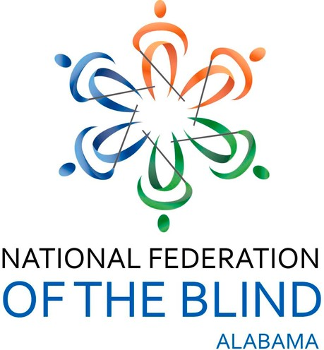
Join the NFB of Alabama as We Host Our

“Transforming Dreams Into Reality Virtual Walk”

Friday and Saturday, October 16 - 17, 2020 7:00 AM to 7:00PM Daily
Participants can become healthier, have fun and support the Blind of Alabama
Jessica Beachum, NFB Sports and Recreation President and the first blind person to complete the Pike’s Peak Marathon,
along with other energetic blind personalities will join us.

A Virtual Zoom Walk Party will be held Saturday, October 24, 2020, 7:00 PM -9:00 PM

Let’s Celebrate our accomplishments, claim bragging rights and more.
There will be awards, door prizes
and a Grand Prize You will not want to miss (You must be present to win the grand prize)
$20.00 Donation
Register online @ www.nfbalvirtualwalk.eventbrite.com Let’s Come Together and Become
Dream Makers

