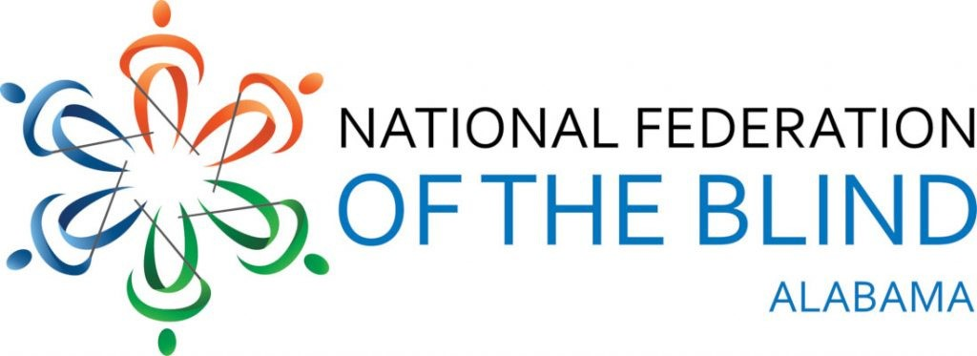
Serves Birmingham, Huntsville, Jasper, Mobile, Montgomery, Talladega, Tuscaloosa and surrounding areas
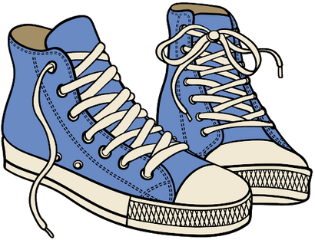
JOIN US ON OUR VERY FIRST VIRTUAL WALK! Transforming Dreams into Reality

WALK-A-THON
October 16-17, 7:00am to 7:00pm Daily
Participants can walk, exercise, and have fun all while using social distancing guidelines!
Our energetic speakers will include Jessica Beachum, NFB Sports & Recreation President & the 1st blind person to complete the Pike’s Peak Marathon.

A Virtual Zoom Walk Party will be held
Saturday, October 24, 2020, 7:00pm-9:00pm
Let’s Celebrate our accomplishments, claim bragging rights and more.
There will be awards, door prizes and a $300 Grand Prize. You will not want to miss.
(must be present for grand prize )
$20.00 Donation

Register @WWW.nfbalvirtualwalk.eventbrite.com Let’s Come together and become Dream Makers!
FOR MORE INFORMATION CALL/TEXT:
JOY HARRIS, FUNDRAISING CHAIR- (205) 515-5220

