Save the Date!
June 3 – 4, 2021
Virtual Technology Symposium
“Staying Connected”
Featuring Google & Microsoft
To Register for this Event, Scan the QR Code Below
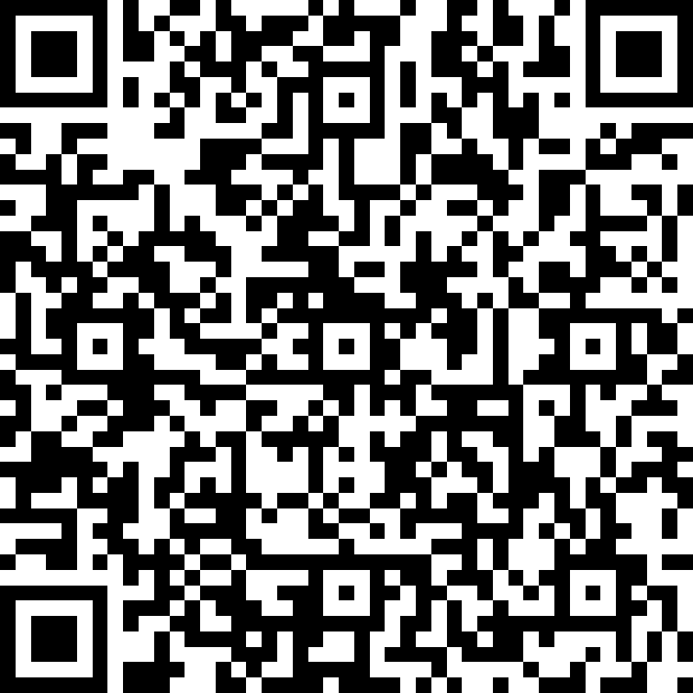

Or Visit
https://tinyurl.com/TechSymposium2021
Sponsored By:
Alabama Department of Rehabilitation Services
Alabama Institute for Deaf & Blind
Alumni Association of the Alabama School for the Blind

