It’s time to …
Sit ‘n Chit Chat

TICKET  BEST SEAT IN THE HOUSE  ADMIT ONE TICKET ADMIT ONE | 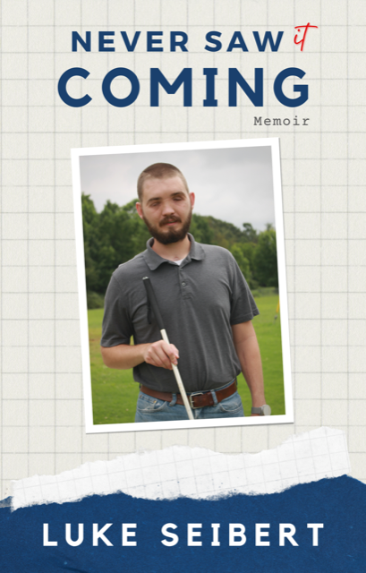
~ meet the author of this very inspiring Memoir. “never saw it COMING” REVEALS FACTS surrounding the accident that instantly CHANGED luke’s life and exactly what steadies his pace as he BLINDLY MANEUVERS through his life journey. ___________________________

TUESDAY,
DECEMBER 28, 2021
7:00 pm CT

Join the NFB of Alabama Zoom “Chat”
https://zoom.us/j/2516565165
Meeting ID: 251 656 5165
One tap mobile
+16468769923,,2516565165#
or Dial: +1 646 876 9923 US
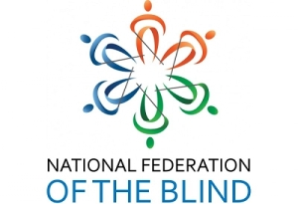

NFB of Alabama
– Transforming dreams into reality

~ The book cover has a white and blue grid pattern background. It has a picture of Luke standing in front of his home, wearing a gray polo shirt and denim jeans, holding his NFB straight white cane. Luke has short brown hair and full facial beard.

To purchase this and other self-published books by Luke Siebert, go to:
http://www.hisministries.com

SNCC DEC 28 2021 – INTERVIEW W/ LUKE SIRBERT – S TYLER

