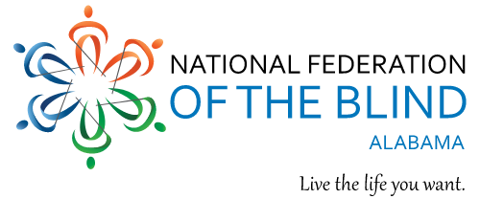

**The National Federation of the Blind of Alabama**

**23rd Annual Convention**

**March 3-5, 2023**

**Hilton Birmingham at UAB**

**808 20th Street South**

**Birmingham, AL 35205**

“Family United, Facing The Future Together”

**Reserve your room at:** <https://www.hilton.com/en/attend-my-event/bhmhhhh-nfb-07ddd5ad-4f60-42b5-9c9d-58acf528ac00/> **or by calling: 205.933.9000**

**More Information Coming Soon**