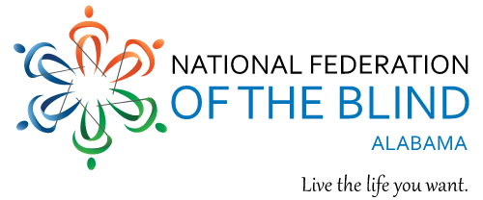

**National Federation of the Blind of Alabama**

**2025 Annual Convention**  
**“The Power of Collaboration”**

March 14th-16th, 2025

**Hotel Capstone**

320 Paul W. Bryant Drive

Tuscaloosa, AL 35401

Phone: 1-205-343-1118

*Collaboration across communities, organizations, and individuals empowers us all to work towards a future where blind people are fully integrated, represented, and respected.*

**What to Expect:**

Advocacy and Accomplishments from our National Office - Empowering Workshops & Sessions - Networking Opportunities - Exhibits & Resources - inspirational Speakers - Collaborating with state agencies - Museum and stadium tour - A Blast from the Past Reception

**Let’s make a difference together.**  
We are stronger when we collaborate. Join us in shaping a future of empowerment, inclusion, and opportunity for all blind individuals.

For more information

Visit our website at [www.nfbal.org](http://www.nfbal.org)

Contact President Barbara Manuel at 251-656-5165