Good Morning to my Friends

I have good news to share with you today – the photos tell it all.
So very happy to win this Best of Show award and happy for my friends, too.
Lynda McKinney Lambert

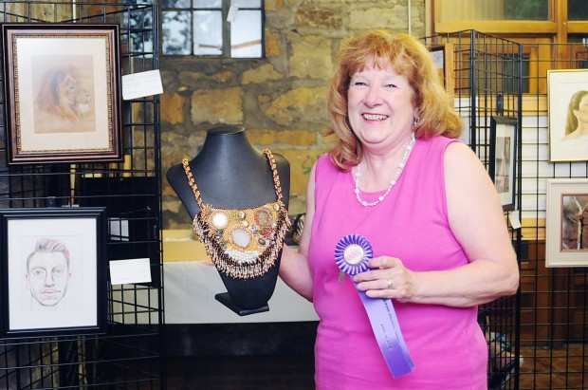

Lynda Lambert winds Best of Show for her encrusted beadworking fiber art; Dance of the New Moon.

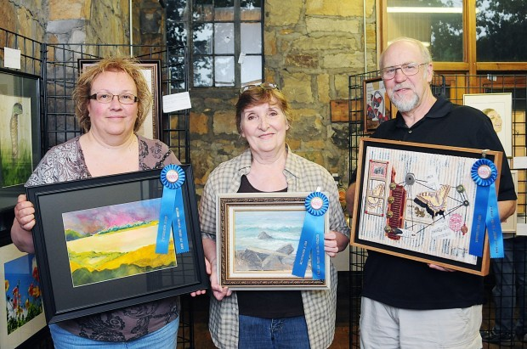

Distinguished Awards went to (left to right)
Grace Hufnagel, and John Conway of Ellwood City.

