“Vision and Revision: Two Artists with Limited Sight,
Not Limited Vision”

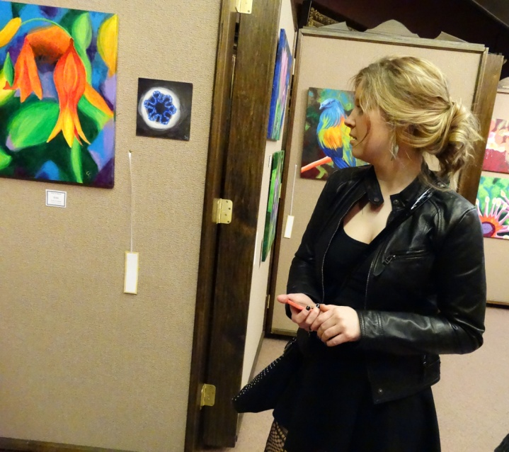
Visitor looks at paintings

Merrick Art Gallery, New Brighton, PA
7 March to 3 April 2014

Jemeson Health System, New Castle, PA
17 April to 5 July, 2014

Description:
This is a two-person exhibition - pottery, paintings, and mixed media fiber works.
The exhibit was created by Suzanne Gibson and Lynda McKinney Lambert
Gibson makes acrylic paintings on canvas.
Lambert created mixed media fiber art from fabrics, gems, stones, found objects, and beads -
AND clay sculptures.

Suzanne uses a magnifier device to assist when she paints. Her art was done totally by sight with this assistive technology. She is considered “legally blind” with the visual acuity for this designation.

Lynda’s sight is “off the chart” for sight loss measurement. She combines technology with non-visual techniques to create complex fiber work. Her pottery is made non-visually, by TOUCH. Her condition is labeled, “Profound Sight Loss.” Her range of light perception is less than two feet. She sees no details, colors, or distinct forms.

Today’s Presentation will take students on a “walking tour” of pottery and mixed media works by Lynda McKinney Lambert.

Theme: A Pennsylvania Woman in the Arts: Historical Context and Journey

LOOK for Influences from:
The Middle Ages, Byzantium, Mosaics, Jewelry, Icons, Sacred Space, Texts

COLOR? TEXTURE? FORMS? SHAPES? LIGHT? SHADOW? MOVEMENT?

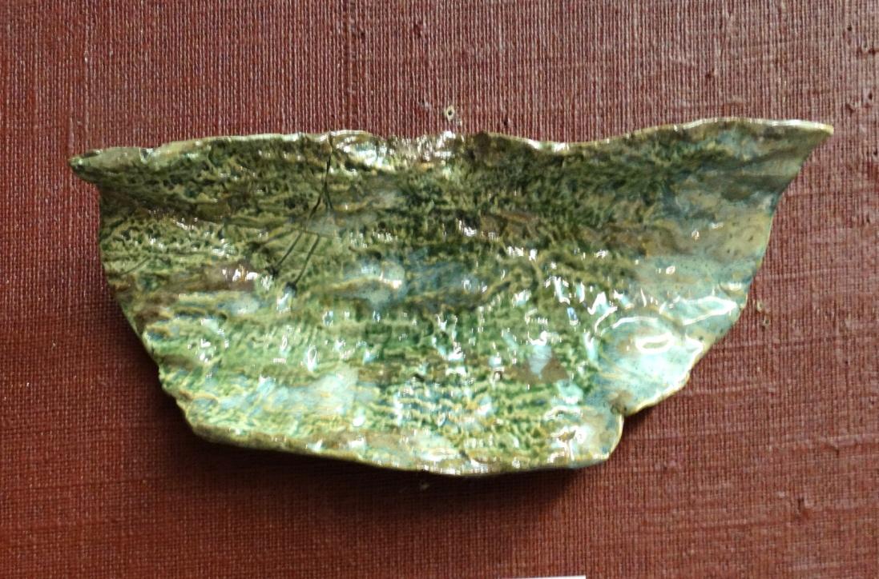

Moss on the Log: Flight - by Lynda McKinney Lambert

What to LOOK for in my art work?

Creation/ Nature - Sky/Earth/Water

Water ( the Sea, a voyage, journey )
Vegetation (Trees, Leaves, Bark, Stones, etc.)
Life forms – living creatures and people
Passing Seasons and Passage of Time
The Universe/Heavens

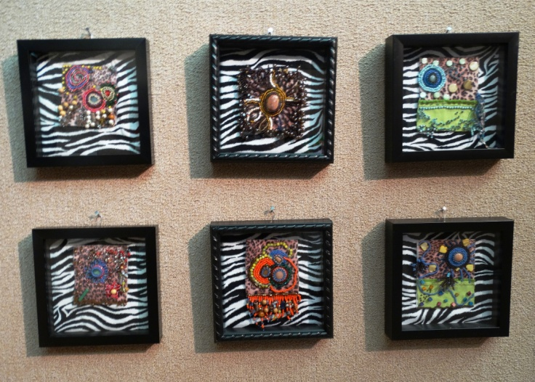
Six Meditations by Lynda McKinney Lambert

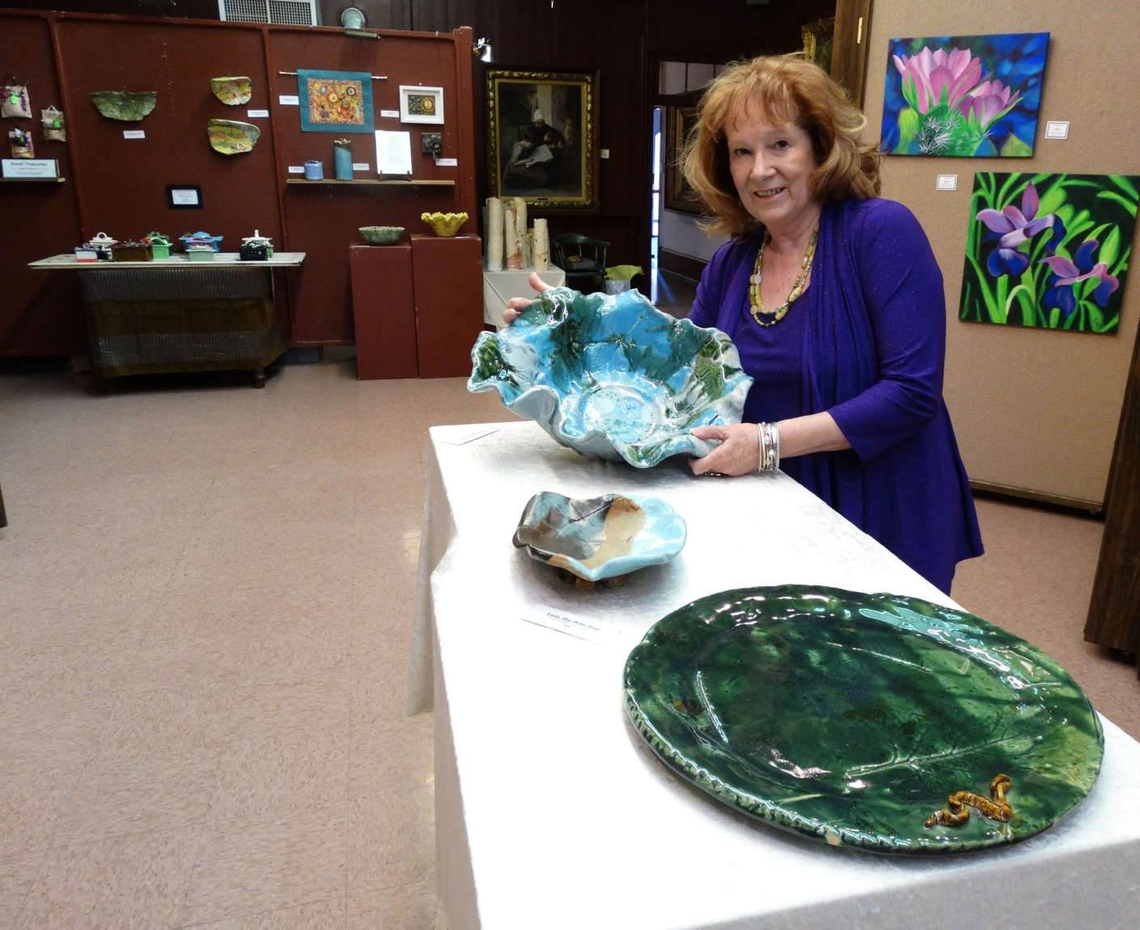

Lynda McKinney Lambert with The Caribbean Sea, a bowl.
Foreground: “Little Snake in the Grass,” a large platter.

Art History:

Icons and “sacred” space
Vessels to hold a treasure
Byzantine aesthetic of beauty
Ancient relics and artifacts
Symbols of protection, healing, guidance
Literature: mythology, contemporary stories, and ancient texts

Q. Can you FIND examples of Human EMOTIONS in the work?

Q. Can you DETERMINE the World View of the Artist in this work?

Q. Can you FIND examples of FEMALE concerns of the Artist?
You turn things upside down! Shall the potter be regarded as the clay, that the thing made should say of its maker, “He did not make me”; or the thing formed say of him who formed it, “He has no understanding.”? ~ Isaiah 29:16

Muddy Hands

October 2007;
I suddenly lost most of my eye sight.

I did not know night from day.
I could not see a clock. Time vanished
I could not find a phone number or dial a phone.
“Normal” was now upside-down days and nights.

I could DREAM.
I could envision wonders.
I could try, I could try, again.
I could pick up a piece of wet clay.

Slowly, the muddy substance felt like a new possibility in my hands. The clay brought back memories.

My muddy hands began to do the work of remembering
Muddy hands gave new confidence in me.
Muddy hands brought wholeness.

I took MUD and made “treasures.” The wet clay gave me. “Magic Spirit Treasure Boxes” for cherished objects; Wall sculptures to honor the Creator, Earth, Nature, and the healing of my broken eyes when I use my Muddy Hands!

by Lynda McKinney Lambert, 2014

