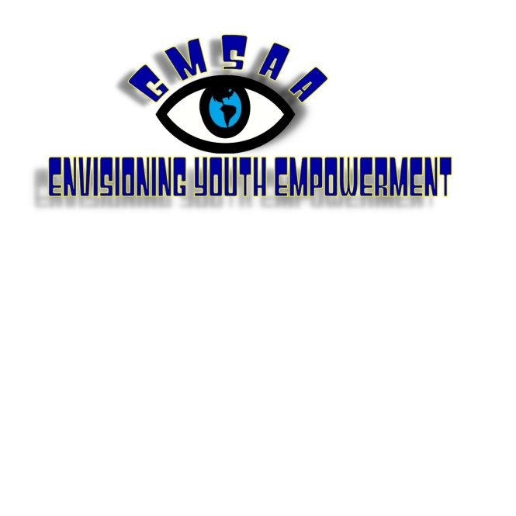

President: Ricky Scott Treasurer: Fred McEachern
Vice President: Tim Snyder Secretary: Alan Chase

APPLICATION FOR PARTICIPANTS
4th annual Envisioning Youth Empowerment Retreat

BASIC INFORMATION ABOUT THE EYE RETREAT:
Who: Youth with visual impairments who intend to attend college or wish to learn more about higher education options.
What: A program for youth with visual impairments 16-26 years old.
When: Monday, July 30 to Friday, August 3rd
Where: The Governor Morehead School for the Blind and North Carolina State University
Why: To provide an opportunity for youth with visual impairments to experience a glimpse of college life through mock classes, assistive technology demonstrations, advocacy workshops, and mentoring by current college students.

REGISTRATION FEE:

Much of the EYE Retreat is provided to participants free of cost. In order to ensure participation and commitment, we ask you reserve a spot by submitting a nonrefundable registration fee.

Applications received before May 1st, 2012 pay $25.00. *
Applications received after May 1st, 2012 pay $45.00. *

Payment must be sent with the application. Please make checks or money orders payable to The Governor Morehead School Alumni Association, Inc. (GMSAAI).

Contributions: The Governor Morehead School Alumni Association is a 501(c)3 nonprofit organization. Tax deductable donations are kindly accepted so that we may continue to offer this summer youth experience at little cost to our participants.

*Individuals with financial need or concerns about the registration fees should contact Alan Chase, Program Coordinator, for more information about scholarships.

PERSONAL INFORMATION: (all information is confidential)
Name: Age:
Address:
City: State: Zip:
Day Phone: Evening Phone:
E-mail address:
I am currently: High School College
Graduate School Working
I am: Blind Legally Blind Visually Impaired

ACCOMMODATIONS: (check all that apply)
I use: Braille Large Print Regular Print
I have special dietary needs. Explain:
I have allergies or a medical condition. Explain:
I take medications. They are:
Other:

ACTIVITIES: The following list is a sampling of possible workshops, classes, or activities being planned for 2012. Parent/guardian permission may be required for some activities. Some activities may require the use of public transportation or long walks.

- Mock class taught by a Professor at NC State University.
- Mock disability services intake and accommodations advocacy.
- Workshop on assistive technology.
- Workshop on differences between high school and college accommodations/services.
- Workshop on campus and community resources.
- Accessing public transportation.
- Mentoring and social activities with current college students.
- Mock goal ball activity.

PERSONAL STATEMENT:
Please use this space to tell us why you want to attend this retreat or something interesting about you!

EMERGENCY CONTACT:
Name:
Address:
City: State: Zip:
Day Phone: Evening Phone:
Relationship to you:

CONTACT:
Alan Chase, Coordinator Brice Smith, Assistant Coordinator
919-720-4100 919-720-4100
achase11@nc.rr.com brice.smith319@gmail.com

Completed applications may be sent to:

Alan Chase
1217 Manassas Court
Unit C
Raleigh, NC 27609

SIGNATURE: (I agree that all information is true and accurate)

Applicant Signature: Date:
Parent/Guardian (if under 18): Date:

