Warm Greetings from BLIND, Incorporated:

It is once again time to start planning for our 2015 Buddy program!
This three-week summer fun and learning program is for children ages 9 to 13.
The dates are July 18, 2015 through August 7 2015.
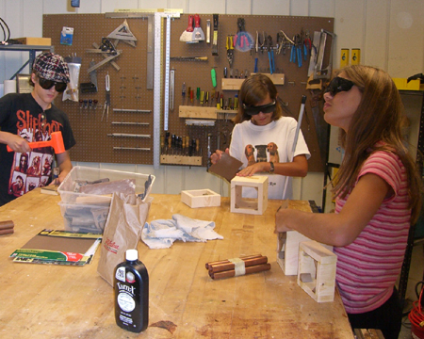
The Buddy Program offers an opportunity for blind children to make friends and have fun in a positive and secure setting. Students will learn and practice alternative techniques of blindness while building self-confidence.

The training in alternative techniques includes instruction in reading and writing Braille, basic cane travel, cooking skills, and introductions to independent living skills. Students may learn to pour liquids, carry a food tray, do laundry, follow a recipe, and much more while building self- confidence and problem solving skills.
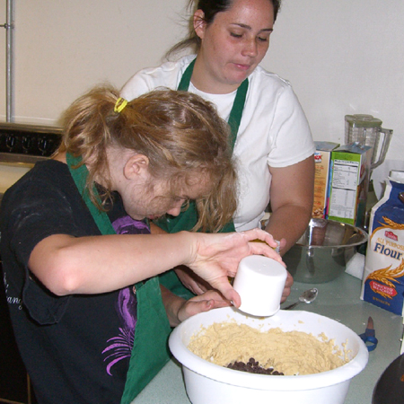
Students also participate in "talk time," where they discuss important issues about blindness with blind peers and instructors. This time gives the students a chance to discuss their feelings about blindness, their frustrations with uncomfortable situations, and helps them to problem-solve and develop a positive attitude about blindness and their abilities as blind students.
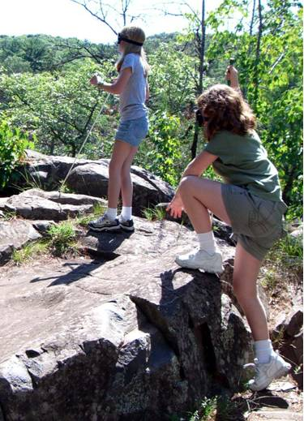
In addition, students participate in many exciting activities in the Twin Cities area, such as visits to nature parks, Wild Mountain Water Park, and rock climbing. These activities allow students to develop their socialization skills. Activities are well supervised and mentoring for the children is provided by active blind role models. Lifelong friendships begin during this brief summer experience.

One of our goals during these recreational\educational activities is to teach our students the alternative techniques of blindness and help them gain the self-confidence that would allow them to return home and actively participate in even more fun activities with their sighted friends.
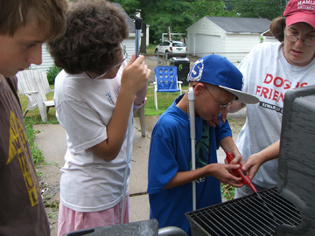
Activities are excellent opportunities to teach and reinforce a wide variety of alternative techniques, as they apply to real life. These learning experiences are usually most effective when there is plenty of fun involved!

If you have questions please call 612-872-0100 (ext. 251), toll-free
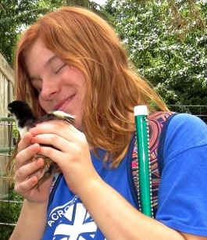
800-597-9558, or email cguggisberg@blindinc.org. You may complete an application by visiting our website at www.blindinc.org

Sincerely,

Charlene Guggisberg
Admissions and Special Programs Manager

