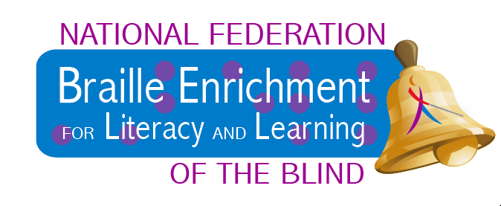
The National Federation of the Blind is excited to offer its Braille Enrichment for Literacy and Learning Program, BELL, this summer in Illinois. This opportunity will be a weeklong residential program in Springfield, IL.

Where: Springfield, IL

When: July 31- August 4, 2017

Who: Blind child/Parent pairs

Cost: $50

The children will explore and learn new braille and blindness skills.
A Parent session will run parallel with the student portion. Information on allowing for independence, community resources and child advocacy and much more will be covered.

Apply NOW at: https://nfb.org/bell-academy

