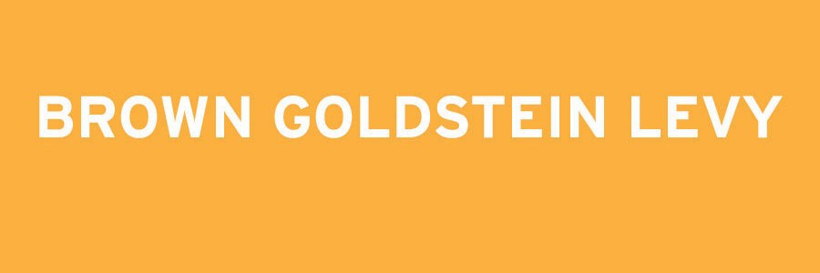

The 2013
BROWN, GOLDSTEIN & LEVY DISABILITY RIGHTS FELLOWSHIP
In September 2009, Brown, Goldstein & Levy, LLP welcomed its first disability rights fellow. We are now accepting applications for our fith annual Disability Rights Fellowship
to begin in September 2013. The Fellowship offers a recent law school graduate or judicial clerk with a disability the opportunity to participate for a year in all phases of disability rights litigation at our firm in Baltimore, Maryland. Brown, Goldstein & Levy is a 16-lawyer law firm devoted principally to litigation. The firm has developed a national reputation for its high-profile, high-impact disability rights cases. Information about Brown, Goldstein & Levy, including our past and
present work, is available at www.browngold.com.

Terms of the Fellowship

The Fellowship is available to law school graduates with a disability and zero to three years of legal experience. The term of the Fellowship is one year (September 3, 2013 – August 29, 2014). Salary and benefits will be commensurate
with the salaries paid and benefits provided to non-Fellowship Brown, Goldstein & Levy attorneys of equivalent experience and qualifications. The firm offers health insurance, group
life insurance, and group disability insurance. The Fellow should be a member of a state bar or be planning to obtain admittance to a state bar.

Application and Selection

Applicants must have strong academic credentials, excellent writing skills, and a demonstrated commitment to disability rights. A completed application will consist of the following:

1. a cover letter, no longer than two pages,
explaining the ways in which you meet the selection criteria;
2. a copy of your law school transcript, including an explanation of your institution’s grading policy;
3. a legal writing sample with a cover page indicating the source of the sample, any editing or contributions by persons other than the applicant, and the legal citation style used;
4. a current resume; and
5. a list of three references, including name, relationship, and contact information.

Applications must be received no later than November 16, 2012. Please submit your application by e-mail to info@browngold.com or by mail to:

Disability Rights Fellowship
Brown, Goldstein & Levy, LLP
120 E. Baltimore Street, Suite 1700
Baltimore, MD 21202

