Lobbying for Disability Rights
A Disability Awareness Month Roundtable
Finding your voice and identifying your message
Techniques for Using the Media

Building a Lobbying Strategy

Join us to discuss how YOU can get involved!
Lobbying Basics  Andrew Smullian, Deputy Chief, Legislative Affairs | Lobbying the General Assembly  Delegate Samuel Rosenberg, District 41
Lobbying the City Council  Councilman Robert Curran, City Council District 3 | Using the Media to Generate Support  Chris Danielsen, National Federation of the Blind
Wednesday October 23, 2013
1:00 pm - 3:00 pm
City Hall, 100 N. Holliday Street
Curran Room
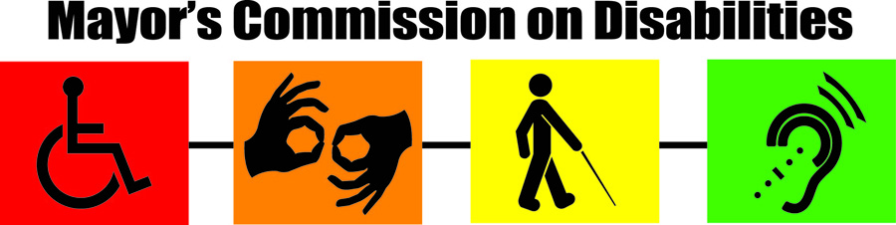
To arrange special accommodations (Interpreter, Hearing/Vision, Parking) contact by October 16th Dr. Nollie Wood @ Nollie.Wood@baltimorecity.gov or 443-984-3170.

