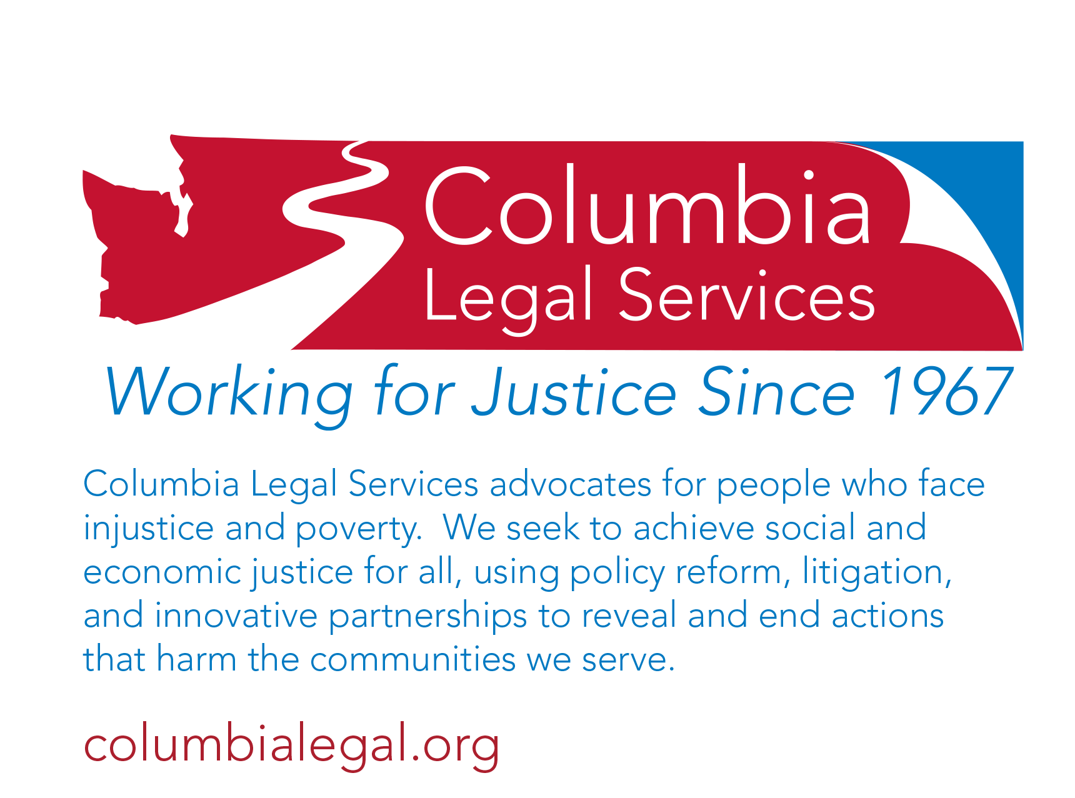**Program Description**

## **Policy Director**

## **Olympia, WA**

# Position Description

For many years, Columbia Legal Services has represented some of the most marginalized people in our

community. We use every legal tool available on their behalf. Our role to serve people and use advocacy that might otherwise not be available makes our work an integral part of the Washington Alliance for Equal Justice. Our vision of justice is when people have the necessary tools and opportunity to achieve social and economic justice, a more equitable and inclusive society is possible. Through large‐scale litigation, policy reform, and innovative partnerships, our lawyers and other staff work in furtherance of our mission. The ideal candidate for any position at Columbia Legal Services will be able to articulate their role in the achievement of that vision.

**Position**

Columbia Legal Services seeks a full-time Policy Director to work closely with a dynamic advocacy team that spans five locations and [five statewide practice](http://columbialegal.org/advocacy) groups. The Policy Director will work collaboratively with an executive leadership team and in partnership with the Advocacy Director and our Directing Attorneys. This position is based in Olympia, with statewide responsibilities. This position reports to the Advocacy Director.

**Responsibilities**

* Plan, coordinate, and strategize our body of legislative and policy activities on a state and federal level, including administrative agency rulemaking and other substantive government-relations matters.
* Work with the Advocacy Director to ensure that the mission, criteria, and quality of legislative advocacy and related projects are consistent with program values and standards of systemic and multi-forum advocacy, and our broader advocacy planning and execution.
* Develop external relations with state and federal legal and advocacy-related communities; network with advocacy groups, legal service organizations, and the private bar to identify opportunities and execute strategies to advance policy for low income populations.
* In partnership with the Advocacy Director and Directing Attorneys, provide mentorship, supervision, and evaluation of advocacy teams.
* Work with the Advocacy Director to develop training protocols and plans and administrative policies related to advocacy standards. Develop regular and periodic policy-related trainings, orientations, and policy advocacy updates and forums.
* Travel around the state for meetings with practice groups, advocacy events, and other legal aid meetings; occasional national travel will be required as well to attend multi-state convenings.

**Qualifications**

* A law degree is preferred.
* Passion, commitment, and proven track record of developing, designing, and championing anti-poverty policy and legislation.
* At least 10 years of experience in legislative and policy work.
* At least 3 years of experience in administrative leadership, working collaboratively with a team on large-scale advocacy campaigns and projects.
* Experience developing best practices and advocacy resources. Additional experience on supervision, mentoring, and understanding of performance management and coaching of advocacy teams a plus.
* Excellent research, writing, negotiation, and analytical skills.
* Ability and willingness to work with multiple teams and manage multiple tasks in a timely manner.
* Willingness to travel and to work flexible hours, especially during the legislative session.
* Demonstrated initiative and creativity.
* Excellent interpersonal and communication skills, cultural competence and experience working with low-income client communities.
* Must have a sense of humor, a healthy self-awareness, be comfortable with managing change, and enjoy leading and supporting a positive, high-performing organizational learning environment.

**Compensation Package**

CLS offers a competitive compensation package including generous holiday, paid time off, and healthcare benefits. Salary is commensurate with experience. Small relocation benefit included.

**Applications**

Position is open until filled, with a preference given to applications received before October 1st. Please note that due to the volume of applications received, CLS is unable to respond to every application. We will contact you if we decide to pursue your application. No phone calls please. To apply, submit your cover letter with salary expectations, resume, a short writing sample, and three references to the address or e-mail address below. Include Policy Director in the subject line of electronic submissions.

Trisa Kern, Director of Program Administration

Columbia Legal Services

101 Yesler Way, Suite 300

Seattle, WA 98104

jobs@columbialegal.org

**Program Policy**

Columbia Legal Services is committed to a policy of pluralism and equal opportunity in an environment free of barriers and discriminatory practices for its client communities, Board and staff. Pluralism refers to the active promotion of mutual respect, acceptance, teamwork and productivity among people who are diverse in work background, experience, education, race, color, national origin, sex, age, religious preference, marital status, sexual orientation, sensory, mental and physical abilities, veteran status, or any other perceived differences. The resulting diversity is both a source of program strength and a matter of fundamental human fairness. If you need a reasonable accommodation for the application process, contact Sharon Nyland at 206-464-1122 or jobs@columbialegal.org.