Exporting Documents from Relativity Review
In Relativity, create a saved search identifying the documents that need to be exported for review, outside of Relativity. Open the Relativity Desktop Client to export the saved search.
- After selecting the case in the RDC, select the Tools
- Navigate to Export>Saved Search
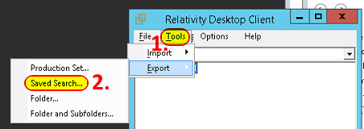
- Select your Saved Search you want to export.
- By default, it will populate the fields in your saved search, if you need to add any or rearrange the order, you can do so here. In this case, we wanted to export the Responsive, Privilege, Confidential and Issue Designations so that the reviewer can update these fields, and then import the coding back into Relativity.
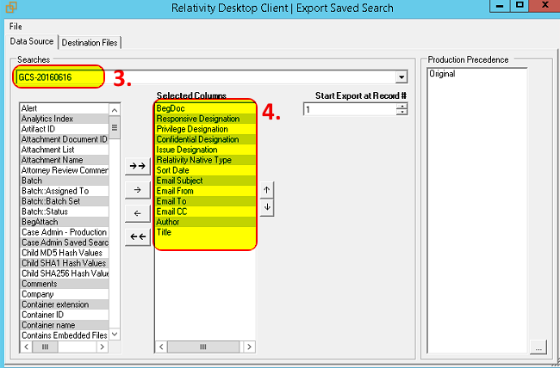

- Select your destination for the export location.
- In order to be able to analyze the documents, it is best to have Native files ONLY as part of your export.
- For the metadata export format, select the CSV option. We will convert this to Excel to make for easier review after the export.
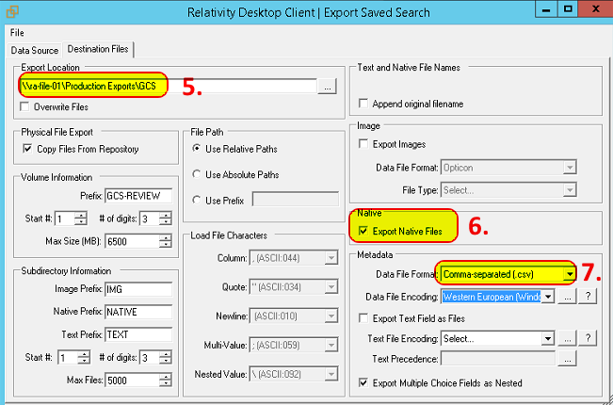
- Once exported, open the csv in Excel, format the fields to look how you’d like, and save as a XLS/x file.
- By default the relative native file path is exported as the last field. Some users may find it helpful to have the filepath, some may not. If it is useful, I find it helpful to create a field that is hyperlinked to the begdoc number. Formula is =HYPERLINK(O2,A2) 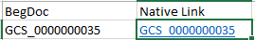
- When the review is finished, save the xls file back to a csv, so long as there are no commas in the review notes field. Also, normalize any data in the fields that were coded to ensure a uniform database.
- Import the coded csv back into Relativity, overlaying on the data.

