
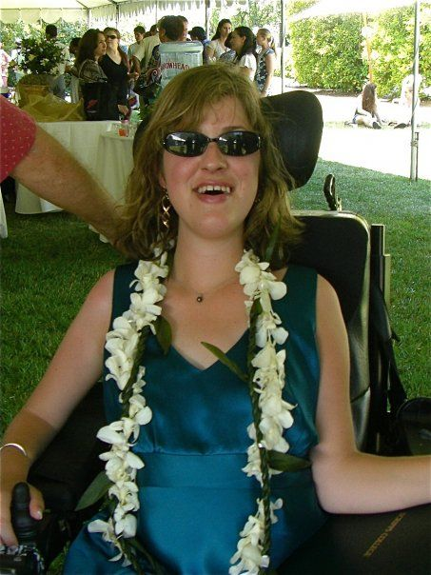
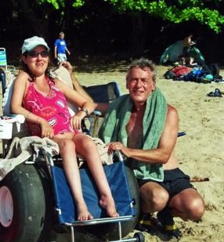
Alexis Bird Schey 2017 Summer Internship Fund

Please circulate to interested disabled students, groups, schools.

This packet is an invitation to high school and college students with disabilities to apply for funding for a 10-week Summer 2017 internship at a non-profit organization selected by the student. The Alexis Bird Schey Summer Internship Fund will select one student to receive $3,000 towards the student’s internship salary. The Application form is at the end of this document.

Alexis is one of hopefully thousands of examples of people who face unimaginable challenges in their lives and yet, through some unfathomable mysterious gift, see life through a lens of courage and creativity, mixed with a good dose of whimsical wit and humor. She graduated from Windward High School in Los Angeles, and Scripps College in Claremont, California, majoring in psychology. Alexis ambulated in a wheelchair. She had a congenital neuromuscular weakness and passed away November 2013 at the age of 28. She was a fire-ball, lived as independently as possible, was kind, constantly was learning and broadening her mind, was a good friend to many people, held no prejudices against anyone, loved music, film and theatre, and travel, learned how to cook gourmet meals, and had a great sense of humor – she’s an inspiration to those dealt a difficult hand to play in life, and showed how to live to the fullest regardless of the obstacles and challenges.

Here are a couple of examples of the strength of her spirit. When she was about six we were on one of the many camping trips we took with about ten of Alexis's best friends in a campground surrounded by beautiful sycamore trees. Her friends were scrambling up those trees and would get about half way up when they could go no higher as the branches thinned out. I (dad) saw Alexis sitting on the ground watching her friends yelling encouragement that they should climb higher. Walked up to her and said "honey, you OK, do you want me to lift you to the lower branches?" She looked up with shining eyes. "They're only getting half way up with their hands and legs, I'm already at the very top using my imagination."

One more experience, though there are many we could share. Alexis was about seven years old. On a trip to San Diego and stopped in Del Mar State Park to look at the ocean from the top of the cliffs. There were people jumping off the top of the cliff strapped to hang-gliders, soaring around and landing on the beach far below. "Dad," she said almost immediately, "I've got to do that." A few minutes later a hippie looking guy was running towards the edge of the cliff with Alexis hanging under him and they soared off the edge of the cliff into the thin air. She looked back and waived. Ten minutes later she landed on the beach. "That," she said, flushed with excitement, "is how I want to live my life. Unafraid." Like a zen master, looked up and said “wherever I leap, a net will appear." She must have read that somewhere.

Alexis was dealt an extraordinary difficult hand to play in life, but she played it like she had a handful of aces. Her inner beauty overwhelmed her family and friends, she taught us to overcome fear with the power of courage. This internship fund is in her honor.

Application Instructions

Please use this form to insert your responses below digitally. You may copy and paste the application form into a new document or simply use this one. If you’re unable to use a computer, please print and complete the form and fax it to Peter Schey (310) 526-6537. Internships must be at least 10 weeks long.

When you save your application digitally, use following protocol for re-naming the document: Your last first and last names, date you email the application, and Alexis Schey Internship Application (e.g. Michael Diaz, 5-15-14 Alexis Schey Internship Application). Please forward your application (best in MSWord or PDF) before March 30, 2017 to: Peter Schey pschey@centerforhumanrights.org, Melinda Bird ruthie1711@gmail.com Roxanne Rose roxannehrose@gmail.com
and Sjuli Senn Van Basel Wagemans sjuli.senn@gmail.com

Feel free to attach other material to your application (anything of interest)

All applications must be received no later than March 30. Decision will be made by April 15, 2017

Alexis Bird Schey 2017 Summer
Internship Fund Application

Please do not complete and send this application until you have identified a non-profit organization where you can do an internship in the summer of 2017 and have discussed with that program the specific project you will be doing. Please see questions below about the nature of your proposed project that should be discussed with the non-profit before you complete this form.

The funding is for a 10-week internship. However, if you’re only able to complete less than ten weeks during the summer, the remaining hours may be performed during the Fall.

Please forward a completed application (best in MSWord or PDF) on or before March 30, 2017 to:
Peter Schey pschey@centerforhumanrights.org
Melinda Bird ruthie1711@gmail.com
Roxanne Rose roxannehrose@gmail.com
Sjuli Senn Van Basel Wagemans sjuli.senn@gmail.com

Please type in responses below.

PART I.

Name:

Address:

City:

State:

Zip:

Phone:

Email:

Address and phone are good through what date?

Permanent Address (if different from above):

Address:

City:

State:

Zip:

______________

School attended in Spring of 2017:

Year completed in School as of June 2017:

School you plan to attend or any work you plan to do in the Fall of 2017:

College Major:

Do you ambulate in a manual wheelchair or electric wheelchair:
Yes manual /__/ Yes electric /__/

Age:

Gender:

Optional Information (may be used for purposes of affirmative action):

Underrepresented Community:

Disability:

Do you live with your parents or in a group home:

Provide any information you wish about your financial situation including your parent’s or others’ ability to provide financial support:

Name of proposed host non-profit organization:

Name of contact person for host organization:

Telephone number of host organization contact:

Email address of host organization contact:

Website of proposed host organization:

Dates available to work:
From:
To:

How did you hear about the Alexis Bird Schey Memorial Summer Internship Fund:

Please list the name, organization, position, how you know the person, email and phone number of two references:

1.

2.

PART II. Short Essay

1. Please briefly describe the non-profit organization for which you seek funding and include links so further information may be reviewed on the internet.

Response:

2. Briefly explain your work or volunteer experiences (if any) relevant to this project?

Response:

3. Please describe:

(a) The goals of your proposed internship (about ½ page)

Response:

(b) How and why you decided on your goals (about ½ page)

Response:

(c) Most importantly, explain what you propose doing to achieve those goals (about ½ page)

Response:

(d) How you will measure what was actually achieved (about 1/2 page)

Response:

4. Briefly explain how this type of work may relate to your long-term career goals (about 1/2 page)

Response:

5. Add any further information you think may be useful to help us select a disabled student for the summer 2014 internship funding (about 1/2 page):

Thank you.

/ / /

