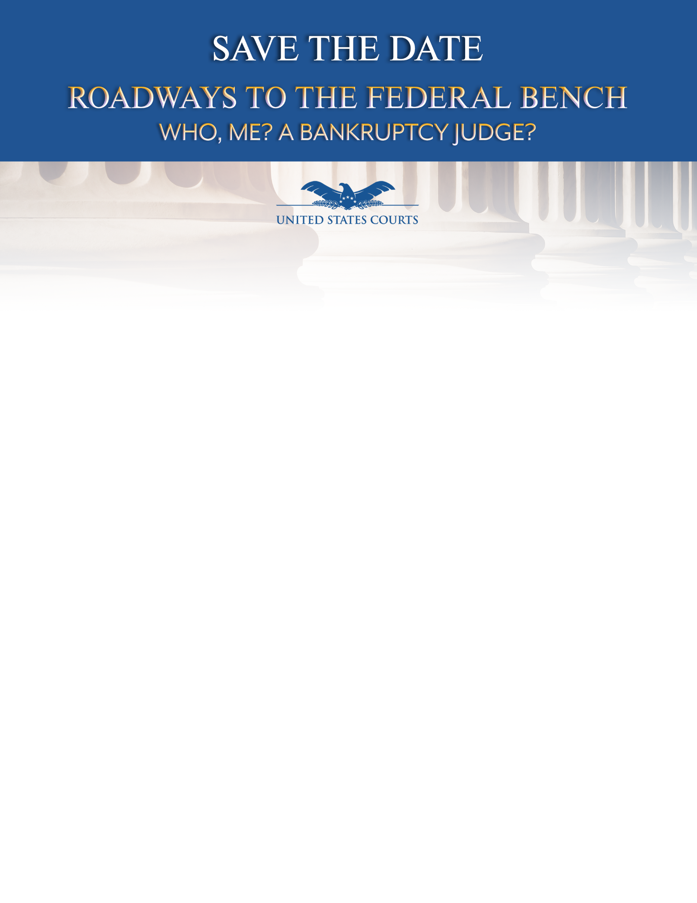

**Live Broadcast from Washington, D.C.**

**Local Roundtable Discussions Among Federal Bench, Bar, and Law Students**

Seattle, Washington

United States District Court  
700 Stewart Street

**October 24, 2019**

1:00 - 3:00 p.m. PST*

As part of its efforts to foster diversity in the bankruptcy bench and bar, the Judicial Conference of the United States Committee on the Administration of the Bankruptcy System presents:

***Roadways to the Federal Bench: Who, Me? A Bankruptcy Judge?***

Interested lawyers and law students will be invited to participate in roundtable discussions with local federal bankruptcy, magistrate, district, and appellate judges about pathways to the federal bench for candidates with diverse backgrounds.

More information will be provided as the date approaches. Registration may be limited due to space constraints.

For more information, please contact:

Paula Sutton, psutton@bskd.com

* Panel broadcast will begin promptly at 1:00 p.m. PST,

please arrive at least 30 minutes prior to check in and find a seat.