Dear all,

We have cherished friends and family this year very much. We love and appreciate all of you and hope you are happy and well.

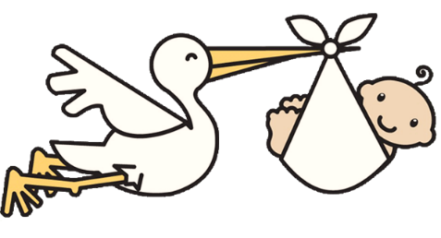
This year we have much news. First and foremost, we are expecting a new addition to our family. Johnathon and Rebecca are expecting their first child due in early April. Everyone is excited. First grandchild on both sides of the family. Rebecca isn’t telling whether it is a girl or boy yet. The big reveal will happen in January.

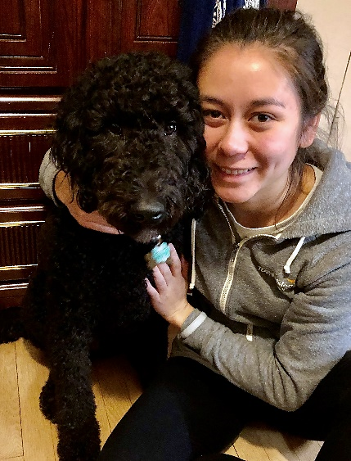
1Julia and Schinkel Dog Dec. 2019

Julia is assigned to the Four Rivers Casino expansion project in South Bend, Indiana for the next 18 months. Long hours and frequent weekends home are the norm. She has become very active in the Bridge Church. Her puppy has turned into a very lovely grown up doodle. When he is gone Patti and Francisco miss the happy dog homecoming dance when they enter the house. Glad he is in South Bend with Julia though.

2Family on Yangtze River Cruise at Captain's Party, August 2019
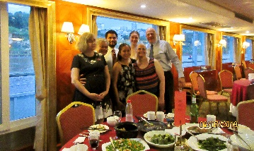
Patti and Francisco finally took their long awaited “honeymoon” in China. Francisco promised a trip to China when they first married, and they took a two-week trip in August. They expanded plans and Julia, Johnathon, Rebecca, Mitch, and Joanne joined them. Mitch and Joanne are Rebecca’s parents. The entire group started in Beijing and travelled for a week to the Three River Gorges Dam. The kids returned to the states and the parents went for a second week ending up in Shang Hai. Just downloaded Francisco’s 663 pictures and videos. It was an amazing trip for lots of reasons but mostly because the group spent time together creating wonderful memories.

Francisco, Patti, Johnathon, Julia, and Rebecca travelled to Michigan in September to attend Grandma Lauer’s 100th birthday party. It was an amazing event. People came from all over and she even sang her favorite song. Grandma passed away a couple months after her party and is missed by all of us. Glad to have the memories from that big bash to keep close.

Francisco, Patti, and Johnathon are still working for the same organizations. Johnathon has been promoted which is a good thing given that a little one is on the way. That covers it for our big news this year.

Please share your news with us. We are blessed to have so much family and many friends and colleagues in our lives. Know that we appreciate you.

Love,
Francisco, Patti, Johnathon, Rebecca, and Julia
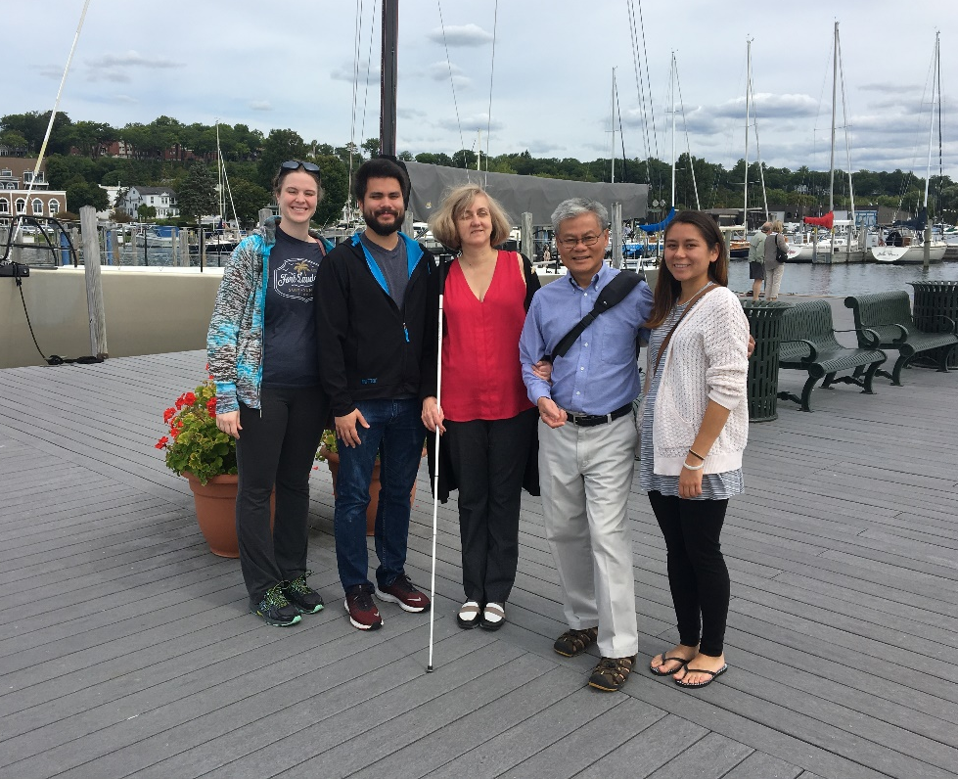
3Family in Harbor Springs, Michigan, Labor Day 2019

