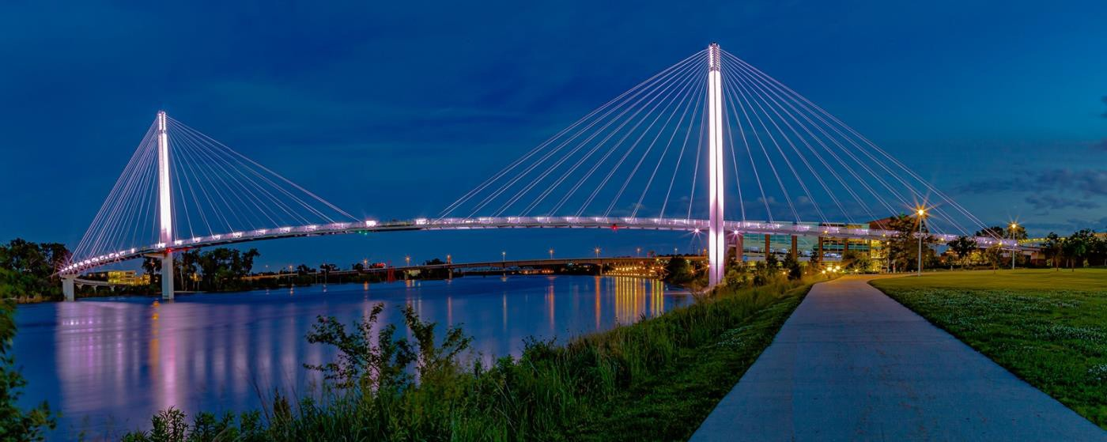

61st Annual National Conference & Convention American Council of the Blind and Special- Interest Affiliates
June 22 – July 8, 2022 Dan Spoone, President

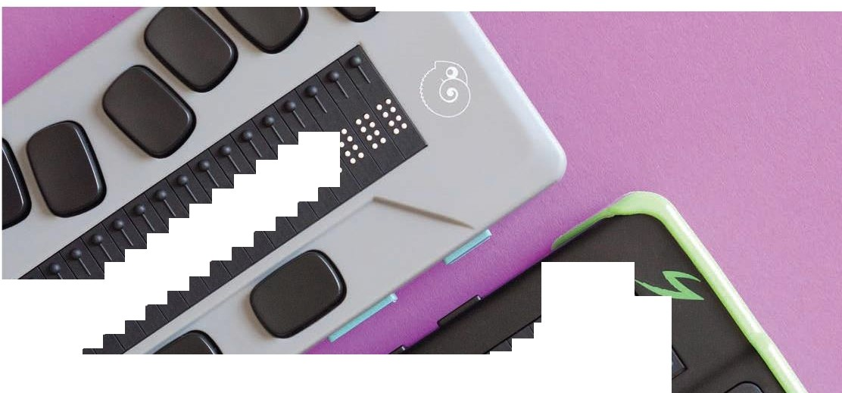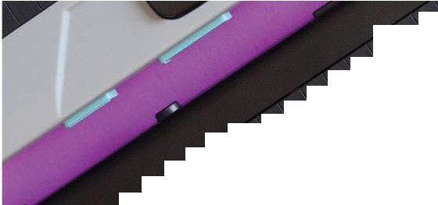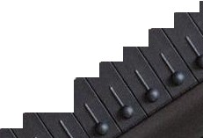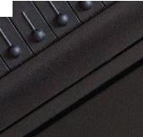
• •
•••• •
•••• •••
••
•
••
••
•••
•••• ••
••• •••
••
•
••• • •
••• • •••
,
• • •••
•
••• • •••
•
•
••.•
. .
• •• •• • •
•
•
• •
•
••
•
••• • •
•• • •
•••
••• • •• •
•
\
•
••
•
•••• •••
•••
•• •
\
\
\
\
• •
•• ••• •
••
•••
\
•
•
•••• •
v \\
\
• ••
••
•••
••• • •
\
•• •••• •
•
•••••••
•
•
• •
•
•
•
• • ••••
•
•
•
•
:, \
;\
<;
\ \
')
'/\
•••
•
••
\
"ii.
••
•
•••
• • • •• •
••• • •••
"8
'

•
•
•
•
•
•
•
•
•
•
•
•
•
•
•
•
•
•
•
•
••
•
?o
•
•
•
•
•
•
•
•
•
•
•
•
•
•
•
•
•
•.
•-
•
•
•
•
•
•
•
•
••• '
••
•
•
••
•
•
•
•
•
•
•
•
•
•
•
•
•
•
•
•
•
•
•
•
•
•
•
•
•
• •
• • •
• •
•
•
•
•
•
•
•
•
•
•
•
•
•
•
•
•
•
•
•
•
•
••
•
•
•
•
•
•
•
•
•
•
•
•
•
•
•
•
•
•
•
• •
• • •
• • •

AMERICAN PRINTING HOUSE

APH.ORG
II
Braille is special, but it shouldn't be rare.
APH's vision to create an accessible world with opportunity for everyone, guides us in our efforts to innovate technology solutions that enable people with vision loss to conquer their challenges and pursue their dreams. Visit the APH booth to learn more about our latest refreshable braille technology, including the Mantis™Q40 and Chameleon™ 20 .

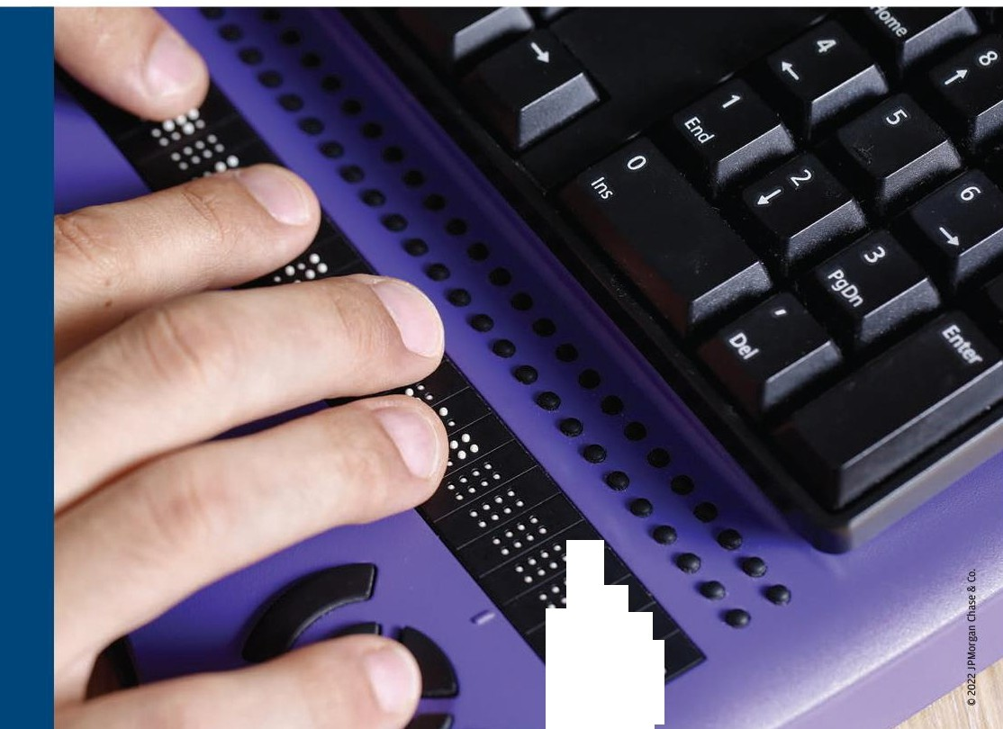
.
.....
.
•
•
...
.
..
•
••
•
•
•
•
•
••
.•
•
.•
.
.

CoII1II1itrnent to access and inclusion
•
•
•
•
•
•
•
We proudly support the American Council of the Blind for its developing innovative education, technology and training programs and legislative advocacy that create pathways to independence
and success for their constituents.

JPMORGAN CHASE &Co.
jpmorganchase.com

amaz,,on

Amazon's vision is to be Earth's most customer-centric company. Our goal isn't simply to make things accessible, but to make products, services, and experiences that are delightful for customers with disabilities.

Customers can enjoy a rich set of accessibility features on Amazon devices, such as the award-winning VoiceView screen reader on Fire TV, Fire tablets, and Echo Show devices. They can also enjoy Fire tablets' compatibility with Bluetooth refreshable braille displays and use Alexa for things like identifying pantry items, shopping, and controlling smart home appliances by voice and touch.

To learn more, tune in to our sessions featuring Peter Korn, Director of Devices Accessibility, Dr. Josh Miele, Principal Accessibility researcher for Devices and 2021MacArthur Grant fellow, and other Amazon innovators.

To learn more about Fire TVs, Fire tablets, Kindle, and Echo Devices
Visit www.amazon.com accessibilit

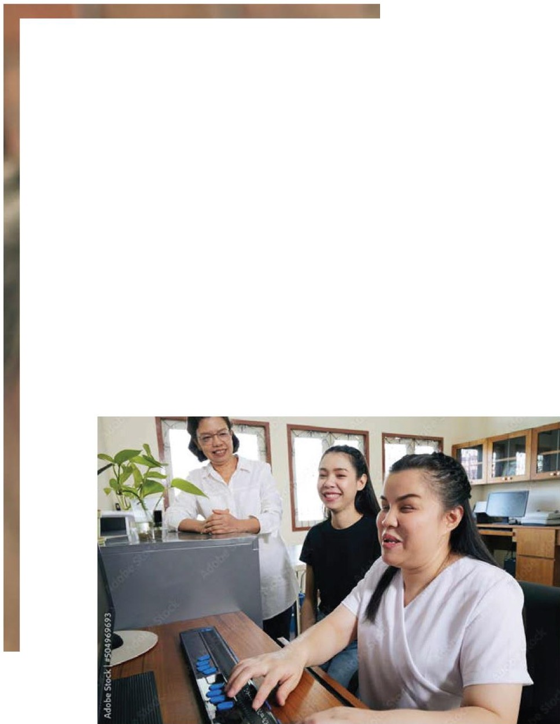
FOCUSED ON
WHAT MATTERS
A BRIGHTER FUTURE.

As an advocate for blind and visually impaired people, the American Council of the Blind has worked to strengthen communities and offer resources and education to help bridge the gap of equality and create connections amongst all people. MGM Resorts is proud to support the American Council of the blind in all its efforts.

MGM RESORTS
INTERNATION AL"

Table of Contents

61st Annual National Conference & Convention 1
President’s Message 7
Conference Gems 9
Calendar 17
Abbreviations in this Program 37
ACB Café 38
Registration Information 39
Communication Center Services 42
Digital Information & Internet 45
ACB Photography/Videography 48
Medical Information 49
Guide Dog User Information 50
Veterinary Care 51
Religious Activities 52
Convention Standing Rules 52
General Session Agenda 56
Special-Interest Affiliate Meeting 64
Aliance on Aging and Vision Loss 64
American Association of Blind Teachers 67
American Association of Visualy Impaired Attorneys 69
ACB Diabetics in Action 71
American Council of Blind Families 75
American Council of Blind Lions 78
ACB Next Generation 79
ACB Radio Amateurs 84
American Council of Blind Students 85
Blind Information Technology Specialists 88
Braille Revival League 90
Blind LGBT Pride International 93
Council of Citizens with Low Vision International 101
Friends-in-Art of ACB 103
Guide Dog Users, Inc. 107
Independent Visually Impaired Entrepreneurs 110
Library Users of America 112
Randolph-Sheppard Vendors of America RSVA® 113
Visually Impaired Veterans of America 117
ACB Committee Meetings 117
ACB Women’s Committee 117
Advocacy Services Committee 120
Auction Committee 121
Audio Description Project Committee 122
DKM First-Timers Committee 126
Employment Committee 127
Information Access Committee 128
International Relations Committee 130
Leadership Training Committee 133
Membership Committee 133
Multicultural Affairs Committee 135
Pedestrian Environment Access Committee 139
Rehab Issues Task Force Committee 141
Resource Development Committee 142
Sight and Sound Impaired Committee (SASI) 142
Scholarship Committee 143
Transportation Committee 143
Walk Committee 145
Other Meetings and Programs 145
2022 Tours 154
Kids Explorers Club 169
ACB Fundraisers 171
2022 ACB Exhibitors 173
Marketplace 175
ACB Officers and Board of Directors 175
ACB Board of Publications 177
ACB Enterprises & Services 177
2022 Convention Coordinating Committee 179
2022 Convention Program Committee 179
Local Host Committee 180

President’s Message

I want to welcome everyone to the 61st annual conference and convention of the American Council of the Blind, for our first ever hybrid gathering broadcast across ACB Media Network and in-person in Omaha, Nebraska. In these unique times, the efforts of our members to pull together and present an outstanding event is a testimony to the passion and tenacity of our ACB Family.

The theme of the 2022 convention is “Here, There and Everywhere!” This is a great theme for this year’s convention since today’s obstacles represent tomorrow’s opportunities. Making opportunities turn into successes for people who are blind or visually impaired is what our work at ACB is all about!

You will hear more about ACB’s successes during what should be our busiest and most information-packed convention ever.

Every ACB convention relies on scores of volunteers who work to make this event possible. I want to personally thank the members of the Convention Committee, chaired by Janet Dickelman; the Convention Program Committee, and the ACB Media Network team.

Likewise, let me acknowledge the work of our Alexandria and Minneapolis staff. You are all fabulous!

Finally, a very warm welcome to those of you attending the ACB convention for the first time. This hybrid event will offer our members and friends a wonderful chance to experience a truly exceptional program in the comfort of your own home or in Omaha at the fabulous Hilton Hotel in the heart of the city. There will be over 25 hours of audio-described virtual tours, a robust vendor exhibit hall and amazing live tours, daily general sessions with knowledgeable presenters across the full range of issues that impact our community and over 100 breakout sessions from our affiliates, committees, and sponsors. This unique experience will shape our organization for years to come, and we can’t wait to get together in person or on the ACB Media Network. Plan on joining us in 2023 and come to Schaumburg, Illinois next year.

Enjoy a great convention! Dan Spoone, ACB President

Conference Gems
Many, many thanks to our 2022 corporate sponsors. Their continued generous support of the American Council of the Blind and our conference and convention is sincerely appreciated.

Look for the 2022 corporate sponsors on www.acb.org, in the conference and convention program and newspaper, on ACB Media, on the convention T-shirt, and throughout the week. Be sure to thank them personally for their generous support.

Diamond Sponsors
- JPMorgan Chase – Conference & Convention Announcements
- Meta – ACB Banquet
- Microsoft – ACB Media Streaming
- Vanda Pharmaceuticals
- Vispero – ACB Videography

Emerald Sponsors
- Amazon - Technology Help Desk
- Johnson & Johnson
- MGM Resorts International – Conference Exhibit Hall and Guide
- Spectrum – Conference podcasts

- Verizon

Ruby Sponsors
- AT&T – Conference Registration
- Cruise
- Google – ACB Diversity, Equity, and Inclusion session tracks
- NCTA (National Cable and Telecom Association) - ACB Scholarship Mentoring Program
- Waymo

Onyx Sponsors
- American Printing House for the Blind – ACB Life Membership Reception
- Democracy Live - Membership Monday
- Tusk Montgomery Philanthropies - ACB Life Member Reception

Topaz Sponsor
- ACB Lions - Sponsor a student, future ACB Leader or Young Professional

Pearl Sponsor
- Library Users of America - Talking Book Narrator

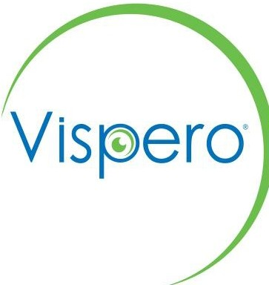Vispero is a proud sponsor of the American Council of the Blind National Convention.
Learn more about our innovative technology for blindness and low vision, and the passionate team behind it at vispero.com!

We're excited to see you again-in person!
Please visit us in the exhibit hall and during our presentation-we have many convention specials and a free gift just for visiting us!

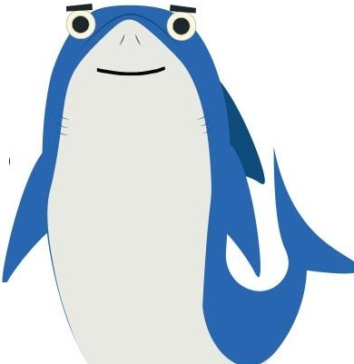
What's New with JAWS, Fusion, and ZoomText
Saturday, July 2, 10:00 AM - 11:15 AM

Join Douglas Gerry for the annual User Group meeting. All skill levels are welcome. We'll demonstrate and discuss the recent developments and look at what's coming in 2023. Bring your questions and join the fun as we kick off the 2022 Convention with the JAWS teams from Training, Sales, and Marketing.

enhanced Freedom Optelec

VISIOn

Scientific8
TPGi l

V I S P E R O '" B R A N D S - - - - -

PROUD TO SUPPORT

The2022
American Council of the Blind Conference and Convention

OO M et a

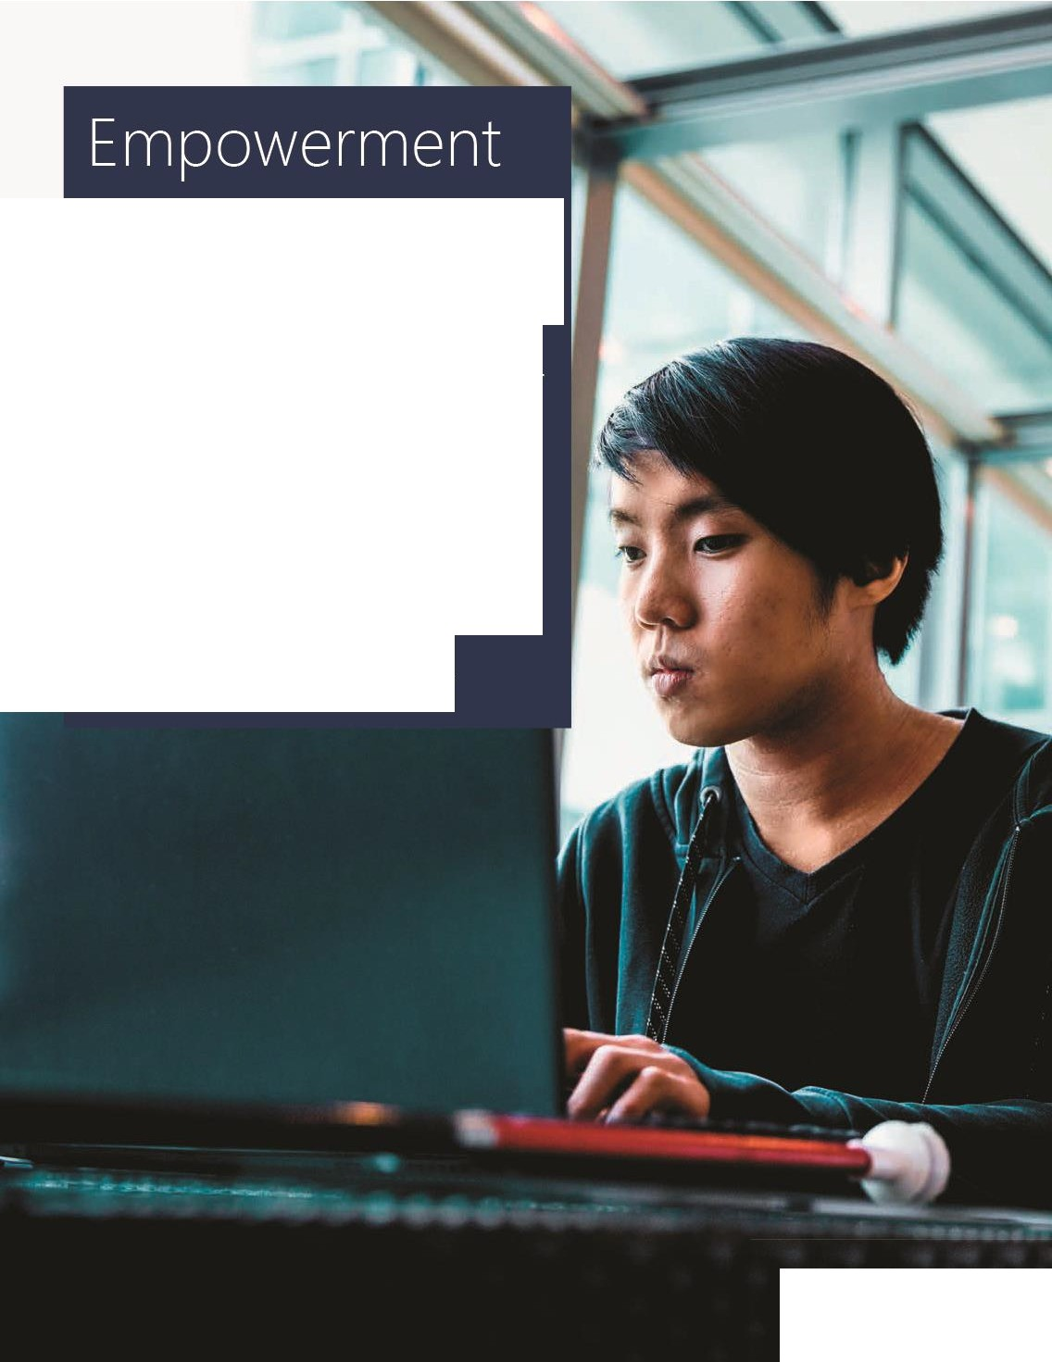

Microsoft is a proud sponsor of the 2022 American Council of the
Blind Conference and Convention. ,r

Microsoft's mission is to empower every person and every organization on the planet to
achieve more. This includes

creating and delivering technology that is accessible and functional for everyone.

M icrosoft.com/accessibiIity

■J■■ M1crosoft
.

To all you forward
thinkers, thanks for striving to make things better.

Spectrum is proud to support
ACB's 2022 Conference & Convention.

Spectrum►

_ MOBILE
\tOTING
n Our mission is to expand voting options to include secure, accessible
mobile voting so any voter, regardless of ability, canvote from anywhere.

Electronic remote ballot delivery and return options are needed so voters with disabilities canvote independently and privately from home.
g
g
We continue to stand with the American Council of the Blind to expand voting options.
0 Learn more at mobilevoting.org

crui•se
Building the world's most advanced autonomous vehicles.

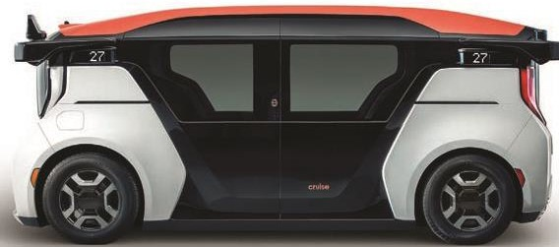

We are proud to work with the American Council of the Blind and their members, and to support the 2022 Conference & Convention.

GetCruise.c om

THEINTERNET& TELEVISION ASSOCIATION
ncta
PROUDLY SUPPORTS
AMERICAN COUNCIL OF THE BLIND AND THE 61st ANNUAL ACB CONFERENCE AND CONVENTION

DEM @C RACYLIVE
VOTER INFORMATION TECHNOLOGIES

Democracy Live - AccessibleVoting Technologies. Anytime. Anywhere.

In too many states, voters with disabilities don't have equal access to voting independently and privately from home. Fortunately, there are new accessible at-home voting technologies now available.

The Democracy Live OmniBallot accessible at-home voting system is a fully ADA Section 508, WCAG 2.1 compliant remote ballot marking solution. The system has been tested to meet the accessibility requirements of over 90 combinations of browsers, operating systems, screen readers and devices. OmniBallot has been deployed as an accessible absentee tool since 2008, in over 4,000 elections, serving 3,000 jurisdictions, in 27 states and 96 countries around the world. OmniBallot has been tested and reviewed by members of most every leading disability organization in the nation.

For further information, please contact Democracy Live:
855-655-VOTE (8683) Toll Free I Email : info@democracvlive.com I www.democracvlive.com

Calendar

Saturday, June 18
6:00 pm - 11:00 pm: ACB Summer Auction; Virtual

Wednesday, June 22
10:00 am - 1:00 pm: Exhibit Hall Virtual Tour; Virtual 7:00 pm - 8:00 pm: Reading of Standing Rules
Credentials; Virtual

Thursday, June 23
10:00 am - 11:15 am: Reaching Beyond Their Borders: International Programs of US Schools for the Blind; Virtual
11:30 am - 2:15 pm: GDUI: School Updates; Virtual 1:00 pm - 2:15 pm: BRL Constitutional Changes; Virtual 1:00 pm - 2:15 pm: AI in Music and Pictures; Virtual
1:00 pm - 2:15 pm: Audio Description: “Nothing About Us Without Us”; Virtual
2:30 pm - 3:45 pm: ACBRA Business Meeting; Virtual
2:30 pm - 3:45 pm: BRL Nominations and Candidate Forum; Virtual

2:30 pm - 3:45 pm - Seeing Eye Woofs and Wags; Virtual 4:00 pm - 5:15 pm: BRL Other Business; Virtual
4:00 pm - 5:15 pm: Yoga with Leslie Spoone; Virtual
4:00 pm - 5:30 pm: Audio Description Update on TV Broadcast and Cable Networks and the CVAA; Virtual
5:30 pm - 6:45 pm: AABT Business Meeting; Virtual
5:30 pm - 6:45 pm: Adaptive Sports: GET UP, GET MOVING, and Make Life Fun!; Virtual
7:00 pm - 9:00 pm: Nominating Committee; Virtual 7:30 pm - 8:45 pm: Prose and Poetry Reading; Virtual

Friday, June 24
1:00 pm - 2:15 pm: Residential Adjustment to Blindness; Virtual
1:00 pm - 2:15 pm: You Gotta Have Harp; Virtual
1:00 pm - 2:15 pm: Science for Superheroes: Video presentation and discussion of Cryopreservation; Virtual
1:00 pm - 2:15 pm: NLS Expands its Foreign Language Collection; Virtual
2:30 pm - 3:45 pm: Super Computers and Super Pups; Virtual

2:30 pm - 3:45 pm: LUA Business Meeting; Virtual 2:30 pm - 3:45 pm: En-Vision America; Virtual
4:00 pm - 5:15 pm: Cardio Exercise with Leslie Spoone; Virtual
5:30 pm - 6:45 pm: ACBS Business Meeting; Virtual 5:30 pm - 6:45 pm: Affiliate Presidents Meeting; Virtual 5:30 pm - 6:45 pm: Bookshare Office Hours; Virtual
7:30 pm - 10:00 pm: Showcase of the Performing Arts; Virtual
10:00 pm - 11:15 pm: Showcase After Hours; Virtual

Saturday, June 25
10:00 am - 11:15 am: IVIE Business Meeting; Virtual 11:30 am - 12:45 pm: Do you really need Indeed?
Indeed you might; Virtual
1:00 pm - 2:15 pm: AAVIA Business Meeting; Virtual 1:00 pm - 2:15 pm: ACBF Business Meeting; Virtual 1:00 pm - 3:45 pm: RSVA Business Meeting; Virtual
1:00 pm - 2:15 pm: ACB Committee Chairs Meeting; Virtual

1:00 pm - 2:15 pm: The Art of Disability Culture: Nontraditional Visually Impaired Artist panel; Virtual
2:30 pm - 3:45 pm: CCLVI Business Meeting and Elections; Virtual
2:30 pm - 3:45 pm: Audio Description Project: Self- Description: Too Much or Just Enough - Blind Community Perspectives; Virtual
2:30 pm - 3:45 pm: Social Security at Work; Virtual
4:00 pm - 5:15 pm: BPI/MCAC/GDUI Candidates Forum; Virtual
4:00 pm - 5:15 pm: Sister Power Happy Hour; Virtual 5:30 pm - 6:45 pm: ACB Families Goes to Camp; Virtual
5:30 pm - 7:30 pm: ACB Next Generation and ACB Students Convention Pep Rally; Virtual
7:30 pm - 8:45 pm: FIA Writers' Workshop; Virtual 7:30 pm - 10:00 pm: ACB Film Night; Virtual
7:30 pm - 8:45 pm Keys to the Convention (Virtual) 9:00 pm - 11:00 pm: ACBL Milly's Place; Virtual

Thursday, June 30
6:00 pm – 9:00 pm – Registration, HH Blackstone Ballroom A

Friday, July 1
8:00 am – 7:00 pm – Registration, HH Blackstone Ballroom A
8:00 am - 3:15 pm: Henry Doorly Zoo; Left Outside Hilton Lobby
10:00 am - 4:00 pm: ACB Board Meeting; HH Hill & Virtual
4:00 pm - 6:45 pm: CCLVI/BITS: Vendor Showcase; CHI 213 & Virtual
6:00 pm - 8:00 pm: Scholarship Winners' Dinner (by invitation only); CHI 215
8:00 pm - 10:00 pm: ACBS/Next Gen Friday Night Bash; CHI 208
8:00 pm - 11:00 pm: "Come Together!" Welcome to Omaha; HH Blackstone B
9:00 pm - 12:00 am: RSVA/IVIE Mixer; CHI 215

Saturday, July 2
8:00 am – 6:00 pm – Registration, HH Blackstone Ballroom A
8:00 am - 9:30 am: AABT Breakfast and Program: The Statue of Liberty - The Rest of the Story; CHI 215 & Virtual

8:30 am - 10:30 am: Goalball; TBA
10:00 am - 11:15 am: Berl Colley Leadership: Moving from Safe Spaces to Brave Spaces; CHI 211 & Virtual
10:00 am - 11:15 am: BITS: Navigating Your World; CHI 213
10:00 am - 11:15 am: BrailleSense 6, Productivity has Never Been More Fun! CHI 208 & Virtual
10:00 am - 11:15 am: What's New with JAWS, Fusion, and ZoomText; CHI 215 & Virtual
10:00 am - 12:00 pm: City Bus Tour with a Twist; Left Outside Hilton Lobby
10:00 am - 3:45 pm: Boys Town; Left Outside Hilton Lobby
11:30 am - 12:45 pm: AAVIA and Advocacy Committee: Civil Rights Panel; CHI 215 & Virtual
11:30 am - 12:45 pm: Berl Colley Leadership; CHI 211 & Virtual
11:30 am - 12:45 pm: BITS: On the Go - Laptops and Tablets; CHI 213 & Virtual
11:30 am - 12:45 pm: Furry Tails; CHI 208 & Virtual
1:00 pm - 2:15 pm: Making Gay History; CHI 208 & Virtual

1:00 pm - 2:15 pm: RSVA: “All about the Nebraska Business Enterprise Program”; CHI 215 & Virtual
1:00 pm - 2:15 pm: Safety Education Empowering Defense Intro Workshop; HH Merchant
1:00 pm – 2:15 pm: NLS Focus Group, HH Rome
1:00 pm - 5:00 pm: Exhibit Hall Opens; CHI Exhibit Hall A 1:00 pm - 5:00 pm: Community Hospitality; HH St.
Nicholas & Virtual
1:00 pm - 3:00 pm: City Bus Tour with a Twist II; Left Outside Hilton Lobby
2:30 pm - 3:45 pm: ACBS, Blind Activism and Advocacy Panel; CHI 208 & Virtual
2:30 pm - 3:45 pm: RSVA: The Value of Randolph- Sheppard Business Enterprises as Career Opportunities; CHI 215 & Virtual
2:30 pm - 3:45 pm: Pitch in an Elevator: Talking It Up When You Are Going Down; CHI 211 & Virtual
2:30 pm - 3:45 pm: 411 From the IAC: Low-Tech, High- Tech Fitness Journey; CHI 213 & Virtual
4:00 pm - 6:00 pm: BPI Movie: Rocky Horror Picture Show; CHI 208
4:00 pm - 5:30 pm: CCLVI: Fred Scheigert Scholarship Winners' Reception; HH Cozzens

4:00 pm - 5:15 pm: RSVA: “Outlook Enrichment Assistance”; CHI 215 & Virtual
4:00 pm - 5:15 pm: ACB Next Generation: Meet the Framily; CHI 211 & Virtual
4:00 pm - 5:15 pm: 411 From the IAC: Unlocking the secrets of shopping; CHI 213 & Virtual
4:00 pm - 5:15 pm: Keys to the Convention; HH Hill 4:00 pm – 5:30 pm: NLS Focus Group, HH Rome 4:00 pm - 5:15 pm: Catholic Mass; HH Prague
4:00 pm - 5:15 pm: Interdenominational Church Service; HH Mercer
4:00 pm – 5:15 pm: Jewish Service: Temple Israel, HH Flat Iron
5:00 pm - 6:45 pm: Come Tailgate with ACBDA; HH Grand A
6:00 pm - 7:00 pm: Walking Everywhere! HH Grand Ballroom Foyer & Virtual
6:30 pm - 10:00 pm: Kids Explorers Club; HH Paxton
7:00 pm - 10:00 pm: Opening General Session: CHI Grand Ballroom & Virtual

Sunday, July 3
7:00 am - 8:15 am: GDB Breakfast; CHI 213 & Virtual 7:00am - 5:00 pm: Kids Explorers Club - Fontanelle
Forest; HH Paxton
8:00 am – 5:00 pm – Registration, HH Blackstone Ballroom A
8:30 am - 12:00 pm: ACB General Session; CHI Grand Ballroom & Virtual
10:45 am - 4:45 pm: Malcolm X Center and Black History Museum; Left Outside Hilton Lobby
11:00 am - 5:00 pm: Exhibit Hall Opens; CHI Exhibit Hall A
12:15 pm - 2:15 pm: AAVL Lunch: Unraveling the Medicare Tangle; CHI 213 & Virtual
12:15 pm - 2:15 pm: RSVA® Awards Luncheon "Celebrating over 50 years of achievement and advocacy"; CHI 215 & Virtual
12:45 pm - 3:45 pm: Mormon Trail; Left Outside Hilton Lobby
1:00 pm - 2:15 pm: "BPI: Beyond Swiping: Seeking Romantic Connection and Compatibility in the 21st Century"; CHI 208 & Virtual

1:00 pm - 2:15 pm: LUA: Up Close and Personal with NLS Director, Jason Broughton; CHI 211 & Virtual
1:00 pm - 2:15 pm: Safety Education Empowering Defense Intro Workshop; HH Merchant
1:00 pm - 5:00 pm: Community Hospitality; HH St.
Nicholas & Virtual
2:30 pm - 3:45 pm: 3D Audio Excursion; CHI 208 & Virtual
2:30 pm - 3:45 pm: Not Your Mother's Library; CHI 211 & Virtual
2:30 pm - 3:45 pm: Student Led Discussion; CHI 215 & Virtual
2:30 pm - 3:45 pm: Update Your Zoom Profile Pic; HH Washington City
4:00 pm - 5:15 pm: A Day in the Life an Audio Engineer/Describer; CHI 208 & Virtual
4:00 pm - 5:15 pm: Providing Quality and Affordability: APH High-tech Refreshable Braille Solutions; CHI 215 & Virtual
4:00 pm - 5:15 pm: To Mobility and Beyond: Update on Public Right-Of-Way Accessibility Guidelines (PROWAG); CHI 211 & Virtual

5:30 pm - 6:45 pm: The Human Side of They: What are the Colors of Our Rainbow; HH Cozzens
5:30 pm - 6:45 pm: ACBF: Everyone Can Play!; CHI 211 & Virtual
5:30 pm - 6:45 pm: Conversation with the World Blind Union CEO, Marc Workman; CHI 215 & Virtual
5:30 pm - 6:45 pm: Scholarship Winners Reception; HH Grand Ballroom A/B
5:30 pm - 6:45 pm: What’s new with GPS Products at HumanWare; CHI 213 & Virtual
6:00 pm - 8:00 pm: Get Up and Get Moving with a walk across the Bob Kerrey Pedestrian Bridge; Left Outside Hilton Lobby
7:30 pm - 8:45 pm: 1st Act: Enjoy some laughs with RSVA® Comedian Willie Farrell; HH Blackstone B
8:00 pm - 9:45 pm: BPI Mixer: Bobbing into Omaha!; HH Cozzens
8:00 pm - 10:00 pm: Get Social with SASI; HH Hill
9:00 pm - 12:00 am: 2nd Act: Show your talent with RSVA® Karaoke!; HH Blackstone B
10:00 pm - 12:00 am: Open Mic Night with BPI; HH Cozzens

Monday, July 4
7:00 am - 8:15 pm: ACBF Breakfast; Preserving Our Memories; CHI 213 & Virtual
7:00 am - 8:15 pm: BRL Breakfast; CHI 211 & Virtual
7:00 am - 5:00 pm: Kids Explorers Club- Amazing Pizza Machine; HH Paxton
8:00 am – 5:00 pm – Registration, HH Blackstone Ballroom A
8:30 am - 12:00 pm: ACB General Session; CHI Grand Ballroom & Virtual
11:00 am - 5:00 pm: Exhibit Hall Opens; CHI Exhibit Hall A
12:15 pm - 2:15 pm: "Selling Yourself: How to Put Your Best Foot Forward in the Evolving Employment World."; CHI 213 & Virtual
12:15 pm - 2:15 pm: Voices from Around the World Luncheon: A Tapestry of Stories: Overcoming Challenges and Achieving Success in the US; CHI 211 & Virtual
12:30 pm - 2:30 pm: City Bus Tour with a Twist III; Left Outside Hilton Lobby
12:15 pm - 4:30 pm: Strategic Air Control and Aerospace Museum; Left Outside Hilton Lobby

1:00 pm - 3:45 pm: VIVA Business Meeting; HH Hill
1:00 pm - 2:15 pm: Blind Dating in a Sighted World: The Non-verbal Cues of Dating; CHI 208 & Virtual
1:00 pm - 5:00 pm: Community Hospitality; HH St.
Nicholas & Virtual
2:30 pm - 3:45 pm: Breath and Sound; HH Cozzens 2:30 pm - 3:45 pm: Smart Home Living; CHI 211 &
Virtual
2:30 pm - 3:45 pm: Social Justice and Identity-Based Training; CHI 208 & Virtual
2:30 pm - 3:45 pm: To Mobility and Beyond: Challenges Facing Pedestrians in 2022; CHI 213 & Virtual
2:30 pm - 5:15 pm: IVIE Business Expo; HH Merchant
3:00 pm - 5:00 pm: City Bus Tour with a Twist IV; Left Outside Hilton Lobby
4:00 pm - 5:15 pm: How to Not be Afraid of Your Kitchen 101; CHI 208 & Virtual
4:00 pm - 5:15 pm: MCAC Social; HH Grand Ballroom A
4:00 pm - 5:15 pm: To Mobility and Beyond: Yes, You Can! Local Success Stories; CHI 213 & Virtual
4:00 pm - 5:15 pm: Unraveling Advocacy for Vision Rehabilitation Services; CHI 215 & Virtual

5:30 pm - 6:45 pm: BPI: Colors of the Rainbow: What Is an Ally; HH Cozzens
5:30 pm - 6:45 pm: What’s new with Braille at HumanWare; CHI 213 & Virtual
5:30 pm - 6:45 pm: Empowering Ourselves to Advocate for the Best Mental Health and Emotional Well Being Care; CHI 208 & Virtual
5:30 pm - 6:45 pm: Wine Tasting: Sparkles and Fireworks; HH Washington City
5:30 pm - 10:45 pm: Baseball and Fireworks; Left Outside Hilton Lobby
6:00 pm - 12:00 pm: RSVA® Casino Trip; Left Outside Hilton Lobby
7:30 pm - 9:00 pm: Bingo - It's a Families Tradition; CHI 215
7:30 pm - 10:00 pm: Community Karaoke; CHI 208 & Virtual

Tuesday, July 5
7:00am - 5:00 pm: Kids Explorers Club - Henry Doorly Zoo; HH Paxton
8:00 am – 4:00 pm – Registration, HH Blackstone Ballroom A

8:30 am - 12:00 pm: ACB General Session; CHI Grand Ballroom & Virtual
11:00am - 5:00 pm: Exhibit Hall Opens; CHI Exhibit Hall A 12:15 pm - 1:00 pm: AAVIA Lunch; CHI 211
12:15 pm - 2:15 pm: ACB Lions Reverse Visit; CHI 213 & Virtual
12:15 pm - 4:00 pm: Outlook Collaborative Tour; Left Outside Hilton Lobby
1:00 pm - 2:15 pm: Meet the Talking Book Narrator; CHI 215 & Virtual
1:00 pm - 2:15 pm: AAVIA - Perspective from an attorney from the UK; CHI 211 & Virtual
1:45 pm - 4:45 pm: Lewis and Clark Visitors Center; Left Outside Hilton Lobby
1:00 pm - 5:00 pm: Community Hospitality; HH St.
Nicholas & Virtual
2:30 pm - 3:45 pm: Choosing Where to Live as You Age: Downsizing Part 1; CHI 213 & Virtual
2:30 pm - 3:45 pm: Knuckling Down on Endocrinology: Current and Future Treatment Strategies; CHI 208 & Virtual
2:30 pm - 3:45 pm: One Book, One ACB; CHI 215

2:30 pm - 3:45 pm: Ten Ethical Issues Lawyers Face Today; CHI 211 & Virtual
4:00 pm - 5:15 pm: Self-Care is Health Care; CHI 215 & Virtual
4:00 pm - 5:15 pm: Choosing Where to Live as You Age: Downsizing Part 2; CHI 213 & Virtual
4:00 pm - 5:15 pm: Knuckling Down on Using and Demonstrating Durable Medical Equipment; CHI 208 & Virtual
4:00 pm - 5:15 pm: Take a Walk in the Park; CHI 211 & Virtual
5:30 pm - 6:45 pm: ACBL: Lessons in Leadership; CHI 215 & Virtual
5:30 pm - 6:45 pm: Me to the Third Power: Finding, Working and Sharing Myself; Our Journey with Mental Health and Emotional Well-Being; CHI 208 & Virtual
5:30 pm - 6:45 pm: RDC "Two Scoops with No Calories"; CHI 213 & Virtual
5:30 pm - 6:45 pm: Wine Tasting: Tannin Tuesday; HH Washington City
5:15 pm - 9:15 pm: TreeRush Adventure Tour; Left Outside Hilton Lobby

7:00 pm - 8:30 pm: DKM/JPMorgan Reception (invitation only); HH President’s Suite
7:30 – 9 pm: A Conversation with Kelly Buckland, U.S. Department of Transportation, CHI 213

Join the ACB Transportation and Pedestrian and Environment Access Committees for a wide-ranging conversation regarding accessibility and disability rights with Mr. Kelly Buckland, Disability Advisor, Office of the Assistant Secretary on Policy, US Department of Transportation (Washington, DC)
7:30 pm - 9:30 pm: Dance of the Ages; HH Grand Ballroom A/B

Wednesday, July 6
7:00 am - 8:15 am: NIB Breakfast; CHI 208 & Virtual 7:00 am - 5:00 pm: Kids Explorers Club - Children’s
Museum; HH Paxton
8:00 am – 4:00 pm – Registration, HH Blackstone Ballroom A
8:30 am - 12:00 pm: ACB General Session; CHI Grand Ballroom & Virtual
9:00am - 1:00 pm: Exhibit Hall Opens; CHI Exhibit Hall A

10:00 am - 3:00 pm: Update and Audio Describe Your Profile Photo, HH Flat Iron
12:15 pm - 2:15 pm: MCAC Luncheon; CHI 213 & Virtual
12:15 pm - 5:15 pm: Train Day; Left Outside Hilton Lobby
12:45 pm - 4:45 pm: Sweet Tooth Tour; Left Outside Hilton Lobby
1:00 pm - 2:15 pm: "It Takes a Village: Working Together to Prepare Students in Transition"; CHI 211 & Virtual
1:00 pm - 2:15 pm: ACBRA Program; CHI 208 & Virtual
1:00 pm - 2:15 pm: Understanding where our writing system Braille has been; CHI 215 & Virtual
1:00 pm – 2:15 pm: NLS Focus Group, HH Rome
1:00 pm - 5:00 pm: Community Hospitality; HH St.
Nicholas & Virtual
2:30 pm - 3:45 pm: A Candid Conversation about a Critical Concept; CHI 213 & Virtual
2:30 pm – 3:45 pm: ACBDA: Accessible Pharmacy. Knuckling down on Accessibility; CHI 211 & Virtual
2:30 pm - 3:45 pm: New uses for Braille in Periodicals; CHI 215 & Virtual

2:30 pm - 3:45 pm: The History and Current Role of Fraternal Benefit Societies; CHI 208 & Virtual
2:30 pm – 3:45 pm: NLS Focus Group, HH Rome
4:00 pm - 5:15 pm: ACB Membership Committee Seminar; CHI 213 & Virtual
4:00 pm - 5:15 pm: Audio Description Award Winners; CHI 215 & Virtual
4:00 pm - 5:15 pm: Games with Ralph; HH Hill
4:00 pm - 5:15 pm: Knuckling Down with Peer Mentor Relations; CHI 211 & Virtual
5:30 pm - 6:45 pm: DKM Reception; CHI 211 & Virtual
5:30 pm - 6:45 pm: GDUI: Wrap-up and Awards CHI 215 & Virtual
5:30 pm - 6:45 pm: Making Sense of the Census; CHI 208 & Virtual
5:30 pm - 6:45 pm: Microsoft Windows Accessibility and Features; CHI 211 & Virtual
5:30 pm - 6:45 pm: Wino Wednesday; HH Washington City
6:00 pm - 9:45 pm: Riverboat Cruise; Left Outside Hilton Lobby
7:30 pm - 10:00 pm: It's Play Time!; CHI 208 & Virtual

Thursday, July 7
7:00 am - 5:00 pm: Kids Explorers Club - Urban Air; HH Paxton
8:00 am – 2:00 pm – Registration, HH Blackstone Ballroom A
8:30 am - 5:00 pm: ACB General Session; CHI Grand Ballroom & Virtual
10:00 am - 3:00 pm: Update and Audio Describe Your Profile Photo, HH Flat Iron
6:30 pm - 9:30 pm: Kids Explorers Club Party; HH Paxton
7:00 pm - 9:30 pm: ACB Banquet; HH Grand Ballroom A/B/C/D & Virtual
9:00 pm - 11:30 pm: Get Up and Move Dance Party; HH Grand Ballroom Foyer

Friday, July 8
10:00 am - 3:00 pm: Update and Audio Describe Your Profile Photo, HH Flat Iron
10:45 am - 3:00 pm: Brewery Tour; Left Outside Hilton Lobby
5:45 pm - 8:30 pm: Crime Dinner; Left Outside Hilton Lobby

Abbreviations in this Program

ACB - American Council of the Blind
AABT - American Association of Blind Teachers AAVL - Alliance on Aging and Vision Loss
AAVIA - American Association of Visually Impaired Attorneys
ACBDA - ACB Diabetics in Action ACBF - ACB Families
ACBGE - ACB Government Employees ACBL - ACB Lions
ACBNG - ACB Next Generation ACBRA - ACB Radio Amateurs ACBS - ACB Students
ADP - Audio Description Project
AFB - American Foundation for the Blind APH - American Printing House for the Blind
BITS - Blind Information Technology Specialists BOP - Board of Publications
BPI - Blind LGBT Pride International

BRL - Braille Revival League
CCLVI - Council of Citizens with Low Vision International DKM - Durward K. McDaniel First-Timer
FIA - Friends-in-Art of ACB GDUI - Guide Dog Users, Inc.
IRC - International Relations Committee
IVIE - Independent Visually Impaired Entrepreneurs KEC - Kids Explorers Club
LUA - Library Users of America
MCAC - Multicultural Affairs Committee NIB - National Industries for the Blind
NLS - National Library Service for the Blind and Print Disabled
RSVA - Randolph-Sheppard Vendors of America SASI - Sight and Sound Impaired Committee VIVA - Visually Impaired Veterans of America

ACB Café

Stop by the ACB Convention Café to grab a quick cup of coffee, pastry, sandwich, salad or snack as you rush

from one meeting to another or as you head out on a tour. Meet at the Café to visit with friends or just rest a while between activities.

The Café is in the convention center in room 210. The Café menu will be printed in the newspaper and available at the information desk, along with any daily specials.

Registration Information

Sponsored by Vanda Pharmaceuticals

Registration is in the hotel in the Blackstone Ballroom A.

Pre-registration packets can be picked up anytime Registration is open, but Thursday evening, June 30th from 6:00 pm to 9:00 pm and Friday and Saturday from 8:00 am to 11:00 am are reserved exclusively for pre- registration pickup only.

Onsite registration will only be done from 11:00 am to 7:00 pm on Friday and 11:00am to 6:00 pm on Saturday. This will help to better manage the lines during the first days of the convention.

Hours are:
- Thursday, June 30: 6:00 pm – 9:00 pm

- Friday, July 1: 8:00 am to 11:00 am (pre-reg pick-up only) and 11:00 am to 7:00 pm for pre-reg pick-up and onsite registrations.
Saturday, July 2: 8:00 am to 11:00 am (pre-reg pick-up only) and 11:00 am to 6:00 pm for pre-reg pick-up and onsite registrations.
- Sunday, July 3 and Monday, July 4: 8:00 am to 5:00 pm
- Tuesday and Wednesday, July 5 and 6: 8:00 am to 4:00 pm
- Thursday, July 7: 8:00 am to 2:00 pm

When you register, you will receive your convention ID badge, program, and a goody bag filled with information and surprises. You must register to purchase tickets to events and be eligible to win great door prizes. Always wear your badge because it admits you to the exhibit area and helps hotel personnel and volunteers provide better service.

If you are pre-registered, your packet will be waiting for you. You may not pick up a packet for someone else. If you have any questions about your registration or need to purchase more tickets, go to Registration in Blackstone Ballroom A in the hotel.

A one-day pass is available for $10.00 with no program and $15.00 with a program. This pass is color-coded by day and is good for only the day on which it is purchased. With this pass, you may attend exhibits and other programs and purchase tickets for that day only. If you wish to attend additional days at the convention, you must pay the full administrative fee.

Refunds: ACB will make no refunds for convention administrative and registration fees, sponsorship donations or tickets that you just don't want. Refunds are not made for events that you miss for any reason other than extreme illness (see below) or for events that you simply do not enjoy.

Refunds will be issued only for meals, events, and tours if:
An individual has pre-registered and requests the refund in writing to the American Council of the Blind, 6200 Shingle Creek Parkway, Suite 155, Brooklyn Center, MN 55430, or calls (612) 332- 3242, on or before June 20th, 2022; and the individual does not attend any part of the convention.

In case of illness during the convention requiring you to return home or to be hospitalized, refunds will be issued only for the meals, events, and tours taking place after

your absence begins. If the guarantee has already been given for a meal function or a tour, no refund for that function will be given. Refunds for tour tickets are only made under certain conditions. See tour instructions for more information.

Lost tickets: ACB will not replace tickets that are lost during the convention. All ticket packets are checked before they are distributed at the convention and tickets that are lost or misplaced must be purchased again.
Reselling tickets: Only tour tickets will be accepted for resale. In general, meal functions and social events at the hotel do not sell out. You may wish to explore other methods of selling luncheon, banquet, and other such tickets.

ACB is not responsible for notifying you if you have paid for a ticket through pre-registration for an event or tour that is already sold out. Your name will be put on a waiting list in the event of cancellations, or in case additional tickets become available.

Communication Center Services

The Marcia Nigro Dresser Communication Center is in Herndon in the Hilton and is open from 8:00 am to 5:00 pm, Friday, July 1 through Wednesday, July 6. This is

where you can place ads in the paper, make braille or print copies or volunteer to help produce the newspaper.

Convention Newspaper:
This year's newspaper is “The Goldenrod Gazette” and will be published each day, Friday through Wednesday, in braille and large print; pick up a copy at the Information Desk. The paper is also available on the ACB convention email list and via download at the Information Desk before 10:00 am.

For $10 ACB Students (ACBS) will deliver the newspaper to your hotel room door and it will be waiting for you each morning. After you sign up for newspaper delivery, activate your service by giving your room number and your format preference to the Information Desk.

Ads and Announcements:
Ads and other items for publication must be in the Communication Center by 2:00 pm each day. The BOP allows an ad to run for up to three days to give important convention announcements more space. Ads must be no longer than 75 words. BOP editorial policy prohibits the production or distribution of campaign materials by the Communication Center.

Cost of advertising in the newspaper is:
  - Individuals, ACB affiliates and blind representatives of MLM companies - $20/day or $50 for 3 days
  - Exhibitors - $40/day or $110 for 3 days
  - All others - $50/day or $140 for 3 days.

Pay for advertising at Registration and then show your receipt at the Communication Center when submitting your ad.

Brailling and Photocopying:
Photocopying is available at the Communication Center for 10 cents per page. Brailling services are available as follows:
  - Individuals, ACB affiliates, and blind representatives of MLM companies, 10 cents per page
  - Small businesses and small nonprofits, 20 cents per page
  - All others, 35 cents per page

If your committee or affiliate needs something in braille or large print, bring files early in the day so we can fit your job between other tasks. A test copy will be printed to let you know the number of pages per copy. Be sure to label your computer card or thumb drive and tell us

how many of each format you need and by what time. Please make payment at registration.

Thanks to HumanWare for once again donating the use of the braille embossers and to American Thermoform and American Printing House for their generous donation of braille paper.

Please remember that the Communication Center is a working room. While the convention is a great place to meet and greet, loud conversations make it difficult to hear the speech synthesizers on the computers. Help us help you get the information you need.

Digital Information & Internet

Sponsored by Amazon
If you have registered for the convention, you will receive Zoom invitations for the virtual and all the hybrid sessions. You can join via computer or phone.
Much of the conference will be streamed on ACB Media using multiple streams. All general sessions, and much of our afternoon and evening programming will be live streamed on ACB Media 1.

Other sessions will be recorded and replayed on ACB Media. Sessions will be available as podcasts after the

convention and archived for later listening on ACB Media.

Ways to Connect to ACB Media Programming:
- Amazon Alexa-enabled device (recommended) Alexa “Ask ACB Media to play Media n.” (n = the stream number). For example, to listen to General Session during National Convention; “Alexa, ask ACB Media to play Media 1.”
- PC / browser access (recommended):
Visit acbmedia.org at http://www.acbmedia.org/n (n= stream number). The site has a built-in media player. There is no need to install or use a media player on your device. Hit the play button and the stream will begin playing immediately.
- Smart Device Access (recommended): Download “ACB Link” from your app store. Find “Radio” along the bottom of the screen, then
“Menu” in the top left corner. Select “Streams” and then choose the stream you wish to listen to.
Double tap the play button.
- Victor Reader Stream Access:
Navigate to “Internet radio library” in the “online bookshelf.” Locate the Humanware playlist. From the playlist, select ACB Media n (n = stream number) and hit play.

- Dial-In Access for programming originating in Zoom:
Dial the Zoom access number provided with the schedule information for the session. When prompted, enter the meeting / webinar ID followed by #. You will hear the exact same program that is being streamed on ACB Media.
- Alternate Dial-In access (not recommended) Dial 1-518-906-1820. Listen to the menu prompts and press the number for the stream you want. Please note that this is a free service provided by Zeno Media. This service is limited in terms of simultaneous listeners and ACB does not warrant this service. If dial-in is your only option and the program is originating in Zoom, we recommend that you dial into the Zoom meeting / webinar directly (see above).

The ACB Radio Tuner is no longer supported. If you used the tuner in the past, you may access all ACB Media streams from acbmedia.org (see above).

If you are using alternate ways to access ACB Media streams than those above (such as TuneIn or Winamp using acbradio.org URLs), we kindly ask that you use one of the methods above.

Social Media:
Follow the latest goings-on at the convention on:
Twitter www.twitter.com/acbnational
or Facebook https://www.facebook.com/acbnational or view our YouTube Channel http://tinyurl.com/gloz7bq

Assistance during the convention
If you need assistance during the convention, contact our technology help desk, acb.tech.help@gmail.com, or call us at (888) 777-6730.

For general convention questions, call our convention information desk at (888) 444-8320, or email them at acb.info.helpdesk@gmail.com. You can reach help desk representatives between 8:00 am and 4:00 pm Central time.

Email list
The ACB Convention email list keeps you up to date on all the news. To receive the most up-to-date convention information, subscribe to the convention announce list by sending a blank email to acbconvention+subscribe@acblists.org

ACB Photography/Videography

Sponsored by Vispero

The official ACB photographer for the 2022 conference and convention will be taking pictures and video in the exhibit hall, on selected tours, and at many social events. They will visit committee and affiliate meetings, workshops, general sessions, and the banquet.

It is understood that all activities and programs scheduled at the 2022 conference and convention are subject to be photographed or videoed. Photos and video are the property of ACB and are for ACB's use.

Medical Information
For medical emergencies, dial 0 on a hotel phone or 911 on any other phone. Stay calm and speak distinctly. Give your name, exact location, and a description of the emergency.
For medical care, contact:
Urgent Care: Urgent Care Crossroads (5.1 Miles)
- Address: 325 N 72nd Street, Omaha, NE 68114
- Phone number: (402) 715-5272
- Hours of operation: Mon - Sat: 8 am - 8 pm, Sun: 8 am - 4 pm
Hospital: University of Nebraska Medical Center (2.8 Miles)

  - Address - 42nd & Emile St, Omaha, NE 68198
  - Phone number - (402) 559-4000
Pharmacy: Walgreens Pharmacy (1.6 miles)
  - Address - 3001 Dodge St, Omaha, NE 68131
  - Phone number - (402) 342-3301
  - Pharmacy Hours: Mon - Fri: 9 am - 1:30 pm & 2 pm - 7 pm, Sat: Closed, Sun: 10 am - 1:30 pm & 2 pm - 6 pm

Guide Dog User Information
Guide dog relief areas are built and maintained by Scoop Masters and are located near hotel exits. ACB volunteers and hotel staff will be happy to help you locate the areas.

Please keep in mind that the convention can be very stressful for your dog; you may need to relieve your dog more often than usual. Although the relief areas are cleaned at regular intervals, as always, please pick up after your dog. Trash receptacles are located near relief areas.

Should an indoor accident occur, please report it to Scoop Masters at (661) 714-0049. You should remain at the accident location to help alert others while you

await assistance. If an accident occurs in your room, you may be charged for the clean-up.

A few courtesy reminders from Krissy, the guide dog of Janet Dickelman, ACB Convention Coordinator:

“Thanks for reading these, they will make my job, and that of all your guides, so much easier! Always keep your guide on a short leash when out and about in the hotel. I know my mom gets distracted by people and things so if I am not close to her side, or on a short leash, I sometimes forget my best manners and get into mischief. Please give us guides a chance to relieve at least twice as often as at home, because you know how it is when away from home - different water, lots of excitement and disrupted schedules, etc. And, oh yes, please always pick up after us. I am so embarrassed by what my mom says when she steps in poop!!
Remember that convention is one of the most stressful working environments for us, your fuzzy eyes, so please give us every opportunity to be successful!”

Veterinary Care

Lone Tree Animal Care Center (1.6 miles)

  - Address: 524 South 24th Street, Omaha, NE 68102
  - Phone number: (402) 834-1305
  - Hours: Mon - Tues: 8 am - 5 pm, Wed: 12 pm - 8 pm, Thurs: 8 am - 5 pm, Fri: 7 am - 4 pm, Sat: 8 am
- 12 pm (Every other Saturday), Sun: Closed

Emergency Vet: VCA Midwest Veterinary Referral & Emergency Center (10.4 miles)
  - Address: 9706 Mockingbird Drive, Omaha, NE 68127
  - Phone number: (402) 614-9000

Religious Activities

Saturday, July 2
4:00 pm - Catholic Mass: Father Bernard Kimminau, St Patrick’s Church, McCook, NE
4:00 pm - Interdenominational Church Service: Rev.
Peter Heide, Baraboo, WI
4:00 pm – 5:15 pm: Jewish Service: Temple Israel, HH Flat Iron

Convention Standing Rules
Adopted by the ACB Board of Directors, April 1, 2022

- Each debatable issue before the convention shall be limited to approximately twenty (20) minutes with a two-minute time limit per speaker, alternating between affirmative and opposing speakers, unless a majority of the members agree to extend debate for an additional period of time.
  - Motions to close debate will not be recognized by the chair during the first debate period. After the first debate period, properly moved motions such as “I call for the question” or “I move the previous question” will be handled by the chair and voted on by the assembly.
  - The chair may close debate when no one seeks the floor.
  - Each member is respectfully urged to speak directly to the issue before the assembly and avoid unnecessary and time-consuming dialogue.
  - No member will be recognized a second time to debate until all who wish to debate have been recognized.
  - The parliamentarian will act as timekeeper.
- Recognition to speak will be given to those members who properly address the chair either using the “raise hand” feature of the Zoom internet meeting client program or while standing at a

microphone in the convention hall and giving their names and affiliation.
- Changes to the published convention program may be proposed to the membership as deemed necessary by the presiding officer or his/her appointee. The presiding officer will explain the reason for such change and inform the assembly of their right to question the recommended modification. After this explanation, if twenty-five
(25) or more members object to the proposed change by raising their hands using the Zoom meeting client, or, if in the convention hall, by raising their hands or standing, the change will then require debate and a majority vote to modify the convention program.
- Nominating and seconding speeches shall be limited to five minutes per candidate with the speaking time allocated according to the candidate's wishes. A person nominated for an office more than once shall be limited to one minute.
- When no candidate for office receives a majority vote, the election shall be between the top two candidates. Affiliate votes will be reported in whole or half numbers. In all uncontested elections as

verified after three calls for additional nominations, the chair may declare the candidate elected by acclamation. “Write in” candidacies are not permitted.
- A. Once a voice vote has been taken on a resolution or an amendment thereto, in accordance with Section C of Article III of the American Council of the Blind Constitution, and the chair has announced the result of that vote, the chair shall ask whether anyone voting in the minority objects to the vote. If at least twenty-five (25) members, either using the “raise hand” feature of the Zoom internet meeting client program or, if in the convention hall, raising their hand or standing, object to the result, then a record vote on the resolution shall be required.
B. After debate has ceased on a resolution and it is subsequently determined that a record vote is required, no further amendments may be proposed.

General Session Agenda

Saturday, July 2
7:00 pm: Call to Order: Dan Spoone
  - Moment of Reflection
  - Presentation of Colors - Offutt Air Force Base Honor Guard, Bellevue, NE
  - National Anthem – Amanda Coker, Omaha, NE
  - Welcome to Convention: Mark Bulger, President, ACB of Nebraska, Omaha, NE
  - ACB Highlight Video
7:30 pm: ACB President’s Report: Dan Spoone, Orlando, FL; Executive Director's Report: Eric Bridges, Alexandria, VA
8:00 pm: Diamond Sponsorship Presentation: Bob Ciminera, CEO, Vispero, Clearwater, FL
8:15 pm: Life Member Presentations: Dan Spoone and Nancy Marks-Becker, ACB Chief Financial Officer, Minneapolis, MN
8:35 pm: ACB Angels Presentations:
  - Yolanda Phelan, Hawaii
  - Vicki Johnson

8:55 pm: ACB First -Timers: Kenneth Semien Sr., Chair, Durward K. McDaniel First Timers Committee, Beaumont, TX
9:15 pm: ACB JPMorgan Chase Leadership Fellows: Eric Bridges, Alexandria, VA
9:35 pm: Nominating Committee Report: Brian Charlson, Watertown, MA
9:40 pm: Roll Call of Affiliates: Denise Colley, ACB Secretary, Richmond, TX

Sunday, July 3
8:30 am: Call to Order
    - Pledge of Allegiance - JPMorgan Chase Leadership Fellows: Judy Brown, Shoreline, WA; Cecily Nipper, Covington, GA; Kristin Kelling, Grand Rapids, MI
8:40 am: ACB Business
    - ACB Sponsor Recognitions, corporate and individual sponsors
8:50 am: Credentials Committee Report: Ralph Smitherman, Brandon, MS
9:00 am: Diamond Sponsorship Presentation - Vanda Pharmaceuticals: Jennifer Lyman, Midwest Nurse Educator, Chicago, IL and Vicki Preddy, Southeast Nurse Educator, Orlando, FL

9:15 am:
  - ACB Angels Presentation: Bernice Kandarian, California
  - Presiding Officer: Deb Cook Lewis, First Vice
President, Clarkston, WA
9:30 am: International Guest, Marc Workman, President, World Blind Union, Canada
10:00 am: Scholarship Presentations 10:30 am: Break
10:45 am: News from the National Library Service for the Blind and Print Disabled (NLS), Jason Broughton, Washington, DC
11:15 am: Nominations and Candidate Speeches, Election Information
11:55 am Door Prizes and Announcements

Monday, July 4
8:30 am: Call to Order
    - Pledge of Allegiance: Visually Impaired Veterans of America (VIVA) Singing of America the Beautiful
8:35 am: ACB Business
    - ACB Sponsor Recognitions, Corporate Sponsors:

8:50 am: ACB Angels Presentation: Josette Kernaghan, British Columbia, Canada
9:05 am: Affiliate Roll Call for ACB Board of Director Elections
      - Presiding Officer: Ray Campbell, Second Vice President, Springfield, IL
9:30 am: Omaha Historical Presentation 9:40 am: Scholarship Presentations 10:00 am: Break
10:15 am: ADP Awards
10:50 am: Member and Affiliate Relationships: Cindy Hollis, Manager of Membership Engagement, Flat Rock, MI
11:10 am: Nominations for Board of Director, Candidate Speeches
11:55 am: Door Prizes and Announcements

Tuesday, July 5
8:30 am: Call to Order
      - Pledge of Allegiance: Recipients of Ross Pangere Scholarships
8:35 am: ACB Business
ACB Sponsor Recognition, Corporate Sponsors:

8:40 am: Diamond Sponsorship Presentation: Saqib Shaik, Principal Engineering Manager, Microsoft, Bellevue, WA
8:55 am: ACB Angels Presentation: Rod Chard, Colorado
9:10 am: Affiliate Roll Call
    - Presiding Officer: Denise Colley, Secretary, Richmond, TX
9:35 am: ACB Advocacy Updates: Clark Rachfal, Director of Advocacy, Alexandria, VA; and Swatha Nandhakumar, Advocacy and Outreach Specialist, Alexandria, VA
9:55 am: CCLVI Scholarship Presentations 10:10 am: Break
10:25 am: ACB Scholarship Presentations
10:45 am: Talking Book Narrator: Ray Foushee, American Printing House for the Blind, Louisville, KY
11:15 am: Nominations for ACB Board of Directors Position, Candidate Speeches
11:55 am: Door Prizes, and Announcements

Wednesday, July 6
8:30 am: Call to Order

      - Pledge of Allegiance: DKM First - Timers: Joe Green, Sacramento, CA and Gregg Wandsneider, Waukesha, WI
8:35 am: ACB Business:
      - ACB Sponsor Recognitions
8:40am: Diamond Sponsorship presentation 9:05 am: Affiliate Roll Call
9:30 am: Sylvia Stinson-Perez, Chief Programs Officer, American Foundation for the Blind, Arlington, VA
      - Presiding Officer: David Trott, ACB Treasurer, Talladega, AL
9:45 am: ACB's Growth Report: Eric Bridges, ACB Executive Director, Alexandria, VA; and Nancy Marks- Becker, ACB Chief Financial Officer, Minneapolis, MN
10:00 am: Presentation by Day Al-Mohamed, Director of Disability Policy, Domestic Policy Council, Washington, DC (invited)
10:15 am: ACB Scholarship Presentations 10:35 am: Break
10:50 am: Report on the ACB Walk and Auction: Donna Brown, Walk Chair, Romney, WV; Leslie Spoone, Chair, ACB Auction Committee, Orlando, FL; and Dan Dillon, Chair, ACB Resource Development Committee, Hermitage, TN

11:05 am Spoken Rx: What is the Latest from CVS?
11:20 am: Nominations for ACB Board of Directors or BOP
11:55 am: Door Prizes and Announcements

Thursday, July 7
8:30 am: Call to Order
    - Pledge of Allegiance: JPMorgan Chase Recipients: Danette Dixon, Lynnwood, WA and Byron Lee, Minneapolis, MN
    - ACB Sponsor Recognition, Corporate and Individual Sponsorships
8:50 am: Diamond Sponsorship presentation: Monica Desai, Vice President, Global Connectivity Policy, Meta, Washington, DC
9:20 am: Affiliate Roll Call 9:40 am: Resolutions
10:10 am: Treasurer's Report: David Trott, Talladega, AL 10:30 am: Resolutions
10:50 am: Break
11:05 am: Resolutions
11:25 am: ACBES Report: Rev. Michael Garrett, Chair, ACB Enterprises and Services, Missouri City, TX

11:35 am: Resolutions
12:00 pm: ACB Mentoring, Access and Peer Support, Kenneth Semien Sr., Chair, Durward K. McDaniel First-Timers Committee, Beaumont, TX
12:15 pm: International Relations Committee, International Voices Contest Presentation: Maria Kristic, IRC chair, Albany, NY
12:30 pm: Convention Report: Janet Dickelman, Convention Coordinator, Saint Paul, MN
12:45 pm: First Reading of Constitution and Bylaws Report, John McCann, Constitution and Bylaws Committee Chair, Tucson, AZ
1:00 pm: Brett Oppegaard, The UniDescription Project 1:10 pm: Resolutions
7:00 pm: ACB Banquet
      - Banquet Emcee: Patrick Sheehan, Outgoing ACB Board Member, Silver Spring, MD
      - Moment of reflection:
7:45 pm: Presentation of BOP Awards; Zelda Gebhard, Board of Publications, Edgeley, ND; and Cachet Wells, Board of Publications, Jacksonville, FL
8:00 pm: Presentation of ACB Awards: Awards Committee Co-chairs Koni Sims, Sioux Falls, SD, and Carrie Muth, Coos Bay, OR
8:15 pm: Keynote Speaker: Judy Heumann

8:55 pm: ACB Braille Forum Raffle Drawing: David Trott, ACB Treasurer, Talladega, AL; and Nancy Marks-Becker, ACB Chief Financial Officer, Minneapolis, MN

Special-Interest Affiliate Meeting

Alliance on Aging and Vision Loss President: Jeff Thom Registration: $10

Sunday, July 3, CHI 213
12:15 pm - 2:15 pm: AAVL Lunch
Program begins at 1:00 pm: Unraveling the Medicare Tangle

Lori Scharff, ACB’s Medicare expert, will give you the information you need to better understand the maze that is the Medicare program. Eligibility, benefits, gaps, and special plans are just a few of the areas that she will cover.

Monday, July 4, CHI 215

4:00 pm - 5:15 pm: Unraveling Advocacy for Vision Rehabilitation Services
Explore innovative advocacy efforts wherein states can obtain funding under the Medicaid "Older Individuals who are Blind" program. This program provides an array of vision rehabilitation services; however, funding is extremely limited. Learn how to utilize the Older Individuals who are Blind and Medicaid programs.

Co-sponsored by AAVL and the Rehabilitation Issues Task Force

Tuesday, July 5, CHI 213
2:30 pm – 3:45 pm: Choosing Where to Live as You Age: Downsizing Part 1: How can we know when the time is right? Our panel will offer expert guidance on making important decisions on where we might live as we grow older.

Presenters: Carrie A.B. Hoarty, MD, Physician, Assistant Professor, General Internal Medicine, Omaha, NE; Mary Ann Eusebio, Information & Assistance Division Director, Eastern Nebraska Office on Aging, Omaha, NE.

Co-sponsored by AAVL and ACB Women

4:00 pm – 5:15 pm: Choosing Where to Live as You Age: Downsizing Part 2: How to Choose What's Right for Us. A conversation with a panel of ACB members who have made a variety of choices about where to live as they grow older.

Presenters: Kate Chamberlin, freelance writer and retired elementary school teacher, Walworth, NY; Jean Mann, retired New York State employee, Albany, NY; Linda Yacks, widow, mother, and grandmother, Harrison, AR

Co-sponsored by AAVL and ACB Women

7:30 pm – 10:30 pm: Dance of the Ages, $15, HH Grand Ballroom
Music for all ages will be provided by our DJ. Whether you like waltzes, line dances, or something in between, it will happen. We have also prepared an area for conversation while listening at a lower volume. Light snacks and a cash bar will be available. And plenty of door prizes.

Co-sponsored by AAVL, ACB Next Generation, and CCLVI

American Association of Blind Teachers President: Tabitha Brecke
Program Chair: Carla Hayes Registration: $10 ($12)

Saturday, July 2, CHI 213

8:00 am - 9:30 am: AABT Breakfast and Program “The Statue of Liberty: The Rest of The Story,” $30 ($35)

Learn about the fascinating history of the Statue of Liberty in this humorous and insightful program presented by the most requested historical speaker in Nebraska.

Presenter: Darrel W. Draper, Edutainer, Plattsmouth, NE.

Tuesday, July 5, CHI 215
1:00 pm – 2:15 pm: Meet the Talking Book Narrator - This is your opportunity to hear more from and ask questions of our 2022 talking book narrator, Ray Foushee, American Printing House for the Blind, Louisville, KY.
Co-hosted by LUA, AABT, BRL, and FIA

2:30 pm – 3:45 pm: One Book, One ACB: “Their Plant Eyes: A Personal and Cultural History of Blindness,” by M. Leona Godin

Co-sponsored by LUA, BRL, FIA and MCAC

Wednesday, July 6, CHI 211
1:00 pm – 2:15 pm: “It Takes a Village: Working Together to Prepare Students in Transition.” There are a lot of expectations for schools to provide all the essential academic skills to prepare for life beyond secondary education. There is often not enough funding to meet all the need. We know that technology is an integral part of our daily life. Nancy Flearl from the Nebraska Foundation for Visually Impaired Children will share how a simple non-profit is working in partnership with school districts and Vocational Rehabilitation to support students in transition.

Presenter: Nancy Flearl, Board President, Nebraska Foundation for Visually Impaired Children, Omaha, NE.

American Association of Visually Impaired Attorneys
President: Chris Prentice Registration: $10

Saturday June 25, Zoom only
1:00 pm - 2:15 pm: AAVIA Business Meeting

Saturday, July 2, CHI 215
11:30 am - 12:45 pm: AAVIA and Advocacy Committee Civil Rights Panel. This session will discuss recent achievements, ongoing legal efforts, current risks, and opportunities in the courts concerning issues of importance to members of ACB.

Presenters: Matthew Handley, Partner, Handley Farah & Anderson, Washington, DC; Christina Brandt-Young, Supervising Attorney, Disability Rights Advocates, New York, NY.

Co-sponsored by AAVIA and Advocacy Services Committee

Tuesday, July 5, CHI 211
12:15 pm – 2:15 pm: AAVIA Lunch
1:00 pm – 2:15 pm: Perspective from an Attorney from the UK (program begins at 1:00 pm)

Hear from Adal Ibrar, barrister, London, England, a Visually Impaired Attorney. Mr. Ibrar will talk about key experiences and observations of his training and career in the law. Through discussion with AAVIA members, it is hoped that illuminating contrasts and similarities will emerge.

2:30 pm - 3:45 pm: Ten Ethical Issues Lawyers Face Today

This session, led by Cynthia Hawkins, Professor of Law, Stetson University College of Law, Gulfport, FL, will offer an expert perspective on key ethical issues facing lawyers and affecting public perceptions of the legal profession.

Presenter: Cynthia Hawkins, Professor of Law, Stetson University College of Law, Gulfport, FL.

Wednesday, July 6, CHI 208

2:30 pm - 3:45 pm: The History and Current Role of Fraternal Benefit Societies

This session will feature representatives of a major Omaha-based fraternal benefit society, explaining the historical and contemporary importance of these organizations.

Presenter: Lynn L. Espeland, Vice President and General Counsel, Woodmen Life, Omaha, NE.

ACB Diabetics in Action
President: Tom Tobin Program Chair: Danette Dixon Registration: $25
Those paying the affiliate registration cost will receive handouts upon request.

Saturday, July 2, HH Grand Ballroom A
5:00 pm - 6:45 pm: Come Tailgate with ACBDA, (in- person only)

Join ACB Diabetics in Action Sugar Warriors as we team up with the Get Up and Get Moving Campaign and the Brenda Dillon Memorial Walk Team for some fun, prizes, tasty snacks and a cash bar. The tailgate

party starts before the Brenda Dillon Walk and will remain open during the walk and for a time after the walk concludes.
This will be a great time to socialize with members of ACBDA, Get Up and Get Moving and Brenda Dillon Walk organizers and friends.

Tuesday, July 5, CHI 208
2:30 pm – 3:45 pm: Knuckling Down on Endocrinology; Current and Future Treatment Strategies

Hear from a panel of global, leading endocrinologist regarding current and future best practice treatment strategies for managing Type I and Type II diabetes.

Facilitator: Terry Suarez, Diana Isaacs Endocrinologist Clinical Pharmacy Specialist

4:00 pm - 5:15 pm: Knuckling Down on Using and Demonstrating Durable Medical Equipment

Empowering clients to independently manage their diabetes and other chronic diseases with low or no vision. Kim’s passion for preventing diabetes and its complications through education stems from first- hand experience. Not only does she deal with

diabetes daily, but many of her family members do so as well. Kim will demonstrate how to use many different devices for diabetes.
Presenter: Kim Ladd, RN, BS, Diabetes Educator/Health Education Specialist, Virginia Rehabilitation Center for the Blind and Vision Impaired, Richmond, VA.

Wednesday, July 6, CHI 211
2:30 pm – 3:45 pm: ACBDA: Accessible Pharmacy

Knuckling Down on Accessibility - Three co-founders of Accessible Pharmacy will describe their rationale behind the founding of a full-service pharmacy serving the needs of individuals with blindness and vision impairment. One of the business partners who is blind will explain his vision for a full-service pharmacy, sharing his own personal disappointing experiences with mainstream pharmacies. In addition, you will hear from Accessible Pharmacy’s Chief Medical Officer about accessible durable medical equipment, inclusive of continuous glucose monitors, and generally, how Accessible Pharmacy works to meet the needs of their blind and vision impaired customers!

Presenters: Dr. Alex Cohen, PhD, Chief Marketing and Accessibility Officer, Fairless Hills, PA; Dr. Jason Barrett, PharmD, Chief Medical Officer, Fairless Hills, PA; and Andy Burstein, Chief Executive Officer, Fairless Hills, PA.

4:00 pm - 5:15 pm: Knuckling Down with Peer Mentor Relations

The ACBDA Peer Mentor Relations Program is a scientifically based peer support network which encourages members who have a variety of experiences, or length of time with both diabetes and/or sight loss, (mentors) to interact with one or more of their peers confidentially who request extra support, encouragement or like-experiences through Diabetes and sight loss, (mentees). This peer-to-peer mentoring relationship model allows for not only the sharing of information and experiences, but also the chance to gently challenge others to take a close look into their own personal lives to see what simple adjustments could be made to better support a life of both sight loss and diabetes. Additionally, these bonds provide a safe place to bring new ideas and thoughts to the table, and even move past some of the things that are uncomfortable, safely expanding

our personal comfort zone, to gain a better knowledge and understanding of living with sight loss and diabetes together. Knowing that we are not alone in these experiences or challenges can make such a positive difference in our lives, providing new shed light upon the face of adversity and amidst the darkness, in which so many of us live.

American Council of Blind Families President: Carla Ruschival Registration: $15
Register for ACB Families and be eligible to win door prizes. Lots of fun and lots of winners!

Saturday, June 25 (Zoom only)
1:00 pm: ACBF Business Meeting 5:30 pm: ACB Families Goes to Camp
It's summertime - time for sitting around the campfire, eating hotdogs and s'mores. Whether you're a kid or a kid at heart, camp is a special experience. Share stories; play games; experience a skit called "Forest," written by a student at the Kentucky School for the Blind and performed by the Reader's Touch

Productions from the Tri-State Library Users and directed by Dr. Terrie Terlau, Louisville, KY.

Finally, discover some camping opportunities for today's fun-loving folks!

Sunday, July 3, CHI 211
5:30 pm: ACBF - Everyone Can Play!

Resources and ideas for accessible toys and games; share family-tested tips from parents, grandparents, and teachers alike.

Facilitator: Patty Slaby, retired teacher of the visually impaired, Arcadia, WI

Monday, July 4
7:00 am - 8:15 am: ACBF Breakfast - Preserving Our Memories, $20 ($25), CHI 213

Preserving family memories is more than stuffing pictures into a shoebox. Find out how to preserve tapes and videos and how to begin collecting oral histories with Micheal Hudson, Director of the museum at the American Printing House for the Blind in Louisville, KY.

Always an inspiring speaker, Micheal is sure to get you motivated to actively collect those memories of your kids, cousins, and school and ACB friends.

7:15 pm - 9:00 pm: Bingo - It's a Families Tradition, $8 ($10), HH Grand A (In-person only)

Braille cards, large print cards, and lots of great prizes! Bring yourself, bring a friend, bring the kids - fun for all ages!

Wednesday, July 6, CHI 208
5:30 pm: Making Sense of the Census

It's a once-in-a-decade event! The 1950 Census is here, and it includes cousins, neighbors, aunts and uncles, grandparents - even family friends! They are all waiting to be discovered, and many will be people you know. Every ten years the United States conducts a census, and 72 years after the census date it becomes public. Packed with family information and details; get on the road to discovery.

American Council of Blind Lions President: Ray Campbell Registration: $10
Register for ACB Lions to be eligible to win our special door prizes. Winners will be drawn following the close of the ACB Conference and Convention.

Thursday, June 23
9:00 pm – 10:30 pm: ACBL Business Meeting (zoom only)

Saturday, June 25
9:00 pm: Milly's Place (zoom only)

Share stories about your local Lions Club activities. Bring your favorite chips, sandwiches and beverages and have a good time with Lions from across the country. All Lions, friends of Lions, and anyone interested in becoming a Lion is welcome.

Tuesday, July 5
12:15 pm - 2:15 pm: Lions Luncheon Reverse Visit, $35 ($38), CHI 213

Meet Lions from Omaha and discover how blind Lions are making a difference across America. Open to active Lions, former Lions, and anyone interested in learning more about becoming a Lion.
5:30 pm – 6:45 pm: Lessons in Leadership, CHI 215

Becoming a leader is like climbing a ladder. Some people make it to the top, while others only take two or three steps toward the goal. Lion Mary Lee Turner of Portland, OR, and Lion Jack Lenk of St. Louis, MO, are both members of ACB Lions and they are both past District Governors. They will share how they, as blind Lions, navigated the climb to this office and how they successfully completed the many responsibilities and requirements of this position. True lessons in leadership that can apply to any organization.

ACB Next Generation President: Amanda Selm
Co-Program Chairs, Melanie Alt Sinohui and Cassie Trosper
Registration: $10

Thursday, June 23 (Zoom only)
7:30 pm – 8:45 pm: Prose and Poetry Reading Showcase of the Performing Arts
Co-sponsored by FIA and ACB Next Generation

Saturday, June 25
5:30 pm – 7:30 pm: ACB Next Generation and ACB Students Convention Pep Rally (Zoom only)

Who’s got spirit? We do! Let’s get fired up for the 2022 ACB Conference and Convention. Join ACB Next Generation and ACB Students for our Convention Pep Rally. Enjoy meeting new friends, fun icebreakers, and learn about all our amazing events, as well as important information you will need to make your convention experience, whether virtual or in person, a great one. Bring your favorite snacks and get ready to root for ACB 2022. We can’t wait to cheer with you!

Facilitated by Amanda Selm, ACB Next Generation president, Louisville, KY; Olivia O'Connell, ACBS convention program chair, Commerce Township, MI; Gregg Wandsneider, Waukesha, WI.

Saturday, July 2, CHI 211
2:30 pm – 3:45 pm Pitch in an Elevator: Talking It Up When You're Going Down

Creating Your Personal Elevator Pitch Workshop - Many of us find it very difficult to talk about ourselves but being able to make a lasting impression in a few short seconds is an integral part of networking and sometimes even landing that job opportunity. Join the ACB Employment Committee as we work with participants in a workshop setting to fine tune and share your elevator pitch.

Co-sponsored by the ACB Employment Committee and ACB Next Generation

Saturday, July 2, CHI 211
4:00 pm - 5:15 pm: Meet the Framily

Friends who are family - Whether you've been with NextGen from the beginning or you're hearing about us for the first time, come hang out and mingle with new and old friends to kick off this year’s convention. You might even win a door prize!

Presenters: Melanie Sinohui, ACB Next Generation convention chair, Phoenix, AZ; Amanda Selm, ACB Next Generation president, Louisville, KY; Cassie Trosper, ACB Next Generation board member, North Bend, OR.

Monday, July 4
12:15 pm - 2:15 pm: “Selling Yourself: How to Put Your Best Foot Forward in the Evolving Employment World,” CHI 213, ($32) (program begins at 1:00 pm)
2:30 pm – 3:45 pm: Smart Home Living, CHI 211

A myriad of products that make your life and home more comfortable, cleaner, safer, and independent will be demonstrated and discussed. This is always a crowd-pleaser. Whether you are with us in person or virtually, you won’t want to miss this!

Sponsored by ACB Next Generation and CCLVI

4:00 pm – 5:15 pm: How to Not Be Afraid of Your Kitchen 101, CHI 208

Does the thought of undercooked meat scare you?

Are you nervous when chopping your veggies? Do you want to learn how to prep and meal plan for your budget? Join Herbie Allen as he goes in depth into kitchen and food safety and Janeen Lea as she focuses on making your money go further and meal prepping to make your busy nights easier.

Presenters: Amanda Selm, President, ACB Next Generation, Louisville, KY; Herbie Allen, ACB Community cooking call host, Houston, TX; Janeen Lea, ACB Community call cooking host, Kissimmee, FL.

Tuesday, July 5, CHI 215
4:00 pm – 5:15 pm: Self Care is Health Care

Take charge of your physical, mental, and emotional health. ACB Next Generation and ACB's Get Up and Get Moving invite you to come and learn about the connection between mind, body, and spirit. Come stretch out your body and energize your spirit by learning to relax! Participants will also be able to share their best practices for self-care. You’ll learn from Leslie Spoone, Certified Fitness Instructor, Orlando, FL; Koni Sims, retired Medical Massage Practitioner, Sioux Falls, SD and Terry Suarez,

Certified Respiratory Therapist, Clermont, FL.

7:30 pm – 10:30 pm: Dance of the Ages ($15)

Music for all ages will be provided by our DJ. Whether you like waltzes, line dances, or something in between, it will happen. We have also prepared an area for conversation while listening at a lower volume. Light snacks and a cash bar will be available. and plenty of door prizes.

Co-sponsored by AAVL, ACB Next Generation, and CCLVI

ACB Radio Amateurs President: Harvey Heagy Program Chair: Marcia Moses Registration: $10

Thursday, June 23
2:30 pm - 3:45 pm: ACBRA Business Meeting (Zoom only)

Wednesday, July 6, CHI 208

1:00 pm – 2:15 pm: ACBRA Program

Steve Dresser (WA1RTB) will demonstrate an accessible interface for the NannoVNA, a low-cost microprocessor-based device for analyzing antenna performance.

American Council of Blind Students President: Aaron Espinoza Program Chair: Olivia O’Connell

Friday, June 24 (Zoom only)
1:00 pm - 2:15 pm: Residential Adjustment to Blindness Training Center Panel

Join ACB Students for a panel featuring representatives from three blindness training centers: the Hellen Keller Center, the Carroll Center for the Blind, and one of the National Federation of the Blind centers. These three centers are located across the country, and their representatives will join us to speak about the programs offered within them. Learn how their programs can help you gain your independence in travel, cooking, reading, writing, using technology,

doing recreational activities, and more. Come learn about the importance of having a positive attitude on blindness. There will be a Q&A at the end of the session.

5:30 pm - 6:45 pm: ACBS Business Meeting

Saturday, June 25 (Zoom only)
5:30 pm – 7:30 pm: ACB Next Generation and ACB Students Convention Pep Rally

Friday, July 1
8:00 pm – 10:00 pm: ACBS Next Generation Friday Night Bash, HH TBD

Saturday, July 2, CHI 208
2:30 pm - 3:45 pm: ACBS, Blind Activism and Advocacy Panel

Join ACB Students for our panel on blind activism and advocacy with blind life coach Charlie Kramer, Los Angeles, CA and blind video editor, producer, and podcaster Lance Johnson, Brooklyn, NY!

Come learn just how beautiful self-advocacy can be. Charlie and Lance will discuss their life experiences, outlooks on blindness, and advice for blind students with us.

Sunday, July 3, CHI 215
2:30 pm – 3:45 pm: Student Led Discussion

Join ACB Students leaders to hear their perspectives on some of the many critical issues impacting blind students today. Our students will discuss navigating blindness in education, health care, and in using assistive technology, and then we will give you the chance to meet and interact with other students while participating in these discussions too!

Monday, July 4, CHI 208
2:30 pm - 3:45 pm: ACBS Social Justice and Identity Based Training

Join ACB Students for a transformative social justice training and learning experience. Come meet other blind students, engage in self-empowering and discovery activities, and learn about how important

and impactful the identity of blindness can be for all of us! Get tips on advocating for yourself, finding self- confidence, and dealing with the difficulties of blindness!

Blind Information Technology Specialists President: Earlene Hughes
Program Chair: Penny Moss Registration: $10

Friday, July 1, CHI 213
4:00 pm – 6:45 pm: BITS/CCLVI: Vendor Showcase

If you use a screen reader and/or magnification in your daily life, this showcase affords you the opportunity to see what is new in the Exhibit Hall later in the week. Several products will be demonstrated with time for some questions and answers. It also gives you the chance to prepare your questions for when you visit these vendors’ booths, in-person or virtually, over the next several days.

Saturday, July 2, CHI 213

10:00 am - 11:15 am: BITS: Navigating Your World

Do you get frustrated because you have trouble getting help with reading labels or scanning documents? Come to this enlightening presentation where you can learn about the SuperSense and the Voice Dream Suite. You may be surprised to find out how much these apps can help with everyday tasks.

Presenters: Shane Lowe, SuperSense Team, Community Operations Director, Mediate, Cambridge, MA

11:30 am – 12:45 pm: BITS: On the Go: Laptops and Tablets

Have you ever wondered about the differences between laptops and tablets? Confused about which one to buy? Come enjoy this informative presentation so you can decide which device is right for you.

Presenters: Matt Vollbrecht, Founder and Owner, The Tech Juggernaut (TTJ) Services, Everett, PA; Chris Maae, Vice President, Blind Information Technology Specialists and ACB Next Generation member, Long

Beach, CA; Mike Hartwig, Blind Information Technology Specialists member, Wausau, WI.

Braille Revival League President: Paul Edwards Registration: $10

Thursday, June 23 (Zoom only)
1:00 pm – 2:15 pm: BRL Constitutional Changes 2:30 pm – 3:45 pm: BRL Nominations and Candidate
Forum
4:00 pm – 5:15 pm: BRL Other Business

Sunday, July 3, CHI 211
1:00 pm – 2:15 pm: LUA: Up Close and Personal with NLS Director, Jason Broughton

Mr. Broughton presented at morning general session; here is your chance to learn more from him and ask questions about NLS.

Co-sponsored by LUA, BRL and FIA

2:30 pm – 3:45 pm: Not Your Mother’s Library: The Modern Public Library - What Awaits You There.
Co-sponsored by LUA, BRL, and FIA

Monday, July 4, CHI 211
7:00 am – 8:15 am: BRL Breakfast, $30 ($35)

Guest speaker, Marc Workman, Chief Executive Officer, World Blind Union, Edmonton, Alberta, Canada.

Tuesday, July 5, CHI 215
1:00 pm – 2:15 pm: Meet the Talking Book Narrator

This is your opportunity to hear more from and ask questions of our 2022 talking book narrator, Ray Foushee, American Printing House for the Blind, Louisville, KY.

Co-hosted by LUA, AABT, BRL, and FIA,

2:30 pm – 3:45 pm: One Book, One ACB: “Their Plant Eyes: A Personal and Cultural History of Blindness,” by M. Leona Godin

Cosponsored by LUA, BRL, FIA and MCAC

Wednesday, July 6
1:00 pm – 2:15 pm: Understanding Where Our Writing System Braille Has Been, CHI 215

During this session learn from three panelists fascinating information regarding Braille. Philippa Campsey, University Professor, Toronto, Ontario, Canada, will provide new information about the early history of braille. Tamara Rorie, Arlington, VA will discuss new braille archives. Judy Dixon, retired consumer relations officer, Arlington, VA will enlighten us on methods of doing research about braille and where people can find documents of interest.

2:30 pm – 3:45 pm: New Uses for Braille in Periodicals, CHI 215

This session will feature a panel chaired by Paul Edwards.

Learn about the use of UEB for cooking in magazines and books from Brian Charlson, Watertown, MA, and

Judy Dixon, Arlington, VA.

We will then learn about new knitting magazines and how to use knitting charts from Judy Wilkinson, retired English professor, San Leandro, CA and Tamara Rorie, Arlington, VA. Finally, we’ll learn about crossword puzzle magazines from Ralph Smitherman, BRL secretary, Brandon, MS, and Jane Carona, BRL treasurer, Silver Spring, MD.

4:00 pm – 5:15 pm: Games with Ralph, HH Hill (in- person only)

This session will feature prizes and will include a full set of games hosted by Ralph.

Blind LGBT Pride International President: Gabriel Lopez Kafati Program Chair: Anthony Corona Registration: $10

Saturday, June 25 (Zoom only)
4:00 pm: BPI/MCAC/GDUI Candidate Forum

Saturday, July 2
11:30 am – 12:45 pm: Furry Tails, CHI 208

There have been so many memorable moments and persons in the American Council of the Blind over the last 60 years, but there have been so many furry skilled professionals who live in our hearts and memories. Sunday Edition is partnering with GDUI for a program to recognize some of these amazing guides. Join us as we remember and honor these wonderful dogs and, of course, their handlers.

1:00 pm – 2:15 pm: Making Gay History, CHI 208

Friend to BPI and frequent collaborator Eric Marcus of the Making Gay History podcast joins us to highlight the moments in the LGBTQ fight for equality that changed our world and the course of our history.

4:00 pm - 6:00 pm: BPI Movie Rocky Horror Picture Show (in-person only), CHI 208

Grab your toast points, popcorn, noise makers and water bottles and prepare to “Time Warp” with us

again!

There will be surprises, songs, and of course all the classic hijinks this beloved movie offers, including some members dressed up as movie characters.
There will be a prize for the best costume as well.

Sunday, July 3
1:00 pm - 2:15 pm: BPI Beyond Swiping: Seeking Romantic Connection and Compatibility in the 21st Century, CHI 208

It's a digital world; so much is accomplished by double tapping and swiping. Our fingertips make so many decisions for us. We even try to find dating prospects through apps in this busy, cluttered reality. But how do we seek the unique chemistry between humans that no high-tech interface can replace? How do we know if a connection is real or just a fleeting rightward swipe? How do we recognize attraction and cultivate romance in this fast-paced world? This discussion is meant to explore the complexities of 21st century dating. We'll put our phones in our pockets and talk about the core fundamentals we rely upon in seeking lasting compatibility.

2:30 pm – 3:45 pm: 3D Audio Excursion, CHI 208

Back by popular demand, come with Chris Snyder as he takes you on another 3D audio excursion to places real and fantastic. Put on your headphones, sit back and journey with us as we go from the ordinary to the unbelievable. We’d tell you what to expect, but where would be the fun in that? Life is an adventure, and this is one you won’t want to miss!

4:00 pm - 5:15 pm: A Day in the Life of an Audio Engineer/Describer; CHI 208

Join Chris Snyder as he takes you through a workday for a blind AD professional. You’ll get to hear what it’s like to QC a script, voice, edit and mix a program, and ask questions afterward. The curious and the aspiring AD professionals won’t want to miss it.

5:30 pm - 6:45 pm: What are the Colors of Our Rainbow (in-person only), HH Cozzens

Let's ponder pronouns. Why are "she" and "he" so limiting? How can we expand our vocabulary and minds to celebrate gender diversity and equity? Have you ever asked your colleagues, friends and

neighbors what pronouns they use? We define so much through labels; they help us organize the world around us, but they can be harmful and disrespectful. Inclusivity is not a trend or a fad. Pronouns are not just words on a page. In this candid discussion, BPI presents narratives from community members who embody the gender diversity in our rainbow. Join us as we delve into the deeper meaning of pronouns and why what we say matters.

8:00 pm – 9:45 pm: BPI Mixer -"Bobbing" into Omaha! (in-person only), HH Cozzens

Join BPI as we "Bob" into Omaha! As always, BPI welcomes convention with fun, mingling, and surprises. Bridge your way into our first ever hybrid convention; we invite you to start your convention experience by "Bobbing" with BPI!

10:00 pm – 11:45 pm: Open Mic Night with BPI, HH Cozzens

Shout loud and proud karaoke or comedy, poetry, or interpretive dance. Whatever your talent, the BPI Open Mic Night is where all the wonderful colors of our rainbow will gather and share our talents. Open

to all ACB members as we look forward to entertaining and being entertained by our family and allies. Think of this as ACB's "Cheers" with a mic and stand and cocktails, lol.

Monday, July 4
1:00 pm – 2:15 pm: Blind Dating in a Sighted World: The Non-verbal Cues of Dating, CHI 208

As someone who lost sight mid-life, I am often asked about the visuals in the dating world. In this panel we turn the tables to a few sighted friends as they tell us the visual cues that they respond to and answer questions from our community to dispel the myths and offer advice to us on “Blind Dating.”

2:30 pm – 3:45 pm: Breath and Sound (in-person only), HH Cozzens

Join BPI as we explore the wonders of breath. What is the sound of breath? What can we do with our breath? Let’s discover how breath resonates throughout our body, mind, and soul.

4:00 pm – 5:15 pm: BPI: Colors of the Rainbow: What Is an Ally (in-person only), HH Cozzens

Allies of the LGBTQIA+ Community: Doing What's Right to Protect Civil Rights
What is an ally? What can allies do to support the LGBTQIA+ community? Make a donation? Sign a petition? Is it possible to be a silent supporter as times change in momentous ways?

With regressive legislation such as Florida Governor Ron DeSantis’ “Don’t Say Gay” law and Texas Governor Greg Abbott’s directive authorizing child abuse investigations into parents whose children receive gender-affirming care, allies are standing up and speaking out. Guided by members of the community, they respond and take action.

Come join the discussion with a panel including Anthony Corona, Gabriel Lopez-Kafati, Margie Donovan, Vita Zavoli and Miss Ruth Williams.

Who is an Ally?

5:30 pm - 6:45 pm: Wine Tasting - Sparkles and Fireworks (in-person only), $25 HH Washington City

It's all about Sparkling! Join BPI's Sommelier extraordinaire, Gabriel Lopez Kafati as we go through the world of sparkling wines. From Brut to Demisec, from Blanc to Rose. We will learn to discover our vino type as we mingle and sip!

Tuesday, July 5, HH Washington City
5:30 pm – 6:45 pm: Tannin Tuesday (in-person only)

If you are a red wine aficionado, this is the tasting for you! BPI's sommelier extraordinaire, Gabriel Lopez Kafati, will take us through different regions of the world in a wine tour. From Cabs to Malbecs, from Merlot to Pinot Noir, we will learn why certain regions are famous for each varietal as we mingle and sip.

Wednesday, July 6, HH Washington City
5:30 pm - 6:45 pm: Wino Wednesday (in-person only)
$25

This unique wine experience will take us through the full range. Join BPI's sommelier extraordinaire, Gabriel Lopez Kafati, in this adventure through sparklings, whites, and reds. We will go from sweet to

dry, from light to full. Join us and discover your vino type as we mingle and sip.

Council of Citizens with Low Vision International President: Patti Cox
Program Chair: Terry Pacheco Registration: $15

Friday, July 1, CHI 213
4:00 pm – 6:45 pm: BITS/CCLVI IT Vendor Showcase

If you use a screen reader and/or magnification in our daily life, this showcase affords you the opportunity to see what is new in the Exhibit Hall later in the week.
Several products will be demonstrated with time for some questions and answers. It also gives you the chance to prepare your questions for when you visit these vendors’ booths, in-person or virtually, over the next several days.

Saturday, July 2
4:00 pm – 5:15 pm: Fred Scheigert Scholarship Winners Reception (in-person only), HH Cozzens

We finally have an opportunity to meet and greet several of the last few year’s Scheigert Scholarship winners. These men and women with low vision are our future leaders.

We will also present the Bernice Kandarian Memorial Award during this special event.

Sunday, July 3, HH Washington City
2:30 pm - 3:45 pm: Update Your Zoom Profile Pic

CCLVI has several members volunteering to assist in adding or updating your profile photo on your Zoom account. To take advantage of this opportunity, you will need to bring either your device on which you have your Zoom account or bring your username and password for your Zoom account so you can access it on another device. Remember this pic will then appear whenever you are on a Zoom meeting. So, business casual is probably appropriate.

Monday, July 4, CHI 211
2:30 pm – 3:45 pm Smart Home Living

A myriad of products that make your life and home more comfortable, cleaner, safer, and independent will be demonstrated and discussed. This is always a crowd pleaser. Whether you are with us in person or virtually, you won’t want to miss this!

Sponsored by ACB Next Generation and CCLVI

Tuesday, July 5, HH Grand Ballroom A/B
7:30 pm – 10:30 pm: Dance of the Ages ($15)

Music for all ages will be provided by our DJ. Whether you like waltzes, line dances, or something in between, it will happen. We have also prepared an area for conversation while listening at a lower volume. Light snacks and a cash bar will be available. And plenty of door prizes.

Co-sponsored by AAVL, ACB Next Generation, and CCLVI

Friends-in-Art of ACB President: Mike Mandel Program Chair: Peter Altschul

Registration: $10

Thursday, June 23 (Zoom only)
1:00 pm - 2:15 pm: AI in Music and Pictures

Explore how artificial intelligence interacts with music, pictures, and blindness.

7:30 pm – 8:45 pm: Prose and Poetry Reading

Share some of your original work or just come listen. Facilitator: Carla Hayes, McMurray, PA

Co-sponsored by FIA and ACB Next Generation

Friday, June 24 (Zoom only)
1:00 pm – 2:15 pm: You Gotta Have Harp

Relax while learning about the harp through presentations and performances. In honor of FIA past president Lynn Hedl.

Presenters: Nancy Pendegraph, Huntsville, AL; Jason Castonguay, Manchester, CT.

Co-sponsored by FIA and ACB Next Generation

10:00 pm – 11:15 pm: Showcase After Hours

Participate in our celebration of the Showcase with performers and those behind the scenes who put it all together.

Saturday, June 25 (Zoom only)
1:00 pm – 2:15 pm: The Art of Disability Culture: Non- Traditional Visually Impaired Artist Panel

Visually impaired artists from different creative springboards (pottery, graphical art, movement, and theater) will share their experiences presenting and working with curators to provide interactive and accessible connections to their work.

7:30 pm – 8:45 pm: FIA Writers’ Workshop

Effortless Editing. Learn about the similarities and differences between self-editing and editing for others: how to know when to stop writing and start editing, how to maintain a good relationship with an

editing client, tools of the trade, and other biz tips.

Panelists: Kim Nova, "Our Special" editor, NBP; Mary- Jo Lord of Magnets and Ladders; Kathy King and Cheryl McNeil Fisher, Writing Works Wonders; Chris Kuell, Editor in Chief, Breath and Shadow Journal of Disability Literature; Ann Harrison Barnes, blogger, author and freelance editor, and Cachet Wells, ACB Voices blog contributor and member of ACB Board of Publications

Sunday, July 3, CHI 211
1:00 pm – 2:15 pm: LUA: Up Close and Personal with NLS Director, Jason Broughton

Mr. Broughton presented at morning general session; here is your chance to learn more from him and ask questions about NLS.

Co-sponsored by LUA, BRL and FIA

2:30 pm – 3:45 pm: Not Your Mother’s Library: The Modern Public Library - What Awaits You There. Co-sponsored by LUA, BRL, and FIA

Tuesday, July 5, CHI 215
1:00 pm – 2:15 pm: Meet the Talking Book Narrator

This is your opportunity to hear more from and ask questions of our 2022 talking book narrator, Ray Foushee, American Printing House for the Blind, Louisville, KY.

Cohosted by LUA, AABT, BRL, and FIA,

2:30 pm – 3:45 pm: One Book, One ACB: “Their Plant Eyes: A Personal and Cultural History of Blindness,” by M. Leona Godin

Co-sponsored by LUA, BRL, FIA and MCAC

Guide Dog Users, Inc. President: Sarah Calhoun Program Chair: Maria Hansen Registration: $15
GDUI registrants will be entered into a drawing. Thursday, June 23 (Zoom only)

11:30 am - 2:15 pm: Guide Dog School Updates
A double session of the ever-popular updates from all the guide dog schools.

Friday, June 24 (Zoom only)
1:00 pm - 2:15 pm: Science for Superheroes: Video Presentation and Discussion of Cryopreservation Demonstrating how semen samples from male breeders are frozen and stored. Other topics touched on are genetic diversity, dual careers for dogs and superheroes for years to come. (We thank Bruno for the sample.)

Speaker: Zuhey Medina-Gonzalez, Director, Genetics, Reproduction, & Puppy Care, Southeastern Guide Dogs, Palmetto, FL.

2:30 pm - 3:45 pm: Supercomputers and Super Pups Learn how a guide dog school has teamed up with North Carolina State University and IBM to use artificial intelligence and smart collars to increase the number of exceptional guide dogs available to provide our community with greater independence.

This panel will be facilitated by Carl Richardson,

President, Guide Dog Users of Massachusetts, Brighton, MA.

Panelists: Gerald Brenninkmeyer, Director of Canine Program Development, Guiding Eyes for the Blind, Yorktown Heights, NY; Melissa Carney, Community Outreach and Graduate Support Manager Guiding Eyes for the Blind, Yorktown Heights, NY; Jane Russenberger, retired, Guiding Eyes for the Blind; Lorraine Trapani, Executive Program Manager, Global Risk Management Import Compliance Office (ICO) IBM Government and Regulatory Affairs, Armonk, NY; Dr. Alper Bozkurt, Professor, Department of Electrical and Computer Engineering, North Carolina State University, Raleigh, NC; Dr.
David L. Roberts, Associate Professor, Computer Engineering and CIIGAR Lab Director (Canine Instruction with Instrumented Gadgets Administering Rewards), North Carolina State University, Raleigh, NC.

Saturday, July 2, CHI 208
11:30 am - 12:45 pm: Furry Tails - There have been so many “Furry Skilled Professionals” over the years who will always live in our hearts and memories. Sunday Edition and GDUI want to recognize some of these amazing guides. Join us as we remember and honor

these wonderful dogs and their handlers. (Anthony Corona).

Wednesday, July 6, CHI 215
5:30 pm - 6:45 pm: GDUI: Wrap-up and Awards Margie Donovan, Awards Chair, Folsom, CA, will announce the winners of our drawing for the four plush pups in harness.

The blessing of past, present and future guide dogs, puppy raisers, handlers and those who love them will be hosted by Audrey Gunter and Laurel Jean Walden, Charleston, SC.

Independent Visually Impaired Entrepreneurs President: Ardis Bazyn
Program Chair: Carla Hayes Registration: $10
Saturday, June 25 (Zoom only)
10:00 am - 11:15 am: IVIE Business Meeting

Friday, July 1, room TBD

9:00 pm – Midnight: RSVA/IVIE Mixer

Monday, July 4
12:15 pm - 2:15 pm: “Selling Yourself: How To Put Your Best Foot Forward in the Evolving Employment World,” $32 ($35), CHI 213 (program begins at 1:00 pm)

Join Sara Freeman-Smith, HR professional on the ACB Employment Committee; Pam Shaw, an entrepreneur and IVIE member; and Kaila Allen, recent new hire and ACB Next Generation member, who will share their experience with written, verbal, and visual aspects of positioning yourself as the best job candidate and maximizing those networking opportunities. The panel will tackle these three aspects in each of their facets of the employment/networking processes.

Sponsored by IVIE, ACB Next Generation and the ACB Employment Committee.
2:30 pm – 5:15 pm: IVIE Business Expo (in-person only), HH Merchant

Blind and visually impaired business owners will

showcase their products and services and answer your questions.

Library Users of America President: Judy Wilkinson
Registration: $10: registrants will be eligible for door prize drawings

Friday, June 24 (Zoom only)
2:30 pm - 3:45 pm: LUA Business Meeting

Sunday, July 3, CHI 211
1:00 pm – 2:15 pm: LUA: Up Close and Personal with NLS Director, Jason Broughton

Mr. Broughton presented at morning general session; here is your chance to learn more from him and ask questions about NLS.

Co-sponsored by LUA, BRL, and FIA
2:30 pm – 3:45 pm: Not Your Mother’s Library: The Modern Public Library - What Awaits You There.

Co-sponsored by LUA, BRL, and FIA

Tuesday, July 5, CHI 215
1:00 pm – 2:15 pm: Meet the Talking Book Narrator

This is your opportunity to hear more from and ask questions of our 2022 talking book narrator, Ray Foushee, American Printing House for the Blind, Louisville, KY.

Co-hosted by LUA, AABT, BRL, and FIA

2:30 pm – 3:45 pm: One Book, One ACB: “Their Plant Eyes: A Personal and Cultural History of Blindness” by M. Leona Godin

Co-sponsored by LUA, BRL, FIA and MCAC

Randolph-Sheppard Vendors of America RSVA® President: Dan Sippl
Convention Chair: Scott Eggen

ACB Program Liaison: Ardis Bazyn, Co-liaison Karen Blachowicz
Registration: $40 (RSVA® registration includes a
$20 donation entitling registrants a ticket into a drawing occurring on Friday, July 23.)

Saturday, June 25 (Zoom only)
1:00 pm – 3:45 pm: RSVA Business Meeting

Friday, July 1, CHI 215
9:00 pm – Midnight: RSVA/IVIE mixer (in person only)

Saturday, July 2 CHI 215
1:00 pm - 2:15 pm: RSVA - “All About the Nebraska Business Enterprise Program”

This session will highlight the Business Enterprise Program in Nebraska so participants will learn how they train vendors, the types of facilities they have in the program, and some statistics of relevance: gross sales, number of facilities, number of vendors, etc.
They will also learn how blind persons can become a vendor in the state.

Presenters: Eric Buckwalter, CVRCB, NBE

Coordinator, Nebraska Commission for the Blind and Visually Impaired, Lincoln, NE; Jim Jirak, Owner, Jirak Enterprises, Omaha, NE

2:30 pm – 3:45 pm: RSVA - The Value of Randolph- Sheppard Business Enterprises as Career Opportunities.

Participants will learn the benefits of this career option as well as how states find recruits. They will also learn what skills are necessary as well as the education and training that is provided.

Presenters: Eric Buckwalter, CVRCB, NBE Coordinator, Nebraska Commission for the Blind and Visually Impaired, Lincoln, NE; John Gordon, Bureau Chief and Acting BEP Director, Illinois Department for the Blind, Chicago, IL; Patrick Martin, RSVF Vendor, Tallahassee, FL

Co-sponsored by RSVA and ACB Rehabilitation Task Force

4:00 pm – 5:15 pm: RSVA “Outlook Enrichment Assistance”

In this session, Outlook Enrichment offerings will be explained. It will describe the differing technology and

other skills training that can assist those entering the vending program as well as other careers.
Presenter: Paulette Monthei, BSW, MPA, Enrichment Executive Director, Omaha, NE; Alex Curtis, Vendor Trainee, Omaha, NE

Sunday, July 3
12:15 pm – 2:15 pm: RSVA® Awards Luncheon, CHI 215 "Celebrating Over Fifty Years of Achievement and
Advocacy"

Our speaker will be Deb Cook Lewis, ACB 1st Vice President, retired technology specialist, Clarkston, WA

7:30 pm - 8:45 pm: 1st Act: Enjoy Some Laughs with RSVA® Comedian Willie Farrell, HH Blackstone B, (in-person only)

9:00 pm - 12:00 am: 2nd Act: Show Your Talent with RSVA® Karaoke!, HH Blackstone B (in person only)

Monday, July 4
6:15 pm – Midnight: RSVA® Casino Trip

Take a break and enjoy visiting the Horseshoe Casino.

Visually Impaired Veterans of America President: Tyson Ernst

Monday, July 4
1:00 pm - 3:45 pm: VIVA Business Meeting, HH Hill (in-person only)

ACB Committee Meetings

ACB Women’s Committee Chair: Linda Porelle

Thursday, June 23 (Zoom only)
4:00 pm - 5:15 pm: Yoga with Leslie Spoone

Come and join Leslie Spoone, certified aerobics instructor and personal trainer, for yoga. Use a chair or be on the floor for some easy yoga.

Friday, June 24 (Zoom only)
4:00 pm - 5:15 pm: Cardio Exercise with Leslie Spoone

Come and join Leslie Spoone, certified aerobics instructor and personal trainer, for cardio happy hour!

You can either dance around or be on your treadmill, stationary bike or your elliptical. Happy exercising!

Saturday, June 25 (Zoom only)
4:00 pm - 5:15 pm: Sister Power Happy Hour

Our very popular women's get-together returns with stories from two more amazing ACB women.

Belinda Collins, Assistive Technology Professional, St. Pauls, NC, and Audrey Schading, Academic Communications Instructor, Mount Vernon, NY.

Come join old friends on Zoom or listen in on ACB Media from home.

Tuesday, July 5, CHI 213
2:30 pm – 3:45 pm: Choosing Where to Live as You Age: Downsizing Part 1: How Can We Know When the Time is Right?

Our panel will offer expert guidance on making important decisions on where we might live as we grow older.

Presenters: Carrie A.B. Hoarty, MD, Physician, Assistant Professor, General Internal Medicine, Omaha, NE; Mary Ann Eusebio, Information & Assistance Division Director, Eastern Nebraska Office on Aging, Omaha, NE.

Co-sponsored by AAVL and ACB Women

4:00 pm – 5:15 pm: Choosing Where to Live as You Age: Downsizing Part 2: How to Choose What's Right for Us.

A conversation with a panel of ACB members who have made a variety of choices about where to live as they grow older.

Presenters: Kate Chamberlin, freelance writer and retired elementary school teacher, Walworth, NY; Jean Mann, retired New York State employee, Albany, NY; Linda Yacks, widow, mother, and grandmother, Harrison, AR

Co-sponsored by AAVL and ACB Women

Advocacy Services Committee Chair: Jeff Thom
Saturday, July 2, CHI 215
11:30 am - 12:45 pm: AAVIA and Advocacy Committee: Civil Rights Panel

This session will discuss recent achievements, ongoing legal efforts, current risks, and opportunities in the courts concerning issues of importance to members of ACB.

Presenters: Matthew Handley, Partner, Handley Farah & Anderson, Washington, DC; Christina Brandt- Young, Supervising Attorney, Disability Rights Advocates, New York, NY.

Co-sponsored by AAVIA

Monday, July 4, CHI 208
5:30 pm - 6:45 pm: Empowering Ourselves to Advocate for the Best Mental Health and Emotional Well Being Care

The world can be busy and its often our own self-care that is the first overlooked. With the medical field often more a business than care, knowing how to ask the right questions and advocate for ourselves is a learned and much needed skill set. Join our speakers for this empowering session.

Tuesday, July 5, CHI 208
5:30 pm - 6:45 pm: Me to the Third Power: Finding Myself, Working on Myself and Sharing Myself; Our Journey with Mental Health and Emotional Well-Being

It’s been said we hear parts of our own stories in others and this panel of speakers will share their individual journeys through Emotional Well-Being. Therapy or counseling, 12-step and higher power are just a few of the topics our speakers will share with us as they share the highs and lows of their journeys.

Auction Committee Chair: Leslie Spoone
Saturday, June 18, 6:00 pm (Zoom only)
ACB Summer Auction

Come and enjoy the ACB Summer Auction where we

will be featuring jewelry, homemade baked goodies, technology, vacations and handmade quilts and crafts. We will kick it off with an Appetizer Auction on Thursday, June 16 and Friday, June 17.

Audio Description Project Committee
Co-Chairs: Kim Charlson and Carl Richardson

Thursday, June 23 (Zoom only)
1:00 pm – 2:15 pm: Audio Description, “Nothing About Us Without Us”: Blind Consultants Involvement in Creating AD

Panel Presentation: Moderator: Chris Snyder, Executive Producer/Head, Audio Production, Imagination Video Books, Phoenix, AZ; Tanja Milojevic, Voiceover Talent and AD Voicer, Peabody, MA; Satauna Howery, Award-Winning Voiceover Artist, Voice Actor, and Audio Description Advocate, Clifton Park, NY; Thomas Reid, Audio Producer, Voiceover Artist, Audio Description Narrator, Consultant, & Advocate, Stroudsburg, PA; Nefertiti Matos Olivares, Audio Description Writer, Narrator, and Voiceover Artist, New York, NY; Rick Boggs, Founder and General Manager, Audio Eyes, Voiceover Artist, Description Narrator, Audio

Producer, and Description Script Quality Expert, Los Angeles, CA; and Eric Troup, Description Script Quality Expert, and Audio Producer, Bend, OR

Saturday, June 25 (Zoom only)
2:30 pm – 3:45 pm: ADP: Self-Description: Too Much or Just Enough – Blind Community Perspectives

In Favor: Renee Arrington-Johnson, Member, ACB ADP Steering Committee, Lyndhurst, OH; Gabriel Lopez Kafati, President, Blind LGBT Pride International, Miami Lakes, FL

Opposed: Mark Lasser, Founder, American Association of Blind Theater-Goers, New York, NY; Pat Sheehan, Chair, Audio Description Project Section 508 Sub-Committee, Silver Spring, MD; Audio Description Scholars: Professor Hannah Thompson, Royal Holloway, University of London, London, England; and Dr. Joel Snyder, Founder and Senior Consultant, American Council of the Blind, Audio Description Project, Takoma Park, MD

Tuesday, July 5, CHI 211
4:00 pm – 5:15 pm: Take a Walk in the Park
Get Up and Get Moving as You Explore our Midwest National Parks through the National Parks Service's

Healthy Parks, Healthy People Program. Discover how audio description plays a key part in making parks accessible. Learn how you can be a partner and advocate for equal access in our national parks.

Moderator: Jo Lynn Bailey-Page, Audio Description Project Coordinator, American Council of the Blind, Los Altos, CA; Holly Griesemer, Management and Program Analyst, National Park Service Midwest Region: Rivers, Rails, Conservation, and Accessibility Programs, Omaha, NE; Clark Rachfal, Director, Advocacy and Governmental Affairs, American Council of the Blind, Alexandria, VA

Wednesday, July 6, HH Flat Iron
10:00 am - 3:00 pm: Update and Audio Describe Your Profile Photo

Would you like a free, professional and audio-described portrait photo for your Social Media channels, email, and other formal correspondence? Dr. Brett Oppegaard of the UniDescription Project is studying the Audio Description of portraiture, and as a part of that research effort, he will take your photo and work with you to audio describe it. He will be analyzing the results of those efforts for his academic work, and you will be emailed

an electronic version of the image and the audio description for whatever purposes you wish. These photo sessions will be by appointment. They are expected to take about 15 minutes.

If you would like to book a slot, just send the time and date you would like to brett.oppegaard@hawaii.edu.
Thanks for your interest!

4:00 pm – 5:15 pm: ADP Get to Know More About the 2022 Audio Description Project Award Winner, CHI 215

This is a follow-up to ADP Award presentations July 5 at 10:30 am.

Through a meet-and-greet interview format and audience Q&A, we will learn more about what makes these people such wonderful and deserving award winners and advocates for audio description.

Hosts: Jeff Thom, Chair, Awards Committee of the Audio Description Project, Sacramento, CA; Jo Lynn Bailey-Page, ACB Audio Description Coordinator, Los Altos, CA; and Kim Charlson, Co-Chair, Audio Description Coordinator, Watertown, MA.

Thursday, July 7, HH Flat Iron
10:00 am - 3:00 pm: Update and Audio Describe Your Profile Photo

Friday, July 8, HH Flat Iron
10:00 am - 3:00 pm: Update and Audio Describe Your Profile Photo

DKM First-Timers Committee Committee Chair: Kenneth Semien Sr.
Tuesday, July 5
7:00 pm – 8:15 pm: DKM/JPMorgan reception (invitation only)

Wednesday, July 6, CHI 211 & Virtual
5:30 pm – 6:45 pm: DKM Reception

Attend the 26th annual DKM First-Timers Reception to meet the Classes of 2020, 2021 and 2022. You also get to witness the first-ever induction ceremony of the Durward K. McDaniel (DKM) Leadership Select Honor Society.

Employment Committee Chair: Brooke Jostad
Saturday, June 25 (Zoom only)
11:30 pm - 12:45 pm: Do You Really Need Indeed?
Indeed, You Might.
Learn about how you can leverage Indeed.com to jumpstart your job search.
Presenter: Don Horvath, Senior Instructor, Helen Keller National Center, Sands Point, NY.
2:30 pm – 3:45 pm: Social Security at Work. Learn about how to address the tensions between SSDI, SSI, and money earned while working.

Panelists: Lori Scharff, Certified Financial Incentive Professional, Waynesboro, VA; Chris Peterson, Founder, President and CEO, Penny Forward, Richfield, MN.

Saturday, July 2, CHI 211
2:30 pm – 3:45 pm: Pitch In an Elevator: Talking It Up When You're Going Down - Creating Your Personal Elevator Pitch Workshop

Many of us find it very difficult to talk about ourselves but being able to make a lasting impression in a few

short seconds is an integral part of networking and sometimes even landing that job opportunity. Join the ACB Employment Committee as we work with participants in a workshop setting to fine tune and share your elevator pitch.

Co-sponsored by the ACB Employment Committee and ACB Next Generation

Monday, July 4, CHI 213
12:15 pm - 2:15 pm: “Selling Yourself: How to Put Your Best Foot Forward in the Evolving Employment World.” (Program begins at 1:00 pm)

Information Access Committee Chair: Jeff Bishop

Saturday, July 2, CHI 213 & Virtual
2:30 pm – 3:45 pm: 411 from the IAC: Low-Tech, High- Tech Fitness Journey

The Information Access Committee in conjunction with the Get Up and Get Moving Campaign will present on both low-tech and high-tech options for exercise and tracking your fitness. You'll hear as

members share their journey to better fitness and the devices that helped them along the way. So whether it is a scale, blood pressure cuff, common household item, personal wearable, smart app, or the latest and greatest piece of exercise equipment, there is sure to be something for everyone to help you on your journey to better health.

Clark Rachfal, Alexandria, VA; Don Barrett, Arlington, VA; Koni Sims, Sioux Falls, SD; Jeff Bishop, Kirkland, WA; Leslie Spoone, Orlando, FL; Matt Selm, Louisville, KY; Amanda Selm, Louisville, KY; Satauna Howery, Clifton Park, NY; Sandra Sermons, Rockville, MD.

4:00 pm – 5:15 pm: 411 from the IAC: Unlocking the Secrets of Shopping

We all do it. We all need to buy things and do it in a way that allows us to be independent and efficient. Come learn from top technology experts on tips and techniques that they have used both for in-person shopping and shopping on the internet. Whether you are looking for managing your store coupons, shopping via Shipt or Instacart, it doesn’t matter. We reveal key things to consider as a part of making you more polished in achieving your everyday shopping tasks

Jeff Bishop, Kirkland, WA; Ray Campbell, Second

Vice President, American Council of the Blind, Springfield, IL; Myrna Votta, Brooklyn, NY; Judy Dixon, Arlington, VA; Jason Castonguay, Manchester, CT; Larry Gassman, Fullerton, CA

International Relations Committee
Co-Chairs: Maria Kristic and Meryl Shecter

Thursday, June 23 (Zoom only)
10:00 am - 11:15 am: Reaching Beyond Their Borders: International Programs of US Schools for the Blind

Start your 2022 ACB convention by joining a program with an international flair! Did you know that some US organizations for the blind have thriving international programs? Come learn about what they do, who they serve, and hear about some of their successes.

Presenters: Mark Richert, International Program Coordinator, Overbrook School for the Blind, Arlington, VA; Katherine (Katie) Holland, Executive Director, Perkins International, Watertown, MA; Lee Kumutat, Vice President of Communications, LightHouse for the Blind and Visually Impaired, San Francisco, CA.

Friday, June 25 (Zoom only)
1:00 pm – 2:15 pm: NLS expands its Foreign Language Collection

Come and hear from Kelsey Corlett-Rivera, NLS Foreign Language Librarian, and learn about the library's innovative projects and its implementation of the Marrakesh Treaty in the US.

Sponsored by the Multicultural Affairs Committee and the International Relations Committee.

Sunday, July 3, CHI 215
5:30 pm – 6:45 pm Conversation with World Blind Union CEO, Marc Workman

Mr. Workman will speak at Sunday morning’s general session. Here is a great opportunity to hear from and talk with him directly in a smaller, more intimate setting. Come learn about the challenges and opportunities facing blind people around the world and lessons we can apply in the United States.

Presenter: Marc Workman, Chief Executive Officer, World Blind Union, Edmonton, Alberta, Canada.

Co-Sponsored by IRC and MCAC.

Monday, July 4, CHI 211
12:15 pm - 2:15 pm: Voices From Around the World Luncheon: $34 ($38)
A Tapestry of Stories: Overcoming Challenges and Achieving Success in the US.

We all know how difficult it can be to find successful employment as people who are blind or low vision. Come hear from a group of panelists who have achieved this success with the additional layer of being immigrants. Get ready to be motivated and inspired!

Presenters: Aditi Shah, Senior Data and Applied Scientist, Microsoft, Redmond, WA; Merisa Musemic, Interpreter, Language Line Solutions, Sterling Heights, MI; Gabriel Lopez Kafati, Access Resource Advisor, Miami Dade College, Miami, FL; Sajja Koirala, Contract Specialist, United States Air Force, Dayton, OH.

Leadership Training Committee Chair: Rebecca Bridges
Saturday, July 2, CHI 211
10:00 am – 11:15 am: Berl Colley Leadership: Moving from Safe Spaces to Brave Spaces

This session will explore strategies to turn safe spaces into brave spaces that lead to thought- provoking and deep conversations that help you discover what it means to have an inclusive culture – and what it takes to sustain a culture that works for everyone. You will be challenged to break down barriers.

11:30 am – 12:45 pm: Berl Colley Leadership: You Belong Here: How to Create a Culture of Diversity, Equity and Inclusion: Hear from a panel of ACB leaders who will share conference strategies and best practices for engaging diverse communities.

Membership Committee Chair: Ardis Bazyn

Saturday, June 25 (Virtual)

7:30 pm - 8:45 pm Keys to the Convention (Virtual)

Saturday, July 2 (in-person only), HH Hill
4:00 pm – 5:15 pm: Keys to the Convention (in person only)
This is a session for first-time convention attendees and for people who have not attended a convention recently. Facilitated by Ardis Bazyn, ACB Membership Committee Chair.

Presentations will explain various sessions, business meetings and voting, as well as guide dog info, exhibit info, and some social events. Tips and hand-outs will be available in braille and large print.

Wednesday, July 6, CHI 213
4:00 pm – 5:15 pm: ACB Membership Committee Seminar

Theme: Membership 101:
Panel 1: How to Recruit and Retain Members

Julie Brannon, President, Washington Council of the Blind, Puyallup, WA; Matt Selm, President, Kentucky Council of the Blind, Louisville, KY; and Danette Dixon, 1st Vice President, Diabetics in Action,

Lynnwood, WA

This panel will suggest ways affiliates have retained members as well as what activities they have provided which brought prospective members.

Panel 2: How to Give the Best Orientation to New Members

Gabriel Lopez Kafati, President, Blind LGBT Pride International, Miami Lakes, FL; Amanda Selm, President, ACB Next Generation, Louisville, KY; Meghan Parker, Chair, Diversity Committee, ACB of New York, Albany, NY; and Michael Garrett, Vice President and Membership Chair, ACB of Texas, Missouri City, TX

Members often remain members if they have received information which tells what the organization history is, what advocacy the organization has provided, and ways they can participate in the future.

Multicultural Affairs Committee Chair: Cheryl Cumings

Friday, June 25 (Zoom only)
1:00 pm – 2:15 pm: NLS Expands its Foreign Language Collection

Come and hear from Kelsey Corlett-Rivera, NLS Foreign Language Librarian, and learn about the library's innovative projects and its implementation of the Marrakesh Treaty in the US.

Sponsored by the Multicultural Affairs Committee and the International Relations Committee.

Saturday, June 25 (Zoom only)
4:00 pm: BPI MCAC/GDUI Candidate Forum

Sunday, July 3, CHI 215
5:30 pm – 6:45 pm: Conversation with World Blind Union CEO, Marc Workman

Mr. Workman will speak at Sunday morning’s general session. Here is a great opportunity to hear from and talk with him directly in a smaller, more intimate setting. Come learn about the challenges and opportunities facing blind people around the world and lessons we can apply in the United States.

Presenter: Marc Workman, Chief Executive Officer, World Blind Union, Edmonton, Alberta, Canada.

Co-sponsored by IRC and MCAC.

Monday, July 4, HH Grand Ballroom A
4:00 pm – 5:15 pm: MCAC Social $20 - $23 (in-person only)

Come connect with MCAC, see old friends, make new friends, enjoy food, music and door prizes. Music provided by DJ Kevin Ratliff.

Tuesday, July 5, CHI 215
2:30 pm – 3:45 pm: One Book, One ACB Co-sponsored with LUA

Wednesday, July 6, CHI 213
12:15 pm - 2:15 pm: MCAC Luncheon
Hear from two speakers about Nebraska’s native American history, culture, and current issues. As MCAC’s theme “One community coming together in ACB” expresses our aspiration for a community that is inclusive of all, this session presents a perspective of local communities.

Professor Margaret Huettl, PhD., Lincoln, NE; Donna
L. Polk, PhD, LMPH, Omaha, NE.

2:30 pm – 3:45 pm: A Candid Conversation About a Critical Concept

As we move toward Diversity, Equity and Inclusion in ACB, this panel will discuss the tenets of Critical Race Theory. CRT, what it is, what it isn't, and other terms.

Presenters: Steve Mendelsohn, retired lawyer, San Leandro, CA; Pam Shaw, Speaker, Author and Life Coach, Philadelphia, PA; Gabriel Lopez Kafati, President, Blind LGBT Pride International, Miami Lakes, FL.

Thursday, July 7, HH Grand Ballroom Foyer
Thursday July 7, 9:00 pm – 11:00 pm: Get Up and Get Grooving to the Rhythms of Different Cultures from Around the World.

Music from hot sexy Latin, jamming reggae, British invasion and so many more in this 2-hour dance party that will make you sweat.

Collaboration with the Multicultural Affairs Committee

and ACB Get Up and Get Moving Campaign, so let's dance those calories off together.

Pedestrian Environment Access Committee Committee Chair: Becky Barnes Davidson

Sunday, July 3, CHI 211
4:00 pm – 5:15 pm: To Mobility and Beyond: Updates on PROWAG (Public Right-Of-Way Accessibility Guidelines) Demystified

Whether you travel with a cane or guide dog, you won't want to miss this one, as these guidelines are required for everyone to travel safely. So come learn from the Access Board's Sarah Presley, who will tell us what is included in the PROWAG and update on where the DOT and DOJ are in formally adopting the Access Board's recommendations.

Speaker: Sarah Presley, Accessibility Specialist with the US Access Board Washington, DC

Monday, July 4, CHI 213
2:30 pm – 3:45 pm: To Mobility and Beyond: Challenges Facing Pedestrians in 2022

You don't hear an audible pedestrian signal (APS) so you’re not even sure whether there's a crosswalk, and there's no parallel traffic. ... This presentation will provide strategies you can use in challenging pedestrian situations, though there aren't always good ones. You'll learn about some new environmental modifications that have been shown to help — but your informed advocacy is needed to get them implemented.

Speaker: Beezy Bentzen, Director of Research at Accessible Design for the Blind, Anchorage, AK

4:00 pm – 5:15 pm: To Mobility and Beyond: Yes, You Can! Local Success Stories

A panel of blind and visually impaired advocates will share their experiences successfully advocating for accessible pedestrian signals.

Rehab Issues Task Force Committee Task Force Chair: Doug Powell

Saturday, July 2, CHI 215
2:30 pm – 3:45 pm: RSVA: The Value of Randolph- Sheppard Business Enterprises as Career Opportunities.

Monday, July 4, CHI 215
4:00 pm - 5:15 pm: Unravelling Advocacy for Vision Rehabilitation Services

Explore innovative advocacy efforts wherein states can obtain funding under the Medicaid "Older Individuals who are Blind" program. This program provides an array of vision rehabilitation services; however, funding is extremely limited. Learn how to utilize the Older Individuals who are Blind and Medicaid programs.

Co-sponsored by AAVL and Rehabilitation Task Force

Resource Development Committee Chair: Dan Dillon
Tuesday, July 5, CHI 213
5:30 pm - 6:45 pm: RDC “Two Scoops with No Calories.”

How sweet it is to deposit those walk checks and funds from MMS!

Presenter: Donna Brown, ACB board member, Romney, WV.

Sight and Sound Impaired Committee (SASI)
Co-Chairs: Karyn Campbell and Carl Richardson

Sunday, July 3, HH Hill
8 pm to 10 pm: Get Social with SASI

Meet people who share your unique issues related to DeafBlindness and learn about various ways to communicate in a relaxed atmosphere.

Scholarship Committee
Scholarship Committee Co-Chairs: Rebecca Bridges and Denise Colley

Friday, July 1, CHI 215
6:00 pm: Scholarship Winners Reception (by invitation only)

Sunday, July 3, Grand Ballroom A/B
5:30 pm – 6:45 pm: ACB Scholarship Winners Reception (in person only)

Transportation Committee Chair: Sheila Styron

Sunday, July 3, CHI 211

4:00 pm – 5:15 pm: To Mobility and Beyond: Updates on PROWAG (Public Right-Of-Way Accessibility Guidelines) Demystified

Whether you travel with a cane or guide dog, you won't want to miss this one, as these guidelines are

required for everyone to travel safely. So come learn from the Access Board's Sarah Presley, who will tell us what is included in the PROWAG and update on where the DOT and DOJ are in formally adopting the Access Board's recommendations.

Speaker: Sarah Presley, Accessibility Specialist with the US Access Board, Washington, DC

Monday, July 4, CHI 213
2:30 pm – 3:45 pm: To Mobility and Beyond: Challenges Facing Pedestrians in 2022

You don't hear an APS, so you’re not even sure whether there's a crosswalk, and there's no parallel traffic. … This presentation will provide strategies you can use in challenging pedestrian situations, though there aren't always good ones. You'll learn about some new environmental modifications that have been shown to help — but your informed advocacy is needed to get them implemented.

Presenter: Beezy Bentzen, Director of Research at Accessible Design for the Blind, Anchorage, AK

4:00 pm – 5:15 pm: To Mobility and Beyond: Yes, You Can! Local Success Stories

A panel of blind and visually impaired advocates will share their experiences successfully advocating for accessible pedestrian signals.

Walk Committee Chair: Donna Brown
Saturday, July 2
Walking Everywhere!

Lace up your shoes, grab your water bottle, and be ready to be energized. Join the ACB Walk committee as we gather to raise money for ACB and its affiliates, get some exercise by traversing the halls of the convention hotel and the convention center, and make a grand entrance to kick off the opening general session of the convention.

Other Meetings and Programs

Advocacy Issues
Friday, June 24 (Zoom only)
2:30 pm — 3:45 pm En-Vision America: Accessible

Prescription Labeling Advocacy: Board of Pharmacy Rulemaking vs. Legislation

Guide Dogs
Thursday, June 23 (Zoom only)
2:30 pm – 3:45 pm: Seeing Eye Woofs and Wags Have you ever thought about partnering with a dog guide? Wondering what we've been up to this last year? Come and hang out with us and get your questions answered. Learn about The Seeing Eye's program and what we've been up to this last year. If you have a question you want to make sure we answer, send it to whitec@seeingeye.org before June 22, and we will make sure we answer it during our session.

Sunday, July 3, CHI 213
7:00 am - 8:15 am: GDB Breakfast
GDB grads connect with friends and staff; those considering the guide dog lifestyle welcome. If you’d like to join GDB for breakfast, please email Theresa at tstern@guidedogs.com

Health and Wellness Thursday, June 23 (Zoom only)
5:30 pm - 6:45 pm: Adaptive sports, GET UP, GET MOVING!, and Make Life Fun!

Want to get active and are not sure what exciting things are out there, or how you can re-engage in your favorite game or activity after sight loss? Let our team help you get back into the action! STRIVE4YOU would like to invite everyone to join us for this virtual workshop as we explore all the exciting recreational and sporting activities that are available for the VI/Blind. Together we will take a look at simple adaptations to make your leisure, recreation, and fitness activities more inclusive. Whether you’re a parent, college student, senior or a disabled veteran there is so much out there to get you off the couch living life to its fullest, and you might accidently get healthier both physically and mentally in the process!

Saturday, July 1 (in-person only)
8:30 am - 10:30 am: Goalball
Up for Some Exciting Fun? Try Goalball!
Why not start your day with the premier team sport for the VI/Blind, the sport of GOALBALL! This three-on-

three sport can be played recreationally or competitively. Yes, it’s challenging. Yes, it’s physical. And you better bet it is extremely fun! During this three-hour session we will learn how to play, what are the adaptations to the game, and even will give you plenty of opportunity to strap on some pads and give it a try in a real game. Bring the entire family!!!

Saturday, July 2 and Sunday, July 3 HH merchant (in-person only)
1:00 pm – 2:15 pm: Safety Education Empowering Defense Intro Workshop

Do you have reservations about traveling independently? Do you avoid using your white cane simply because you fear it places a target on your back? Have you been one of thousands of Americans that have unfortunately been physically or sexually attacked? Well you're not alone and the team at STRIVE4YOU want to share our one of a kind safety education & self-defense program that has been specifically designed by and for people with disabilities with you during one of two introductory workshops. The SEED program of STRIVE4YOU’s mission is to create a culture with safety and security for all, implementing a holistic circle of services

training body, mind, and spirit. Come join us as we explore essential techniques for keeping us safe at home and while we are getting out and active in our communities. We will take a look at how what we say and how we say it can empower us. You will also be introduced to some of our hands-on techniques, the SEED Functional Foundations, situational awareness, and various other very important self-defense topics.
These in-person workshops give participants an opportunity to see how practical and efficient our SEED system of techniques are, while providing a welcoming environment for truly meaningful safety education discussions especially as they pertain to specific concerns within the disability community.

Technology
Friday, June 24 (Zoom only)
5:30 pm – 6:45 pm: Bookshare office hours

Join Bookshare to learn about the latest additions to the world’s largest ebook library for blind people, promotions, and new and exciting tools like Bookshare Reader for Alexa and more.

Saturday, July 2, CHI 206
10:00 am – 11:15 am: Vispero, What's New with JAWS, Fusion, and ZoomText

Join Douglas Gerry for his annual User Group meeting. All skill levels are welcome. We'll demonstrate and discuss the recent developments and look at what's coming in 2023. Bring your questions and join the fun as we kick off the 2022 Convention with the JAWS teams from Training, Sales, and Marketing. Receive a special gift for attending!

Saturday, July 2, CHI 209
10:00 am – 11:15 am: BrailleSense 6, Productivity has Never Been More Fun!

Please join HIMS Inc. as we discuss and demonstrate the newest addition to our flagship line of Braille notetakers, the BrailleSense 6 and BrailleSense 6 Mini. Whether you are interested in a highly intuitive and efficient tool for getting work done, or hours of fun and entertainment, the 6 has you covered!

Learn about how the BrailleSense Mini offers the same processor speed, memory and storage as the

32 cell model, but in a much smaller form factor and at a much smaller price. Have anytime access to cloud based storage with support for Google Drive, OneDrive and Dropbox right from within the File Manager. Connect third-party peripherals such as cameras, mixers, microphones and storage devices and take your notetaking experience to a whole new level.

Whether you’re looking to improve your workflow, keep in touch with family and friends via the many third-party meeting and social media platforms, or enjoy hours of entertainment and fun, the BrailleSense 6 has something for everybody.

1:00 pm – 2:15 pm: NLS Focus Group, HH Rome Join one of four NLS special sessions and provide
your feedback on a variety of Collection Development Questions, Text to Speech Options, the NLS Braille Displays, and many other topics.

Alice O’Reilly, Chief of the Collection Division and Tamara Rorie, Head of the newly formed Patron Engagement Section and formerly the Braille Development Officer, will be gathering information to assist in shaping the future of NLS.

We will be discussing upcoming beta test opportunities, showing the two NLS eReaders, and conducting mini focus groups to obtain your feedback on several upcoming initiatives.

To join a session, email abak@loc.gov with your name and preferred session time.

Saturday, July 2: 1:00 pm – 2:15 pm and 4:00 pm - 5:30 pm, HH Rome
Wednesday, July 6: 1:00 pm - 2:15 pm and 2:30 pm - 3:45 pm, HH Rome

4:00 pm - 5:30 pm: NLS Focus Group, HH Rome

Sunday, July 3, CHI 213
5:30 pm – 6:45 pm: What’s new with GPS Products at HumanWare

Join Rachel Feinberg, HumanWare’s West Region Blindness Product Specialist, for an in-depth look with what is new with GPS products at HumanWare. We will look at new updates to our line of talking GPS devices. This includes new map updates, new points of interest for North America, and more! In addition, we will glance into the exciting future of GPS products.

Monday, July 4, CHI 213
5:30 pm – 6:45 pm: What’s New with Braille at HumanWare

Join Rachel Feinberg, HumanWare’s West Region Blindness Product Specialist for an in-depth look with what is new with Braille products at HumanWare. We will look at the newly released KeySoft update for the BrailleNote Touch Plus, which includes integration with cloud storage through the File Manager, and a brand-new PowerPoint viewer, among many other exciting features! We’ve also been working hard to bring you the best new software to the Brailliant BI X series, which includes a Braille editor, shortcuts to switch efficiently between internal applications, and audio support, among other exciting enhancements.

Wednesday, July 6, HH Rome
1:00 pm – 2:10 pm: NLS Focus Group, See description above on July 2

2:30 pm - 3:45 pm: NLS Focus Group, See description above on July 2

5:30 pm – 6:45 pm: Microsoft Windows Accessibility and Features

Come and learn about the in-box accessibility features Windows has to offer and get a quick tour of the new features that have been introduced in Windows 11. Chat with the team and ask any questions and provide feedback on the product.

Presenter: Caroline Hernandez, Principal Program Manager Lead, Redmond, WA

2022 Tours

Important tour information: Please read the following information completely. It will answer many of your tour- related questions and will help you have a more enjoyable tour experience.

- All tour buses will load and drop off to the left outside of the Hilton lobby.
- Bus departure times for each tour are listed in this program. Please be at the bus departure area and ready to board the bus 15 minutes prior to the

listed departure times. Arrival times back to the hotel are approximate.
- The first two rows of seats on both sides of the bus are reserved for the tour coordinators, volunteers and people with mobility difficulties. If you sit in those seats, you will be asked to move.
- All buses are fully ADA-equipped. If you have mobility difficulties or use a wheelchair that requires the lift to access the bus, you MUST check the appropriate boxes on the pre- registration form in order for us to plan the necessary accommodations. If you are able to transfer from a wheelchair into a bus seat, your chair will be placed under the bus for the duration of the ride.
- Indoor facilities are air-conditioned unless indicated, but many tours include significant outdoor time. Dress appropriately and bring sunscreen, insect repellent, hat, and water bottle for your comfort and safety.
- Space is limited on all tours. ACB reserves the right to cancel a tour should sales fall below required minimums.

- All return times are approximate. If you have dietary scheduling concerns, bring a light snack in case we are unavoidably delayed. We ask that you board the bus quickly and safely to avoid delays. We plan 15 minutes to load and unload the bus. Please do not schedule back-to-back events based upon the return time of the tour, as we cannot plan for traffic and road condition delays.
- A limited number of volunteers will accompany each tour. While they will help as much as possible, ACB volunteers are not personal guides or personal care attendants. If you need individual help, plan to attend the tour with a friend who can provide the assistance you need. If you use a wheelchair, you must have someone on the tour with you to push your wheelchair!
- Most tour destinations are ADA-accessible. Some tours that are NOT ADA-accessible may include long walks, steps and steep grades. Some tours may involve strenuous activities. If you have a medical condition that may limit your involvement or participation, please let us know ahead of time and use common sense when making your selections.

- The tour leader will have a list of all paid attendees and the waiting list for each tour. The leader will be stationed at the door of the bus to record your attendance. Please do not board the bus until the tour leader has completed this task.
- If registration for a tour exceeds its capacity, a waiting list is created based on the date and time your order was placed. If you are on a waiting list, you will be asked to stand in a designated area to wait for your name to be called. If you are not present when your name is called, the next person on the waiting list will be called to fill that seat. You may not give your place on the waiting list to another person.
- If you arrive late and your name has already been called from the waiting list, your ability to secure a seat will be entirely dependent on the number of vacant seats remaining on the bus. No one who has answered the call from the waiting list will be asked to give up their seat.
- If there is no waiting list, or if the waiting list has been satisfied, any remaining vacant seats will be sold to walk-up traffic. Such vacant seats will be sold for cash only. To purchase, you must have a

valid name badge, a day pass for the current day or other proof of registration.
- If you have paid for and are issued a tour ticket and do not appear at the designated time and place, no refund will be made. If you are on a waiting list and are not able to get on the bus, the tour leader will report this to the registration office and you will be able to secure a refund the next day after the tour.
Should you not be present at the convention the day after the tour, or if the convention has ended, please call the Minneapolis office by July 31st to arrange for a refund via check or credit card.

July 1
8:00 am - 3:15 pm Henry Doorly Zoo (Onsite) ($58)
Consistently ranked one of the world’s best zoos, Omaha’s Henry Doorly Zoo and Aquarium is the ultimate interactive zoo experience. During your visit you’ll enjoy a catered lunch and guided tours through 3 of our immersive exhibits. Inside the Lied Jungle you will hear waterfalls crashing, see gibbons swinging and feel the tropical rainforest environment surround you.
Journey through the Desert Dome and experience the plant and animal life in the world’s largest indoor desert. The Kingdoms of the Night unearths the mysteries and

animals of the darkness. Day-night cycles are reversed, so guests can experience creatures in their natural nocturnal activity patterns. Explore exotic locations and underground caves to see hundreds of animals from across the globe in their natural habitat.

July 2
10:00 am - 12:00 pm City Bus Tour with a Twist (Onsite) ($31)
Travel by Olly the Trolley on your guided tour of Omaha! Immerse yourself in the rich culture and history of the city.

10:00 am - 3:45 pm Boys Town (Onsite) ($53)
Experience the History of Hope at Boys Town. Father Edward J. Flanagan purchased the Overlook Farm in 1921 and it became the new, permanent site of Boys Town. In the decades that followed, schools, churches and homes were built, and tens of thousands of young lives were transformed. Visit the Village of Boys Town, a National Historic Landmark District, and get an unforgettable glimpse into the history of an organization that has given new hope to so many at-risk children.
Your day at Boys Town will include a guided, walk-thru tour of Dowd Memorial Chapel where Father Flanagan

is entombed. You will be surrounded by the lovely Gothic architecture of the chapel, or what Father Flanagan liked to call a prayer in stone. Take a step back in time with a guided tour of Father Flanagan's Historic Home where he lived for over a decade. In addition to his original living quarters, you will also be able to step into recreations of Father Flanagan's office, the original chapel and dining room and more. Immerse yourself in the 100+ years of Boys Town history in the Hall of History Museum and hear our guides tell of Boys Town's humble beginnings and how Father Flanagan's mission is still being carried out today. Several exhibit stations will be set up throughout the museum where you can have a hands-on encounter with Boys Town history. The tour includes a boxed lunch and time for browsing the Gift Shop. Boys Town...where miracles of the heart happen every day!

1:00 pm - 3:00 pm City Bus Tour with a Twist II (Onsite) ($31)
Travel by Olly the Trolley on your guided tour of Omaha! Immerse yourself in the rich culture and history of the city.

July 3

10:45 am - 4:45 pm Malcolm X Center and Black History Museum (Onsite) ($61)
The Great Plains Black History Museum invites you to tour several exhibits. The Hate & Hope Exhibit focuses on the ugly part of history in the Great Plains, and positive events that have occurred in Omaha and other parts of America. The History of Historically Black Colleges & Universities Exhibit: Over a 12-month period this exhibit will highlight 107 HBCUs telling their history and the role they have played in providing quality higher education. African American History Through Street Signs Exhibit: Focus on all the streets in Omaha, Nebraska that have been named after African Americans. The Black Experience Through the Lens of Rudy Smith Exhibit: Features photos from the late Rudy Smith, and highlights the many accomplishments over his long and distinguished career. A League of Our Own Negro League Baseball Exhibit: In 1920, Major League Baseball was founded, but their league did not allow African Americans to participate, so that very same year the Negro Baseball League was established. 24th & Glory Exhibit: Photos and artifacts feature Johnny Rodgers' Heisman Trophy and looks at the intersection of civil rights and Omaha's greatest generation of athletes to come out of one community.
Lunch from Mama D's is included on this tour.

12:45 pm - 3:45 pm Mormon Trail (Onsite) ($25)
Built in 1996 to commemorate the famous exodus of members of The Church of Jesus Christ of Latter-day Saints from Nauvoo, Illinois to the Great Salt Lake Valley in 1846-47, the beautiful 11,000 square foot Mormon Trail Center in north Omaha, NE is a must-see stop for visitors of all faiths and backgrounds. Between 1840 and 1890, over 85,000 LDS pilgrims came from all parts of the world to make their way along the Mormon Trail to Salt Lake City. Featuring several timepiece artifacts, paintings and murals, a log house construction, handcarts and wagons, videos and much more, the Trail Center hosts 25,000 - 30,000 visitors annually. In addition, located just across the street is the famous Mormon Pioneer Cemetery where stands Avard Fairbanks' unforgettable 1936 bronze monument "Tragedy at Winter Quarters," a stunning artistic masterpiece that begs grateful remembrance of the several hundred Latter-day Saints who died here during the cruel winter of 1846-47.

6:00 pm - 8:00 pm Get Up and Get Moving with a walk across the Bob Kerrey Pedestrian Bridge (Onsite) ($14)

Bob the bridge is 9,000 feet long, spanning the Missouri River between Omaha and Council Bluffs, Iowa. The bridge is lit at night with multi-colored lights and there are lots of fun things to do, dancing across the state line, visiting Omar the blue troll who lives under the bridge; a fun way to get some exercise and enjoy an evening outdoors!

July 4
12:15 pm - 4:30 pm Strategic Air Control and Aerospace Museum (Onsite) ($55)
This white-glove tour will have you hands on with aircrafts and spacecrafts. From an A-26 to an F-117, you'll be able to touch and learn about numerous aircrafts and space vehicles. The SAC Museum is exploring ways to better display its SAC artifacts and more effectively tell the story of SAC's efforts to preserve the peace during the Cold War. Few, if any, museums are as well positioned to tell the story about this critical time in America's history.

12:30 pm - 2:30 pm City Bus Tour with a Twist III (Onsite) ($31)

Travel by Olly the Trolley on your guided tour of Omaha! Immerse yourself in the rich culture and history of the city.

3:00 pm - 5:00 pm City Bus Tour with a Twist IV (Onsite) ($31)
Travel by Olly the Trolley on your guided tour of Omaha! Immerse yourself in the rich culture and history of the city

5:30 pm - 10:45 pm Baseball and Fireworks (Onsite) ($52)
Take me out to the ball game! The "Storm Chasers" are the minor league team for the Kansas City Royals.
Players will be wearing patriotic jerseys and we'll have post-game fireworks. Our buffet dinner will include pulled pork, hamburgers, hot dogs, baked beans, pub chips, cookies, and water.

6:15 pm - 12:00 am RSVA Casino Trip (Onsite) ($30)
Take a break and enjoy visiting the Horseshoe Casino.

July 5

12:15 pm - 4:00 pm Outlook Collaborative Tour (Onsite) ($42)
Outlook Collaborative: employment opportunities, rehabilitation services, and community engagement to the blind and visually impaired in the Omaha area. Our primary mission is to positively impact everyone who is blind or visually impaired. 1. Tour our manufacturing facility! For 20 years Outlook Nebraska has produced and sold quality, sustainable janitorial paper products for government, commercial and industrial use through the SKILCRAFT® and other AbilityOne™ Programs. 2. Visit with Outlook Enrichment staff who provide in-person and remote rehabilitation training opportunities in adaptive technology, braille training, independent living skills, and offer a wide range of social and cultural activities to participants. 3. Outlook Business Solutions works with businesses to remove obstacles to their growth. Part marketing agency, part business consultancy and part digital accessibility support desk they provide it all. 4. Outlook is all about creating opportunities for those living with vision loss in our community. Note: we will be visiting a manufacturing facility. You must wear closed-toe shoes to attend this tour. No sandals!

1:45 pm - 4:45 pm Lewis and Clark Visitors Center (Onsite) ($25)
Attendees will have the opportunity to enjoy all the following activities: Activity 1: A Day in the Life of the Corps of Discovery. This interactive park ranger presentation includes tactile examination of tools, trade items, uniform pieces, musket, furs, tactile maps.
Activity 2: Plants of the Lewis and Clark Expedition. 35- minute garden tour led by a ranger; questions and answers will be integrated into the tour. Includes tactile and scent examination of plants, auditory examination of the garden and potentially plant pressing. Activity 3: The Big Muddy, Missouri River Then and Now. 10 Minute talk at the "then and now" rock that illustrates the change in the river's course over the last 100 years and a short walk up on to the bridge. This will be just enough to feel the change in the wind. Includes tactile examination of the river channel exhibit near the bridge, a quick hello to Omar, and then the short walk. The bookstore will be open and will provide a synopsis of items in the store.

5:15 pm - 9:15 pm TreeRush Adventure Tour (Onsite) ($56)
Climb, zip, and swing through the canopy of an old- growth forest at TreeRush Adventures. Explore zip

lines, suspended bridges, rope ladders, and a variety of exciting aerial challenges. Gear up and learn how to use climbing equipment before setting off on 2 hours of fun. Guests set their own pace while navigating easy to expert treetop trails. Feel the rush of excitement, empowerment, amazement, and fulfillment at TreeRush Adventures. Note: you will be contacted to complete a waiver form prior to convention. You must wear closed- toe shoes; you must also wear gloves, which will be provided by the tour venue.

July 6
12:15 pm - 5:15 pm Train Day (Onsite) ($36)
We will visit the Durham Museum and the Union Pacific Railroad Museum. Train travel brought Nebraska to the forefront of the westward expansion. We will get up close and personal with train cars, and much train memorabilia. Note: This tour involves a lot of climbing in and out of train cars and going through very small doorways. If that will cause you difficulty, this tour is not for you.

12:45 pm - 4:45 pm Sweet Tooth Tour (Onsite) ($22)
Baker's Candies is known for their signature meltaways, decadent fudge, and gourmet confections. Built in 1991

and renovated and expanded in 2018, Baker's is the largest candy store in Nebraska. We'll hear all about the factory from one of the Baker brothers, try samples and spend time candy shopping.

6:00 pm - 9:45 pm Riverboat Cruise (Onsite) ($90)
Cruise down the Missouri River on the River Star with a buffet dinner and cash bar. What a way to spend a summer evening! The lower deck of the star is fully enclosed, surrounded by large viewing windows allowing us to cruise rain or shine. This level is fashioned with a full bar, 2 outer decks, restrooms and is handicap accessible. With a quaint old-time riverboat feel, you will feel like you have been transported to a simpler time of days gone by! The upper viewing deck of the star contains the Captain’s Pilot House and is open- air with a canopy cover. Boasting plenty of seating and extra chairs, this level is optimal for taking in the cool breezes, enjoying some lively summertime music and enjoying the beauty of the "Mighty Mo" river and her surroundings. Grab a tropical drink from the bar below, kick back, relax and enjoy the ride! Enjoy the sights and sounds of the Missouri River while cruising north by Freedom Park Naval Museum and the old Illinois- Central Double Swing Bridge. Then we will cruise South under the Bob Kerrey Pedestrian Bridge, past the

Omaha and Council Bluffs riverfronts and enjoy the beautiful Omaha skyline along the way.

July 8
10:45 am - 3:00 pm Brewery Tour (Onsite) ($110)
Our tour company guide is working on the selection of our breweries; we will visit at least 3 breweries for tasting and brewing information. Lunch will be included.

5:45 pm - 8:30 pm Crime Dinner (Onsite) ($60)
We'll enjoy dinner at a local restaurant and then hear from two amazing speakers who will talk about crimes in Omaha in the ‘20s and ‘30s and the Squirrel Jail where the perpetrators were housed. Why the name? Come to the “Do the Crime, Pay the Time” dinner and find out!

Kids Explorers Club

All Kids Explorers Club activities will meet in the Hilton Paxton room. Breakfast and lunch will be provided Sunday through Thursday. In addition to field trips your day may include swimming and crafts.

Saturday, July 2, 6:30 pm – 9:00 pm
Meet Kids Club leaders and get to know the other kids.
Enjoy games and snacks.

Sunday, July 3, 7:00 am – 5:00 pm
Fontanelle Forest, $40 ($45)
Hike the trails, enjoy a picnic lunch. The highlight of the day will be a visit to TreeRush Adventures. Explore zip lines, suspended bridges, rope ladders, and a variety of exciting aerial challenges. Gear up and learn how to use climbing equipment before setting off on your adventure.

Monday, July 4, 7:00 am – 5:00 pm
The Amazing Pizza Machine, $50 ($55)
Unlimited video games, unlimited rides, and a pizza buffet! What a way to spend the Fourth of July!

Tuesday, July 5 ,7:00 am – 5:00 pm
The Henry Doorly Zoo, $35 ($40)
Adventures and many animals and exhibits await you at this world class zoo.

Wednesday, July 6, 7:00 am – 5:00 pm
The Children’s Museum, $25 ($30)
The Wiggle Room, the Science Show, creative arts area and Maker space are just some of the exhibits you’ll visit!

Thursday, July 7, 7:00 am – 5:00 pm
Urban Air, $30 ($35)
Climbing walls, trampolines, ropes course, bumper cars and tubes playground! What a way to end your time in Omaha!

6:30 pm – 9:00 pm
Kids Club Dinner, $20 ($25)
Have a final dinner with our kids club leaders and your new friends.

ACB Fundraisers
You can show your support for ACB in several ways.

Convention Sponsorships

Stop by and become an individual convention sponsor. Individual sponsorships are bronze ($25), silver ($50), gold ($100), platinum ($250), and titanium ($500).
Sponsors are recognized both in general session and in the newspaper.

ACB Braille Forum Raffle
Win $5,000 in cold hard cash! Limited tickets available; $50 each. Buy one for yourself or your affiliate or find up to four friends and split the cost five ways. To purchase tickets call (612) 332-3242.

MMS Program
Help support ACB all year ‘round; it's easy and quick. Find out more about the Monthly Monetary Support Program; ask questions at the exhibit booth, call (888) 999-3190 or email us at askacbmms@gmail.com to find out more about our program.

Saturday, June 18, 6:00 pm ACB Summer Auction
Come and enjoy the ACB Summer Auction where we will be featuring jewelry, homemade baked goodies, technology, vacations and handmade quilts and crafts.

We will kick it off with an Appetizer Auction on Thursday, June 16 and Friday, June 17.

Saturday, July 2, 6:00 pm
ACB Walk: Walking Everywhere!
Help kick off the ACB general sessions by joining ACB members and friends during the live Virtual Brenda Dillon Memorial Walk. Lace up your shoes, grab your water bottle, and be a part of one of the kickoff events in the ACB Health and Wellness campaign.

2022 ACB Exhibitors

Sponsored by MGM Resorts International

4Blind
ACB Angels
ACB Monthly Monetary Support (MMS) ACB of Nebraska
Aira (Virtual Only)
American Printing House for the Blind AT Guys
Black Hills Ski for Light Bus Across Nebraska Blind Girl Designs

Bureau of Engraving & Printing (Virtual Only) Central Intelligence Agency (CIA)
Christian Record Services Dream Vision Group
En-Vision America
Guide Dog Foundation for the Blind Guide Dogs for the Blind
Guide Dogs of America Guidelight Dog Products Guidelights & Gadgets Guiding Eyes for the Blind HIMS Inc.
HumanWare Independence Science
International Assoc. of Audio Information Services (IAAIS) JPMorgan Chase
Leader Dogs for the Blind Lutheran Braille Workers National Braille Press
National Library Services (NLS)
Nebraska Commission for the Blind and Visually Impaired

Patriot Vision Industries Polara Enterprises Southeastern Guide Dogs Spectrum
Tell It to the World Marketing (Virtual Only) The Seeing Eye
T-Mobile Accessibility
University of Nebraska Lincoln (UNL) Vanda Pharmaceuticals
View Plus Vispero

Marketplace
Blind Girl Designs Friends-in-Art of ACB
Iowa Council of the United Blind Messin' Around in the Kitchen Wooden Aloha

ACB Officers and Board of Directors

Officers
Dan Spoone, President, Orlando, FL
Deb Cook Lewis, First Vice President, Clarkston, WA Ray Campbell, Second Vice President, Springfield, IL Denise Colley, Secretary, Richmond, TX
David Trott, Treasurer, Talladega, AL
Kim Charlson, Immediate Past President, Watertown, MA

Directors
Chris Bell, Pittsboro, NC Jeff Bishop, Kirkland, WA Donna Brown, Romney, WV Jim Kracht, Miami, FL
Doug Powell, Falls Church, VA Kenneth Semien Sr., Beaumont, TX Patrick Sheehan, Silver Spring, MD Koni Sims, Sioux Falls, SD
Michael Talley, Hueytown, AL Jeff Thom, Sacramento, CA

ACB Board of Publications
Katie Frederick, Chair, Columbus, OH Cheryl Cumings, Boston, MA
Zelda Gebhard, Edgeley, ND
Penny Reeder, Montgomery Village, MD Cachet Wells, Jacksonville, FL

ACB Enterprises & Services
Michael Garrett, Chair, Missouri City, TX Jeff Thom, Vice Chair, Sacramento, CA David Trott, Sec/Treas., Talladega, AL Dan Spoone, Orlando, FL
Kim Charlson, Watertown, MA George Holiday, Volant, PA

ACB Office Staff & Consultants
Eric Bridges, Executive Director
Jo Lynn Bailey-Page, Audio Description Coordinator & Grant Writer
Nancy Christine Feela, Administrative Assistant

Julie Fischer, Human Resources/Payroll Specialist
Kolby Garrison, Membership Services Administrative Assistant
Kelly Gasque, Communication Specialist Kaitlyn Herrera, Administrative Assistant
Cindy Hollis, Manager of Membership Engagement Sharon Lovering, Editor
Nancy Marks-Becker, Chief Financial Officer Rick Morin, Media IT Manager
Swatha Nandhakumar, Advocacy & Outreach Specialist
Clark Rachfal, Director of Advocacy and Governmental Affairs
Chris Sawyer, Thrift Store General Manager

Consultants:
Fred Brack, Audio Description Project Webmaster Larry Gassman, Media Coordinator
Joel Snyder, Audio Description Project Founder and Senior Consultant
Lane Waters, Accounting Consultant

Timothy Wynn, Audio Description Television Listings Coordinator

2022 Convention Coordinating Committee
Janet Dickelman, Chair, St. Paul, MN Margarine Beaman, Austin, TX
Sally Benjamin, Tallahassee, FL Rick Morin, Waltham, MA
Vicky Prahin, Columbus, OH Michael Smitherman, Jackson, MS Rhonda Trott, Talladega, AL
Dan Spoone, Officer Liaison, Orlando, FL Nancy Becker, Staff Liaison, Minneapolis, MN

2022 Convention Program Committee
Dan Spoone, Chair, Orlando, FL
Jo Lynn Bailey-Page, Los Altos, CA Eric Bridges, Alexandria, VA
Mark Bulger, Omaha, NE

Ray Campbell, Springfield, IL Kim Charlson, Watertown, MA
Janet Dickelman, St. Paul, MN, Convention Coordinator
Judy Dixon, Arlington, VA
Katie Frederick, Worthington, OH Rick Morin, Waltham, MA
Staff Liaison: Nancy Becker, Minneapolis, MN

Local Host Committee
Mark Bulger, Omaha, NE Jim Jirak, Omaha, NE Lisa Johnson, Omaha, NE
Tyler Juranek, Council Bluffs, IA Kristal Platt, Omaha, NE

An Accessible World with Opportunity for Everyone APH is committed to building a future that belongs to everyone by offering a wide selection of innovative and accessible pr oduct s, and
valuable resources, to support those who are blind and Low vision. Visit aph.org today to Learn more and shop our products.
The APH ConnectCenter connects the vision Loss community to a world of resources. It i ncludes:

- VisionAware: for adults and seniors
- CareerConnect: for job seekers
- FamilyConnect: for families and parents
- Transition Hub: for school-age youth planning for graduation and Life after college

Visit aphconnectcenter.org to Learn more.
- ConnectCalendar: for people and
organizations to find and share info about upcoming events in the field of blindness
- Information & Referral Hotline (800-232- 5463): for answers to questions related to vision Loss and blindness

The American c_ouncil of Blind
@
.. Lions
ACBL is a proud Topaz sponsor assisting outstanding scholarship winners to attend the ACB National Convention.
ACBL gives Lions across America a chance to share ideas and experiences, and encourages others in ACB to become Lions and participate in service projects in their local communities.
Want to know more? Join our conference calls the first Thursday of each month at 9:00 PM Eastern; dial 712-432-3900 and enter code

Together, we're paving the way to a better future
w
WAY MO

DID YOU KNOW
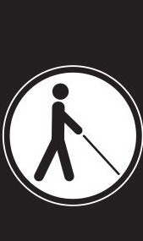
Leader Dogs for the Blind also offers FREE O&M TRAINING?

VISIT US­
LeaderDog.org
/programs for more details.
A
◄ LEADER DOGS
\,J;IFOR THE BLIND

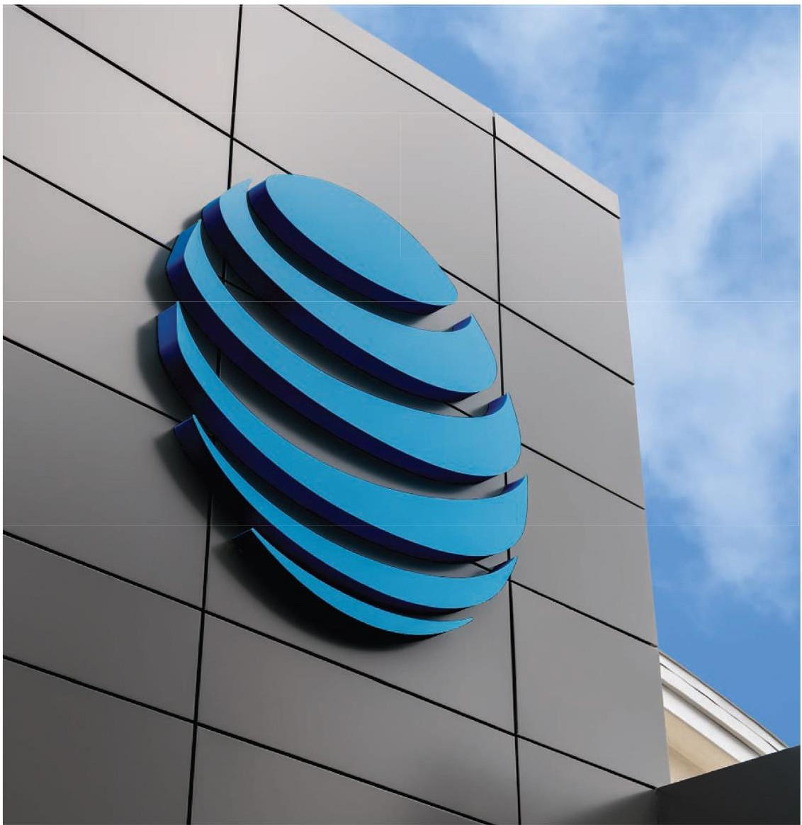

AT&T proudly supports the American Council of the Blind and its ongoing commitment to equal access, rights and opportunities.
AT&T

© 2022 AT&T Intellectual Property. AT&T and Globe logoare registered trademarks and service marks of AT&T Intellectual Property and/or AT&T affiliated companies. All other marks are the property of their respective owners.

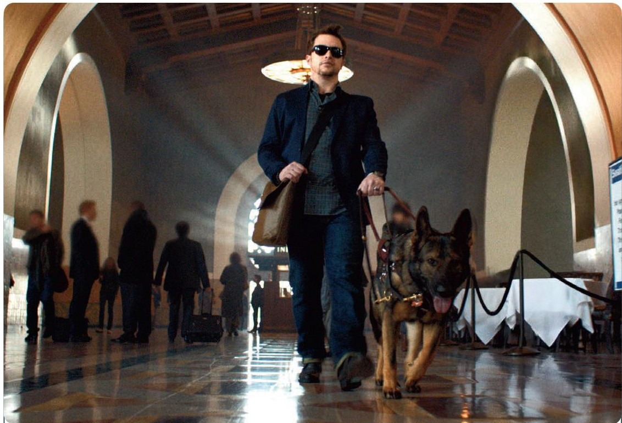

Vanda Pharmaceuticals is dedicated to raising awareness of
Non -24 -Hour Sleep-Wake Disorder (Non-24 ) and supporting the blindness community.
Non-24 is a rare circadian rhythm disorder affecting up to 70% of people who are total ly blind. People living with Non-24 experience excessive daytime sleepiness
and nighttime sleeplessness,which leads to impaired social and occupational functioning. This is due to the misalignment between the inte rnal master body clock and the 24-hour day.

COME VISIT US AT OUR BOOTH TO LEARN ABOUT NON- 24 AND SIGN UP FOR ADDITIONAL INFORMATION!

CALL A HEALTH EDUCATOR TOLL- FREE AT 1·855·856-2424. 24 HOURS A DAY, EVERY DAY.

N l1 N -2 4
a circadian rhythm disorder

VISIT US ONLINE AT www.Non·24.com.

©2015 VANDA Pl--lAAl'TlACEUTICALS in c. All rights reserved. N240298 Printed in the USA 07/15

