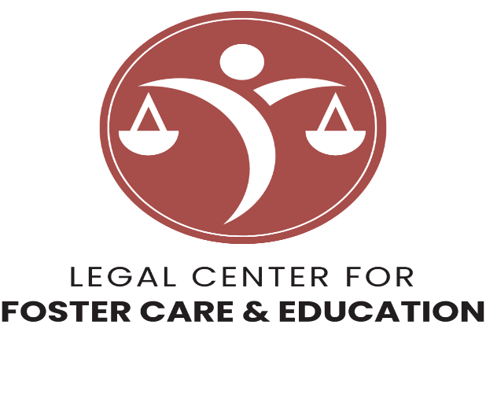
Want to join our team?
The ABA Center on Children and the Law is hiring for a Staff Attorney 2 position (JD and admission to the bar in at least one jurisdiction; 4-6 years of experience) to support education projects.
Ideal candidates:
- Advocacy experience in both the child welfare and education systems;
- Willingness to work a hybrid schedule from our DC office location;
- Ability to travel for up to 25% of job responsibilities (especially PA); and
- Strong interest in working, learning, and contributing as part of a dynamic education project team.

For a full job description and salary details, visit fostercareandeducation.org.
APPLY NOW!


