August 7, 2013

IMPORTANT MESSAGE FROM AMERICAN PRINTING HOUSE FOR THE BLIND

RE: CATALOG #1-07340-00 ORION TI-84 PLUS TALKING GRAPHING CALCULATOR

Dear Valued APH Customer:

You recently received one or more of our new Orion TI-84 Talking Graphing Calculators. APH has discovered a problem with some of these units. The problem, caused by a random sequence of cable connectivity and battery load, can result in damage to the speakers on the Orion unit.

APH recommends that you execute the following steps before using the calculators. If you have already started using the calculators, there is no cause for alarm. You may not experience the problem. However, we hope to ensure that you never do. In either event, please use the following upgrade procedures and links to update the calculators.

NOTE
You do not need to put the triple-A batteries in the Orion TI-84 Plus to accomplish the upgrade, but if you have, that is fine. The first step is to turn off the calculator before performing the upgrade. Take them out of the bubble wrap they were packaged in, if you have not already done so, and execute the following steps. Again, if you have already been using the calculator, simply turn it off and execute the following steps.
UPGRADE STEPS
Begin the upgrade by downloading the following two files to your computer and placing them in a folder where you can reference them for the upgrade procedures.

Software
- Orion TI-84 Plus Upgrade Utility v1.1.6.exe
- Orion TI-84 Plus firmware file Orion TI-84 Plus Release v01.00.04.bin This file sometimes downloads quickly. Check your downloads folder if you’re not sure it downloaded.

Orion TI-84 Plus Firmware Upgrade Procedure
- Turn off the calculator if it is already turned on.
- Connect the Mini-B end of the USB cable to the Orion TI-84 Plus unit and other end of the USB cable to the PC. At this stage, the device is in Normal connection mode.
- To change the mode from connect to upgrade, in the set of keys above the screen, press and hold down the Cursor UP key on the Orion unit (the ports should be facing away from you).
- While Cursor UP key is pressed, press the Control and the Shift (Bottom Left and Bottom Right) keys simultaneously.
- Now release the Control and Shift keys first and then release Cursor UP key. At this point, you will hear a connection sound from your PC and you will be in Upgrade mode
- Now select and run the Orion Upgrade Utility previously downloaded. At this point, the utility shows "Orion TI-84 Plus is connected" in device status and "Do you want to upgrade/downgrade/repair the device?" in the message field (see Figure 1).
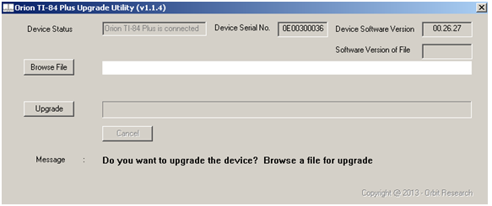
Figure 1. Device is in Upgrade Mode
- If the device is connected in Upgrade mode, the utility shows the device serial number as well as the software version of the device at the top right corner of the window.
- Browse and select the firmware file (e.g., "Orion TI-84 Plus Release vxx.xx.xx.bin"). The GUI (graphical user interface) also shows the software version of the selected file.
- Click on the Upgrade button.
- The utility begins upgrading the device (Figure 2).
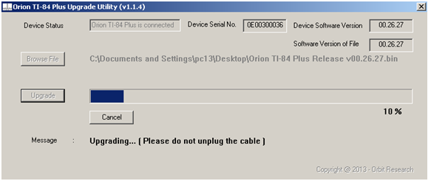
Figure 2. Upgrading the device
- During firmware upgrade, the Orion TI-84 Plus gives vibration indications every few seconds.
- Wait for the message "Device upgrade has been completed" on the upgrade utility (Figure 3). Do not unplug the cable.
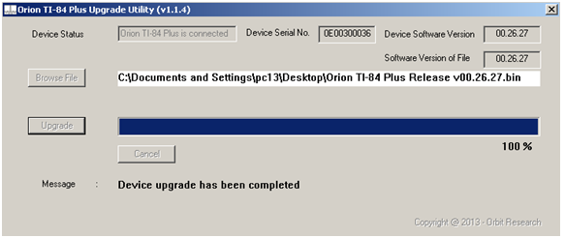
Figure 3. Device upgrade has been completed successfully
- Wait for "Device upgrade is completed successfully" announcement from the device.
- The last screen you will see is “Device is not connected in upgrade mode, read user manual for device upgrade” (Figure 4). The upgrade is now complete. Close the application and continue with the next step.
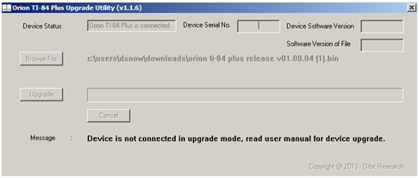
Figure 4. Upgrade is completed
- Next, you will reboot the device. If the TI-84 Plus is already on, turn it off and then back on again. If the device is already off, just turn it on.
- Unplug the USB cable.
- Done. Device is ready to use.

