Stand out among teachers of the blind and visually impaired! Don't miss the opportunity to hold this important, nationally recognized certification of literary braille proficiency.

The National Certification in Literary Braille (NCLB) test will be administered by the National Blindness Professional Certification Board (NBPCB)
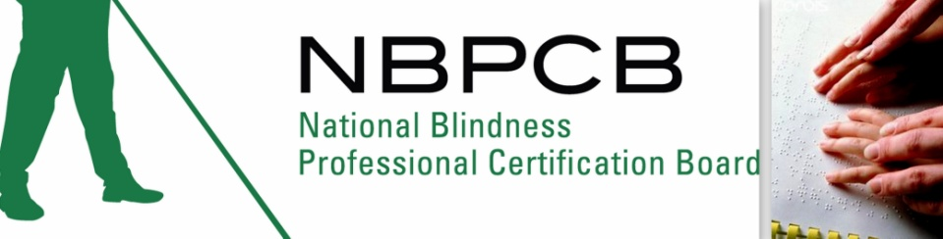
in Albuquerque, New Mexico on
Saturday October 27, 2012
at The New Mexico School for the Blind and Visually Impaired
Early Childhood Programs
Sage Room
801 Stephen Moody Dr. SE
Albuquerque, New Mexico 87123

Please go to our website, www.nbpcb.org/nclb to find out more information and to register for this important test.
Deadline for registration is October 15, 2012!

You may contact the test administrator, Juan Haro at (575) 442-1363, or juan@jfharo.com.
Or contact the NBPCB office at
(318) 257-4554 or by email at braille@nbpcb.org

Register now at: https://nbpcb.org/members/login.php?r=/members/er.php?eid=102

