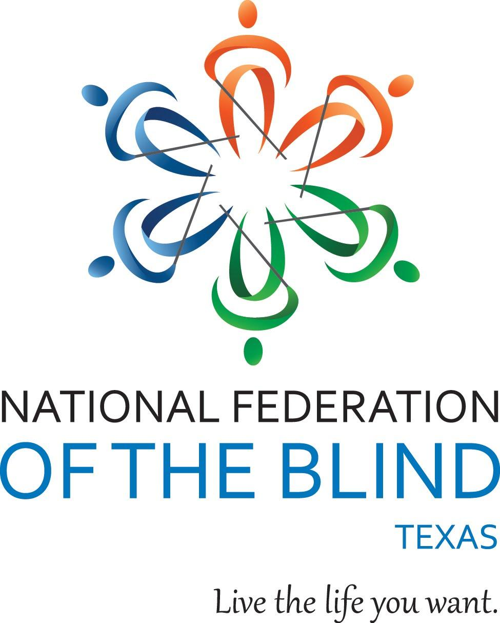
Texas Association of Blind Students presents

2021 Student Summit:

Everywhere and Everything

Date: Saturday, May 1, 2021
Time: 1 p.m.-4 p.m. Central
Location: Zoom

Are you a blind/VI student?
Are you wondering about your college, career options and developing a stable foundation for your life?

Join members of the National Federation of the Blind and Texas Association of Blind Students to learn about resources, programs and strategies that can help you succeed anywhere and everywhere.

Webinar highlights include:
- Breakout sessions lead by successful blind students and professionals
- Tips and strategies to manage your finances independently
- Discussions on dating, networking, and developing interpersonal relationships
- Conversations about classroom accommodations, internships, and study abroad opportunities
- door prizes
- plenty of time for Q&A

Students, teachers, parents, and everyone welcome!

Register online now or call our office at 281-968-7733

Qualifying Texas residents will be registered for the free NFB-NEWSLINE® electronic information service.

Texas Association of Blind Students presents

2021 Student Summit:

Everywhere and Everything

Date: Saturday, May 1, 2021
Time: 1 p.m.-4 p.m. Central
Location: Zoom

Are you a blind/VI student?
Are you wondering about your college, career options and developing a stable foundation for your life?

Join members of the National Federation of the Blind and Texas Association of Blind Students to learn about resources, programs and strategies that can help you succeed anywhere and everywhere.

Webinar highlights include:
- Breakout sessions lead by successful blind students and professionals
- Tips and strategies to manage your finances independently
- Discussions on dating, networking, and developing interpersonal relationships
- Conversations about classroom accommodations, internships, and study abroad opportunities
- door prizes
- plenty of time for Q&A

Students, teachers, parents, and everyone welcome!

Register online now or call our office at 281-968-7733

Qualifying Texas residents will be registered for the free NFB-NEWSLINE® electronic information service.

