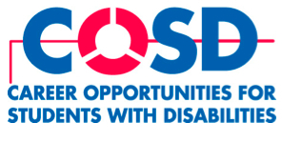

Brown, Goldstein & Levy, LLP, is proud to introduce a one-year disability rights fellowship. The Fellowship offers a recent law-school graduate or judicial clerk (0 to 3 years out) with a disability the opportunity to participate in all phases of disability rights litigation at our firm in Baltimore, Maryland. Brown, Goldstein & Levy is a 16-lawyer, Baltimore-based law firm devoted principally to litigation. The firm has developed a national reputation for its high-profile, high-impact disability rights cases. The one-year fellowship will begin in September 2009.

The application deadline is April 15, 2009. Please visit the following website for additional details about the fellowship and the firm and to download an application: www.browngold.com

