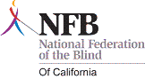

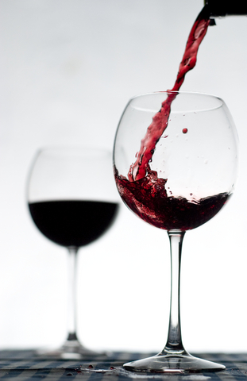

San Antonio Winery Tour, Wine Tasting and Luncheon

Join the San Fernando Valley Chapter of the National Federation of the Blind of California as we tour the historic San Antonio Winery. This winery has been an oasis of good living and culture in the heart of Los Angeles. For over 90 years, the Riboli family has owned and managed the only producing winery in Los Angeles and the last of more than one hundred that once lined the Los Angeles River Basin.

When: Saturday, June 23, 2012

Time: Meet promptly at 11:30 am
Lunch 12 noon to 1:00
Winery tour and tasting 1:00 to 2:00 pm

San Antonio Winery, 737 Lamar St., Los Angeles, 90031

Please RSVP to reserve a spot to:
Racquel Decipeda, nfbevents@gmail.com or 818-457-9449

