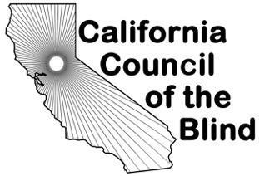
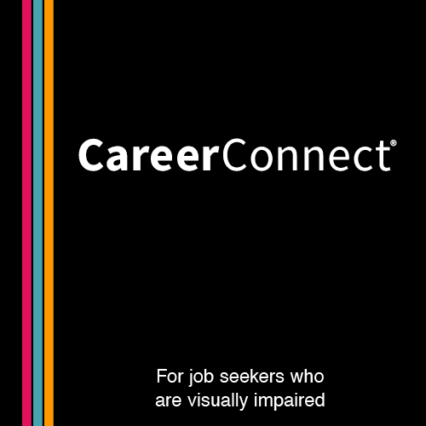
California Council of the Blind
and APH ConnectCenter is pleased to announce…
Our first Employment Mini-Conference:

“Empowering Yourself for the Modern-Day Job Market”

Dates: October 13-15, 2021

Over the past year, CCB has held focus groups to ask its members “What issues are important to them?” Employment was at the top of their list. Just in time for Disability Awareness and Employment month, CCB has partnered with APH ConnectCenter to bring together a group of professionals to empower people who are blind or have low vision to get that job that they have been dreaming about and take the next step to independence.
- Key Note Speaker: Joe Xavier, Director, Department of Rehabilitation, California
- Career Exploration
- Resume Tips and Tricks
- Navigating the World of Benefits: SSI and Employment
- A Special White Cane Day Proclamation
- And Much More!!!!!
Space is limited, so register today!
https://us02web.zoom.us/webinar/register/WN_v2QgDfpVSN6MF1WM4WPMXA

For more information call the CCB office toll free at
800-221-6359 or 916-441-2100, or email at ccotb@ccbnet.org
You can also visit our website at www.ccbnet.org

