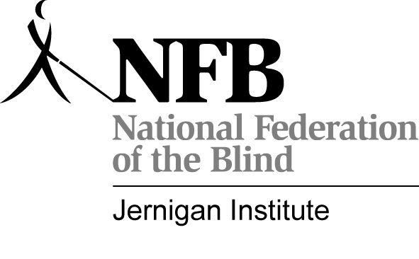National Federation of the Blind
Youth Slam 2009
A STEM Leadership Academy

When: July 26-August 1, 2009
Where: University of Maryland, College Park

Who: Two hundred blind high school students will be selected to participate in this program. Students who would like to be considered must complete the attached application and return it to the Jernigan Institute by March 1, 2009. Students need not have a strong interest in science, technology, engineering, or math (STEM) in order to participate, enjoy, and benefit from this academy. Students will be randomly selected from those eligible to participate. This means that the student must be able to perform basic self-care skills; have some degree of independent travel skills; be able to read Braille, print, or both; and should, at a minimum, be able to understand content appropriate for students entering the ninth grade.

What: This five-day academy will engage and inspire the next generation of blind youth to consider careers falsely believed to be impossible for the blind and bring a unified voice to the next generation of blind professionals. While staying at the University of Maryland, students will be mentored by blind role models during fun and challenging activities meant to build confidence and increase science literacy. Activities will take place with help from instructional supporters such as the National Aeronautics and Space Administration, University of Maryland, and other institutions and corporations working in STEM-related fields. The NFB Youth Slam will culminate in an inspiring rally.

Cost: There is no cost to apply for the program. Students who apply and are accepted to the Youth Slam will be expected to pay a $250 registration fee by May 31, 2009. The total value of the program is estimated at approximately $3,500, including transportation, room and board, materials, and cost of staff and mentors. The NFB and other Youth Slam partners will cover the balance of the program cost. Additionally, local members of the NFB will be available to assist students in raising the registration fee if necessary.

For any questions about the NFB Youth Slam, please contact:
Karen Zakhnini, Education Project Manager
National Federation of the Blind Jernigan Institute
(410) 659-9314, ext. 2293

To send questions or comments via e-mail, please write to youthslam@nfb.org, or visit http://www.blindscience.org/ncbys/Youth_Slam2009.asp
National Federation of the Blind
Youth Slam 2009
A STEM Leadership Academy

Student Application

Return applications by March 1, 2009, to:
Becca Cordell, Youth Slam Project Assistant
National Federation of the Blind
1800 Johnson Street
Baltimore, MD 21230

Please note that you can speed up your application process by applying online at: http://www.blindscience.org/ncbys/Youth_Slam2009.asp

Name of youth:
Gender: Birth date: Grade (as of Jan. 2009):
Race: White African American Asian Hispanic Other:
Parent/guardian name(s):
Home address:
City, state & zip:
Phone numbers: (H) (W) (C)
E-mail address:
Teacher of Blind Students:

School name:

School address:

City, state, & zip:

Phone number: E-mail address:

Primary Reading Medium: Braille Large Print Electronic

Secondary Reading Medium: Braille Large Print Electronic

If you are able to read Braille, at what age did you begin to learn Braille?

There are two parts to this application. Part One should be completed by the student while Part Two is to be completed by the student’s parent and/or Teacher of Blind Students. Both parts should be completed on a separate sheet of paper.

Part One (to be completed by the student):

- Did you attend Youth Slam 2007?
- How did you hear about this program?
- Why do you want to attend the NFB Youth Slam?
- What do you hope to get out of this program?
- What are your primary interests and hobbies? Do you participate in any extracurricular activities?
- What classes have you taken over the last two years?
- Please rate your interest in the following areas on a scale of one to four, one being “not interested” and four being “very interested” (note that this information is for our planning and will not impact your acceptance):
  - Science
  - Technology
  - Engineering
  - Math

Part Two (to be completed by the student’s parent or teacher):
- Describe the student’s academic performance. Please include a list of strengths and weaknesses and any other relevant information.
- What is the student’s reading medium (print, Braille, both)?
- Describe any technology that the student uses.
- Please describe the student’s level of independence and maturity (age appropriateness) in the following areas:
  - Mobility (please include whether the youth uses a cane, dog guide, wheelchair, etc.)
  - Social skills
  - Hygiene
  - Health care
- Has the student ever attended an overnight blindness skills training program? If so, where, when, and for what length of time?
- Has the student ever attended any other type of overnight program (for example, programs related to sports, space, or music)? If so, where, when, and what was the focus?
- Please clearly tell us about any medical conditions or disabilities the student has, including cause of blindness, visual functioning (if any), and any other special considerations (medical or otherwise) of which we need to be aware.
- Other: Please provide any other information you believe would be useful during the application screening.

