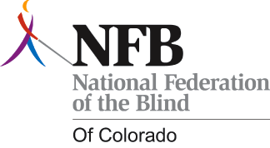

Meet the National Federation of the Blind of Colorado
Join the National Federation of the Blind of Colorado for our second meeting in Grand Junction. We will adopt a constitution, elect a board, and discuss the kind of change we would like to see for blind people on the western slope. To do this effectively, we need to hear from you! We will also be discussing fun upcoming projects such as NFBCO Day at the Capitol and the Nike Fuel Band Fitness Challenge.

Who is invited?
We want to meet people who are blind, low vision, or loosing vision. We also welcome family members, friends, blindness professionals, and others who want to learn more about blindness. We have lots of great resources including scholarships for students, assistance for seniors who are loosing vision, and resources for parents of blind children!

What will we do?
10:30-10:40 introductions
10:40-11:10 NFBCO Grand Junction Constitution
11:10-11:25 discussion of board position and related responsibilities
11:25-11:40 NFBCO Grand Junction elections
11:40-11:55 NFBCO Day at the Capitol
11:55-12:25 NFBCO Grand Junction imagine it, do it! What will the Grand Junction Chapter do first on the Western Slope?
12:25-12:30 Questions, Comments, and Wrap Up

When is this meeting?
Our February meeting will take place on Saturday, February 15 from 10:30am-12:30pm.

Where will the meeting of NFBCO be held?
We will meet at the Grand Junction Center for Independent Living, which is located at 740 Gunnison Ave. Grand Junction, CO 81501.

If you have questions or would like additional information contact Jessica Beecham at jbeecham@cocenter.org or call 720-440-2632.

