National Federation of the Blind of Colorado Presents
2014 Day at the Capitol
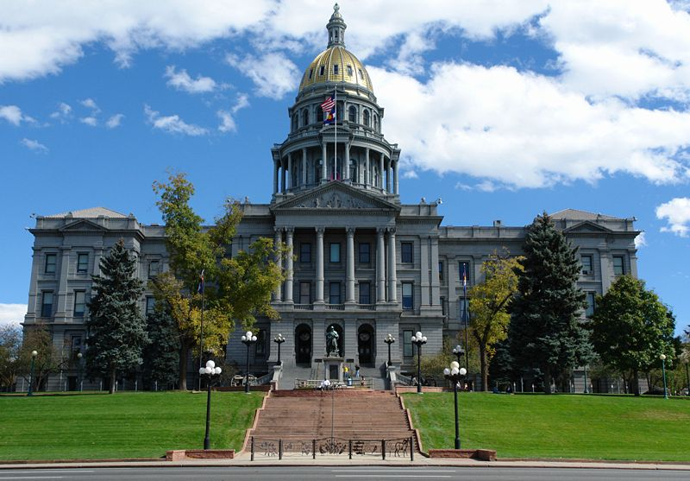
Friday, February 28
8:00am-12:00pm

Meet the NFB of Colorado at 8:00am in the Old Supreme Court Chambers for a fun and effective opportunities to make a difference! Experience the sound of nearly 100 cane tips tapping on marble floor of the capitol as energetic and dynamic blind people take over the halls to impact meaningful change for the blind of Colorado! Eat breakfast, shake hands, and rub elbows with the people who represent US in Colorado!

Addressing the DVR wait list, and insuring opportunity for continuity and growth of NFB NEWSLINE® and Audio Information Network of Colorado, and demanding equality for Coloradans with disabilities are just a few of the ways that your efforts on the 28th will help blind people throughout Colorado.

We need YOU! Participants from across the state are invited and encouraged to join together as we knock on the doors of EACH and EVERY Colorado representative. This year, we are committed to bringing a BIGGER and BOLDER force than ever before! If we have 100 people in attendance the name of each participant will be entered for a chance to win an AWESOME prize courtesy of NFBCO so BRING A FRIEND!

If you need transportation or any kind of assistance in order to attend PLEASE let us know. Email Lisa Bonderson at lbonderson@labarrelaw.com

Make plans to stick around for our NFBCO in person board meeting Friday evening! For more information email Scott LaBarre at slabarre@labarrelaw.com

