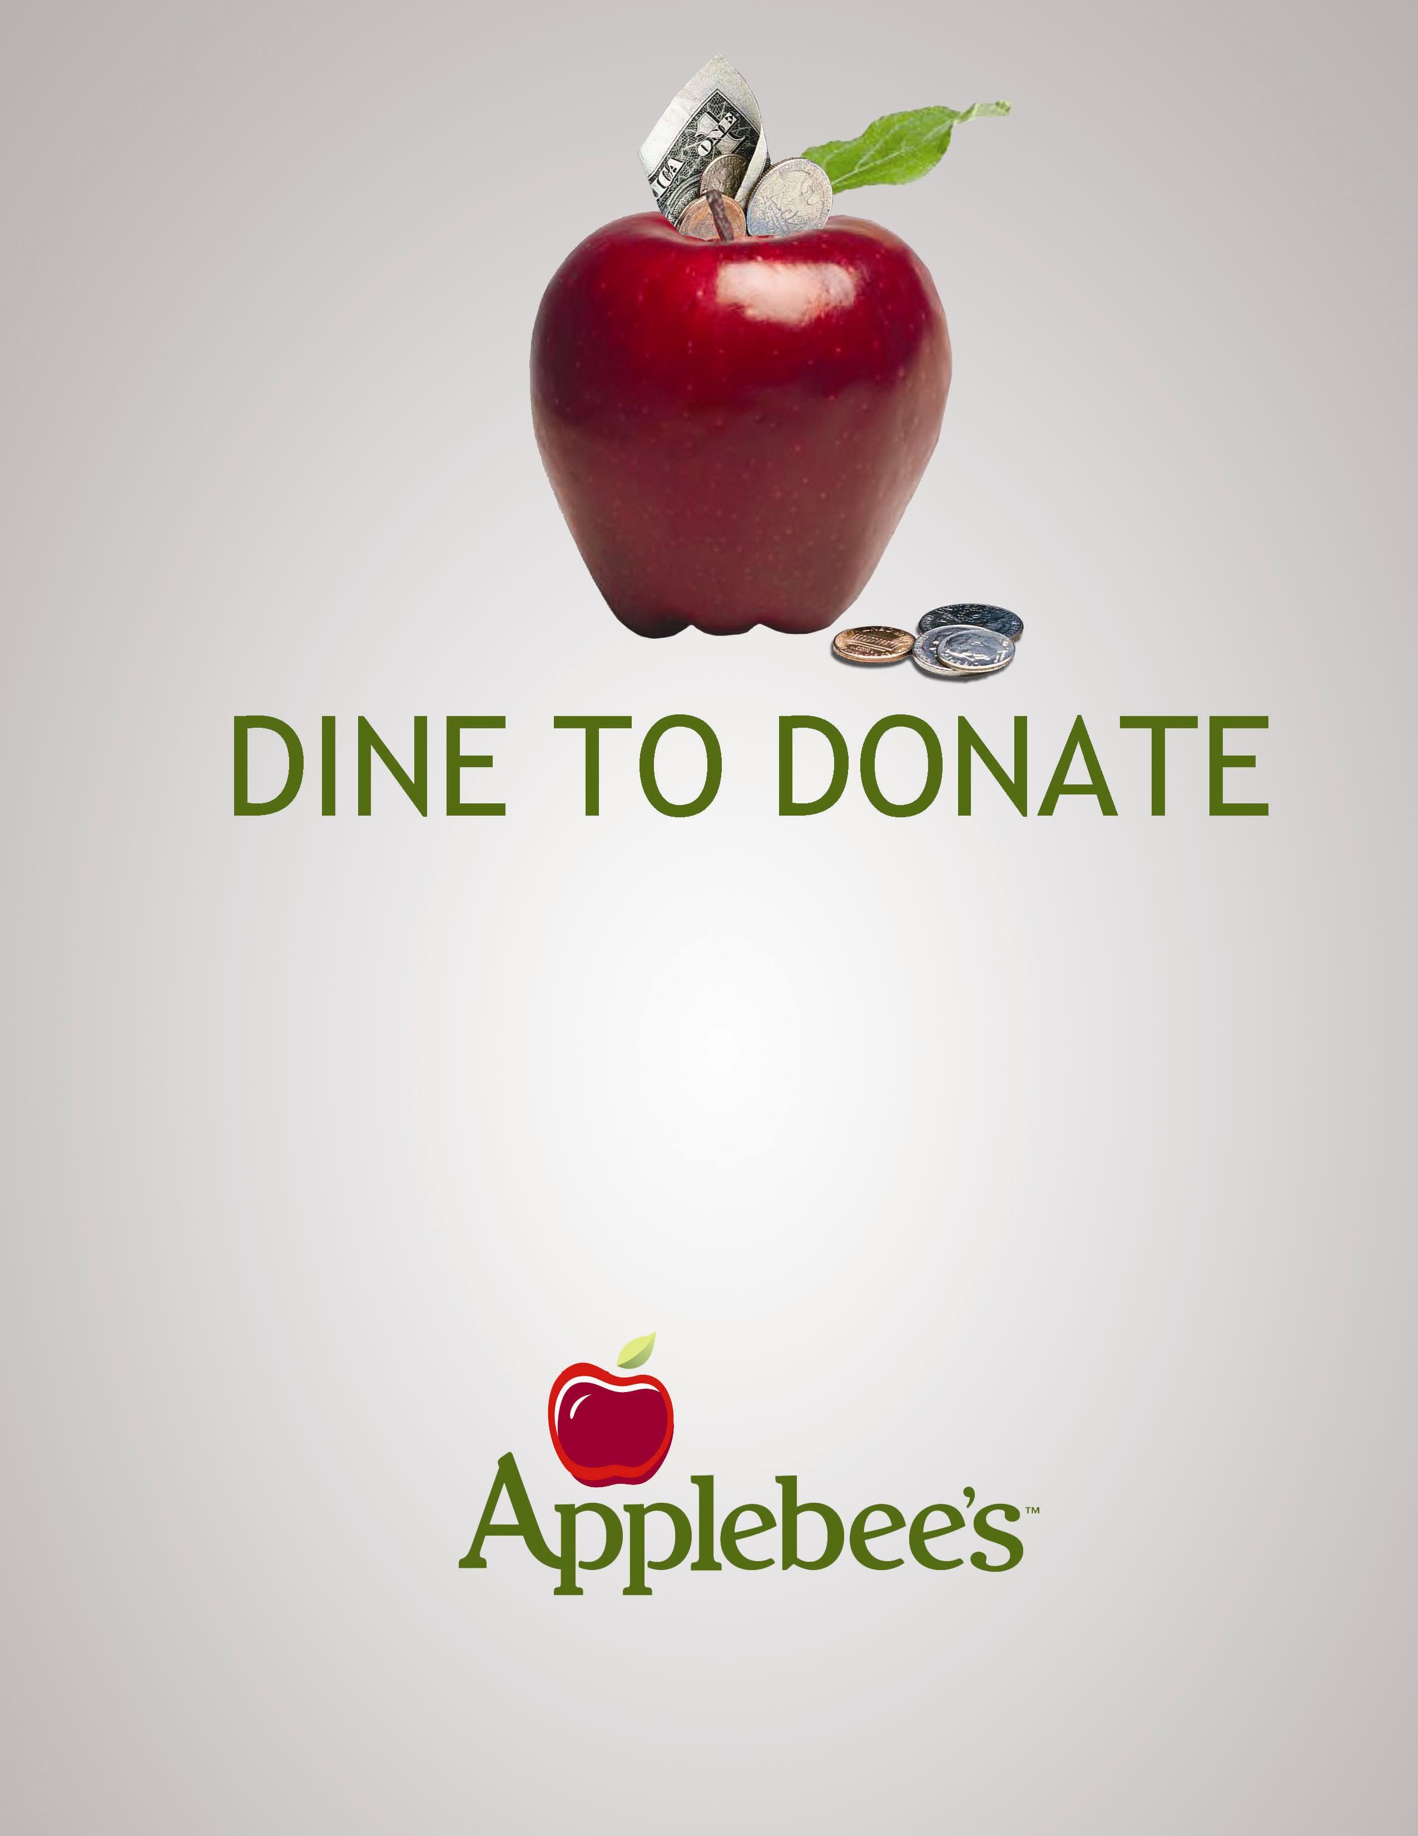

Dine at Applebee’s and 10% of your
bill will be donated to

BlazeSports Columbus

Present this flyer to your Server on
Saturday, May 22, 2010
From: 11:00am to Close
Only Valid at the following:

5037 North High Street, Columbus, OH 43214
Carside To Go Included

