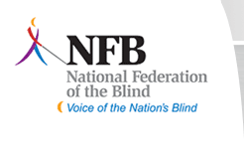
Beth Debus, President, Capital Chapter
(586)-876-4259
mbdebus@yahoo.com
Dear friends and family,
For the next two months the local chapter of the National Federation of the Blind of Ohio is having a fundraising email campaign, and I need your help. I recognize that you receive many requests for donations throughout the year, so we are asking for a modest donation of $10 or $20. Our chapter goal is to raise $1,500.
The NFB improves the lives of blind people through advocacy, research, technology, and programs encouraging independence and self-confidence. During these hard economic times, funding from our state affiliate treasury has been limited. It’s now up to the local chapters to raise funds to send chapter members to Congress to advocate for equal opportunity for blind people.
It’s now up to us to raise money to assist local members who wouldn’t otherwise be able to attend state and national conventions. Your generous donation will also ensure that students attending our annual Ohio State School for the Blind Christmas party will learn about our organization and what it can do for students and young adults looking for jobs.
Please make tax-deductible contribution checks payable to the NFBO Capital Chapter. Checks can be mailed to chapter treasurer Stephanie Claytor at 2467 Lakemere Way, Columbus, OH 43209.
Your generous donation will help change what it means to be blind in the Columbus community.
Sincerely,
Beth Debus

