[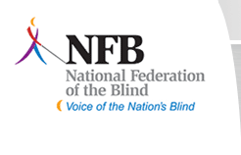](http://www.nfb.org/nfb/default.asp?SnID=1593229015)Beth Debus, President Capital Chapter

(586)-876-4259

mbdebus@yahoo.com

Dear friends and family,

For the next two months my local chapter of the National Federation of the Blind is having a fundraising email campaign, and I need your help. I know you receive many requests for donations throughout the year, so we are asking for a small donation of $10 or $20. Our chapter goal is to raise $1,500.

The NFB improves the lives of blind people through advocacy, research, technology, and programs encouraging independence and self-confidence. During these hard economic times, our funding from the state treasury has been limited. It’s now up to the local chapters to help come up with funds to send members to present legislation for equal opportunity for blind people to their respective representatives.

It’s now up to us to raise money to assist local members who wouldn’t otherwise be able to attend state and national conventions.

Don’t forget your generous donation will also ensure the students attending our annual Ohio State School for the Blind Christmas party will know our organization exists.

Please make checks payable to the NFBO Capital Chapter. Checks can be mailed to Stephanie Claytor at 2467 Lakemere Way Columbus, OH 43209.

Your generous donation will help change what it means to be blind in the Columbus community.

Sincerely,

Beth Debus