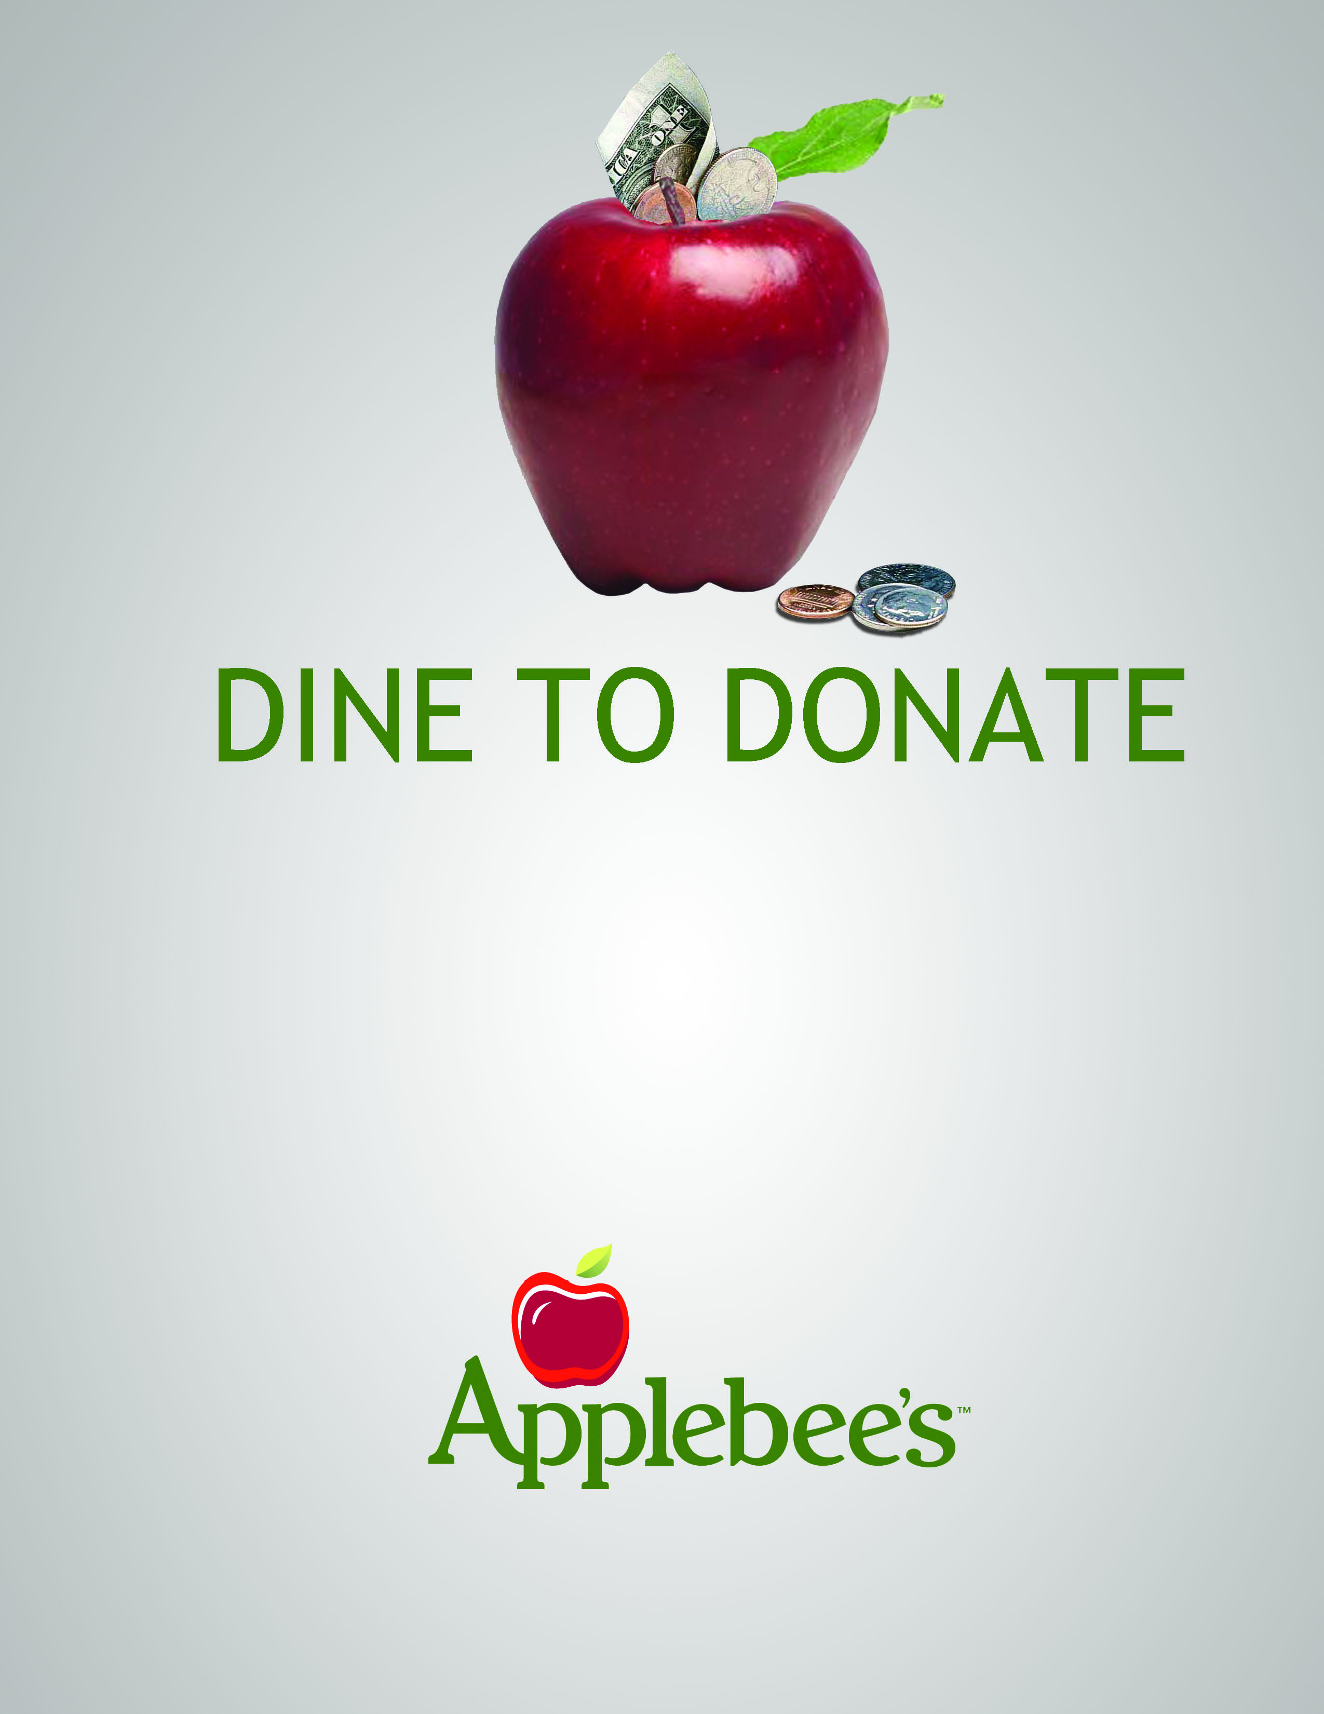

Dine at Applebee’s and 10% of your
bill will be donated to
National Federation of the Blind
(Columbus Capital Chapter)
Present this flyer to your Server on
Saturday, June 22, 2013
From: 11:00am to Close
Only Valid at the following:

5037 North High Street, Columbus
Carside To Go Included

