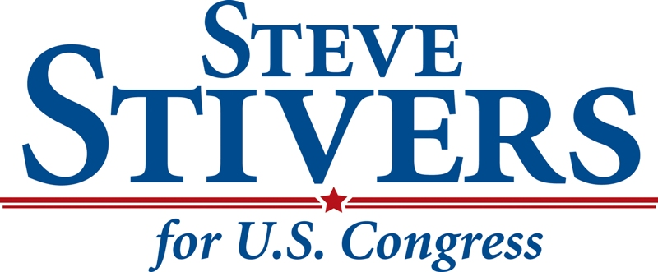

Thursday

April 21st, 2016

8-9 PM
FREE WINGS-APPS

Buffalo Wild Wings
Restaurant Side
23 W. Union Street
Athens, OH 45701

