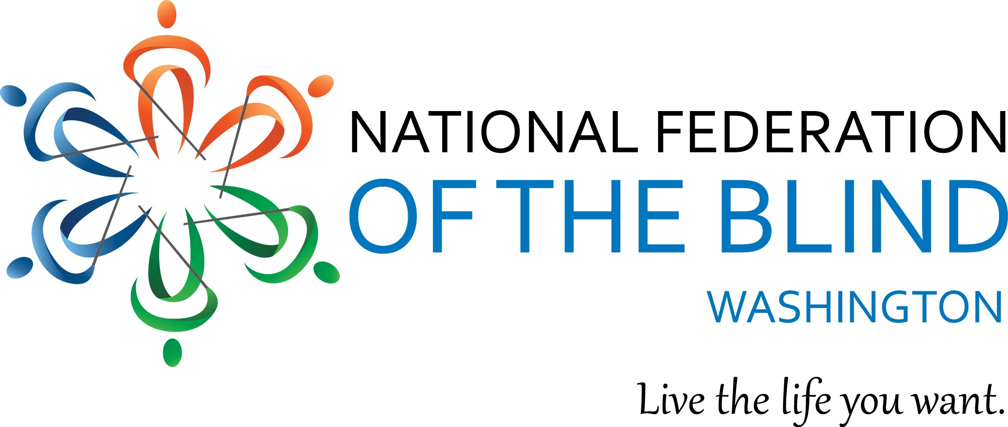
Instructions for Scholarship Application

June 1, 2016

The National Federation of the Blind of Washington is pleased to announce that we are accepting applications for our 2016 Scholarship Program. We will award 2 scholarships totaling $5,000 to 2 outstanding blind scholars in our state. The scholarships will be awarded at the banquet of our state National Federation of the Blind convention, which will be held October 14-16 at the Best Western Plus Tacoma Dome Hotel, located at 2611 East E. Street, Tacoma, WA 98421.

All applicants must be:

- Legally blind in both eyes
- Residents of the state of Washington
- Pursuing a full-time undergraduate or graduate course of study
- Available to participate in the entire NFB of Washington state convention

In addition to a scholarship, each winner will receive assistance to attend the 2016 NFB of Washington annual convention, providing an excellent opportunity for networking with active blind persons in many different professions and occupations. The scholarships are awarded at the banquet on Saturday night of the convention. Attendance at the convention is mandatory.

Each scholarship application must include:

- Completed scholarship application form
- An essay describing the applicant’s abilities, academic achievements, community leadership, future goals and philosophy of blindness
- High school and/or up-to-date college transcripts
- 3 letters of recommendation

All applicants must also contact one of this year’s co-chairmen of the scholarship committee for a telephone interview, Corey Grandstaff in Vancouver at (419) 768-1523, or Bennett Prows in Kirkland, (425) (814-4187.

All completed scholarship packets must be received by Friday, September 23, 2016.

APPLICATION PACKETS RECEIVED AFTER September 23, WILL NOT BE CONSIDERED. INCOMPLETE APPLICATIONS WILL BE DISQUALIFIED.

Send completed scholarship application packets to:

Corey Grandstaff or Bennett Prows
NFB of Washington
Scholarship co-chairpersons
<Corey.grandstaff@gmail.com>; or
Bennett Prows <BJProws@comcast.net>
Or mail to:

National Federation of the Blind of Washington
PO Box 2516
Seattle, WA 98111

If you have any additional questions please contact Bennett Prows or Corey Grandstaff at one of the telephone numbers listed above.

Please feel free to make additional copies of this letter and the application form, and distribute them to any interested blind students.

Scholarship Application Form

Name: ____________________________________________
Date of Birth: _
Home Address: Street: ___________________________________
City:______________________ State______ Zip___________
Home Phone: _____________ Cell Phone:_____________ Email:_________________________
Your Current Grade Point Average:
Your Current class standing: ___________________ (Freshman - Senior, graduate student)
High School Attended: __________________________________________
Address: ____________________________________________________________________
City: _________________________________ State:________ Zip: ___________
Dates Attended:_____________________
College/Institution to be attended in Fall Semester, 2015:_______________________________________
Address:_______________________________________________________
City:__________________ State:______ Zip:__________
Phone:______________________
Major:____________________________________________________
Career Goal:________________________________________________________

