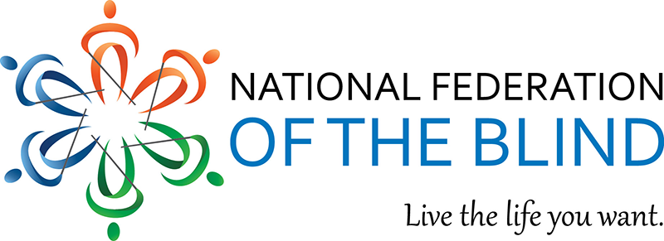

UNCORK FOR BRAILLE
Cellar 55
May 5, 2019 2PM to 5PM

Join us on a Spring afternoon as you sit back and enjoy your succulent sample of wine and cheese, all to the backdrop of local vibrant musicians while supporting valuable programs in our community. The National Federation of the Blind of Clark county presents the fifth annual “Uncork for Braille”.

We continue this annual tradition of relaxation coupled with live music as we raise valuable funds to support the blind and visually impaired living the lives they want. Our programs help the blind and visually impaired achieve independence and equal access to the world around us so that we can participate fully in society. Our president and MC of the event, Corey Grandstaff, will guide you through our mission and vision while presenting stories from the people that our programs help the most.

Tickets are $20 per person and can be purchased prior to the event or at the door. A ticket gives you access to the event and includes a sample of cheese and your choice of a glass of wine, a flight sampler of wine or a soft drink. Tickets can also be purchased over the phone with a debit/credit card and will be available to you at the door.

There will be several raffles of our famous baskets stuffed full of goodies. Raffle tickets are $5 each or get five tickets for $20. Brand new to this year’s event is our silent auction. Stop by and see the great items that you can bid on.

To purchase tickets over the phone or for other event inquiries, please contact Matthew Hines at (360) 980-2385.

Cellar 55 Inc, 1812 Washington St., Vancouver, WA 98660

