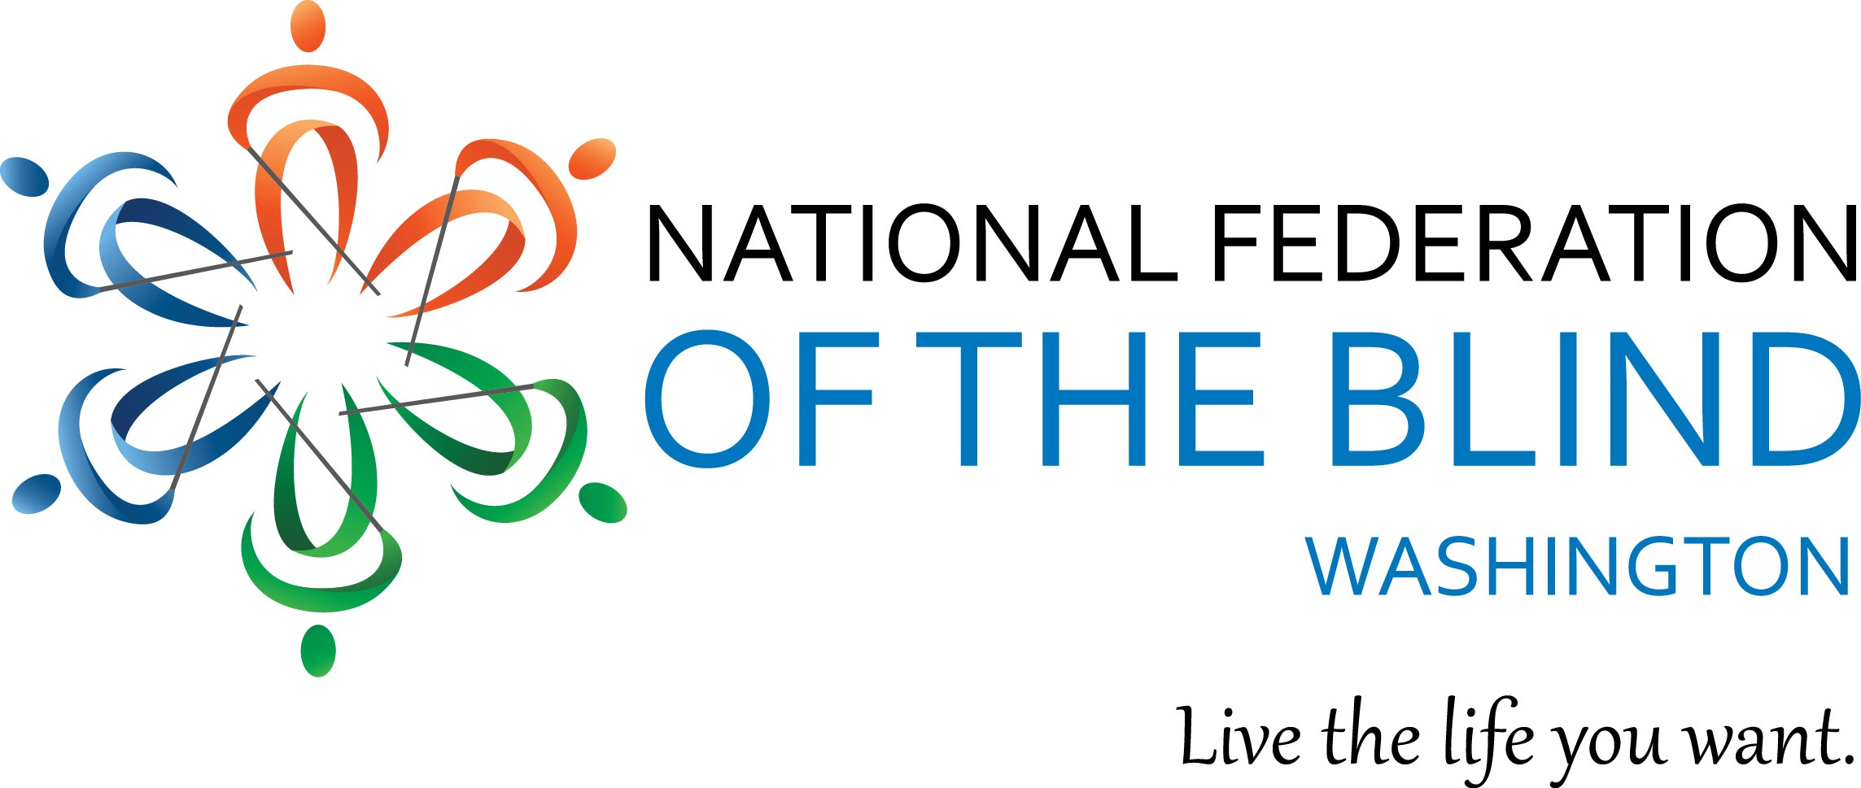
Instructions for Scholarship Application

The National Federation of the Blind of Washington is pleased to announce that we are accepting applications for our 2022 state Scholarship Program. We will award 3 $3000 scholarships to 3 outstanding blind scholars in our state. The scholarships will be awarded at the banquet of our National Federation of the Blind of Washington annual convention, which will be held at the Bellevue Hilton Hotel from November 4-6 2022.

All applicants must be:

- Legally blind in both eyes
- Residents of the state of Washington
- Pursuing a full-time undergraduate or graduate course of study. If employed, part-time study will be accepted.
- Available to participate in the entire NFB of Washington state convention
18 years of age by the first date of convention, which is November 4.

In addition to a scholarship, each winner will receive directions and financial assistance to attend the 2022 NFB of Washington annual convention, providing an excellent opportunity for networking with active blind persons in many different professions and occupations. The scholarships are awarded at the banquet on Saturday night of the convention. Attendance at the convention is mandatory.

Each scholarship application must include:

- Completed scholarship application form
- An essay describing the applicant’s abilities, academic achievements, community leadership, future goals and philosophy of blindness. Please let your personality shine through. We want to get to know you.
- High school and/or up-to-date college transcripts
- 3 letters of recommendation

All applicants must also contact one of the scholarship committee co-chairpersons for a telephone interview. Please contact Nikki Palm at 360-703-8641 or Bennett Prows at 425-814-4187.

All completed scholarship packets must be received by Friday, October 14, 2022.

APPLICATION PACKETS RECEIVED AFTER October 14 WILL NOT BE CONSIDERED. Additionally, INCOMPLETE APPLICATIONS WILL BE DISQUALIFIED.

Send completed scholarship application packets to:
Nikki Palm & Bennett Prows
NFB of Washington Scholarship co-chairpersons
Nikki Palm: nikkirae83@gmail.com
Bennett Prows BJProws@comcast.net.

If you have any additional questions please contact Nikki Palm or Bennett Prows at the telephone numbers listed above.

Please feel free to make additional copies of this letter and application form and distribute them to any interested blind students.

Scholarship Application Form

Name: ____________________________________________

Date of Birth: ___

Home Street Address: ___________________________________
City:______________________ State______ Zip___________

Home Phone: _____________

Cell Phone:_____________

Email:_________________________

Your Current Grade Point Average:

Your Current class standing: ___________________ (Freshman - Senior, graduate student)

High School Attended: __________________________________________

Address: ____________________________________________________________________

City: _________________________________ State:________ Zip: ___________

Dates Attended:_____________________

College/Institution to be attended in the Fall of 2020:_______________________________________

Address:_______________________________________________________

City:__________________ State:______ Zip:__________

Phone:______________________

Major:____________________________________________________

Career Goal:________________________________________________________

