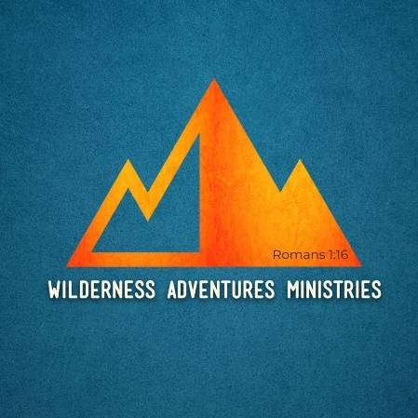

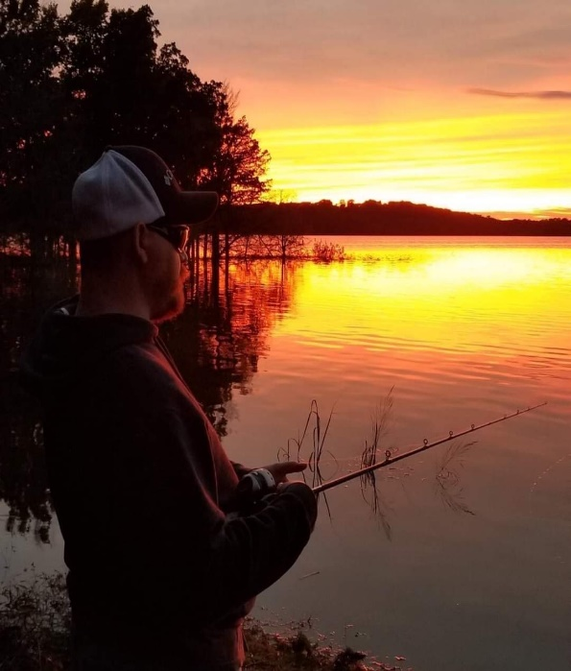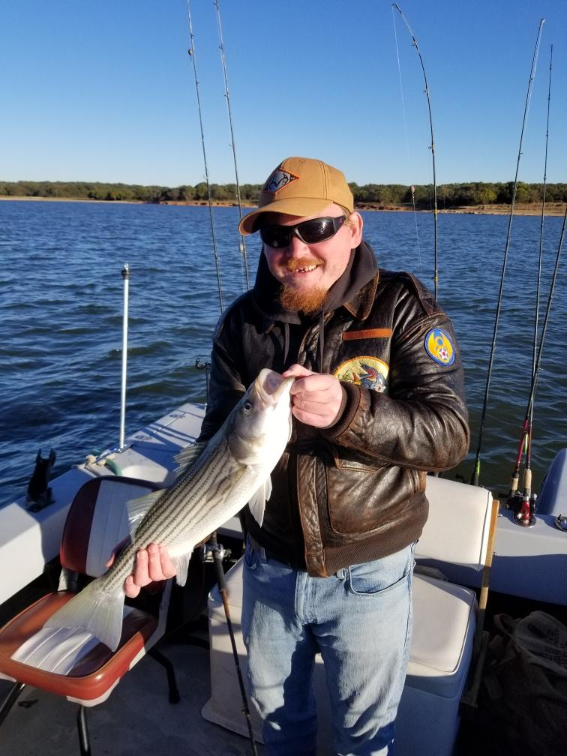Wilderness Adventures Ministry is a 501C3 non-profit ministry that is striving to assist individuals with disabilities experience and accomplish their outdoor goals and dreams. WAM will do our best to accommodate anyone with any type of disability. We can organize a wide selection of activities and events such as a day of fishing, hiking, camping, and learning basic survival skills. WAM will learn about our participants disabilities and adapt in any way necessary. But, the mission of Wilderness Adventures Ministry is twofold. Our second and probably our most important purpose is to let individuals with disabilities know that they are loved by others, and especially that they are loved by God and can be used for his kingdom and glory. So, no matter what type of event you attend, in one way or another, you will hear the Gospel presented and learn more about why we do what we do. And, if you want to receive salvation or grow in your faith after attending an event, WAM will be delighted in discussing options with you to do so. We can assist in getting faith-based materials for you in an accessible format if needed. Please consider joining us for an event as a participant or volunteer. And, we welcome all support that you wish to give along with your continuous prayers.