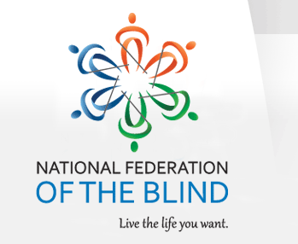
GARAGE SALE
SATURDAY SEPTEMBER 6, 2014
9:00 AM – 2:00 PM
Clovernook Center for the Blind and Visually Impaired
7000 Hamilton Ave Cincinnati

ITEMS INCLUDE: Exercycle * Collectable Porcelain Dolls * Bullet Express Food Processor * Clothing * Kitchen Items * Household Goods * Movies

ALL PROCEEDS SUPPORT THE EFFORTS OF THE NFB CINCINNATI CHAPTER TO GET OUR FIRST-TIME MEMBERS TO OUR STATE CONVENTION IN COLUMBUS, OHIO, OCTOBER 31 – NOVEMBER 3, 2014. PLEASE HELP CHANGE THE LIVES OF BLIND PEOPLE IN YOUR COMMUNITY! THANK YOU. For more information on the NFB, please go to NFB.ORG.

