Our Host for the evening will be:
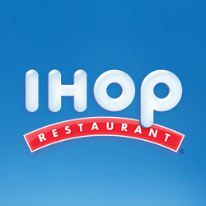
which is where you get to Dine…

When: Monday March 16, 2015 4:00pm – 9:00pm
Where: 1309 E Kemper Rd
Springdale, OH 45246
and they will generously Donate 20% of the proceeds to…
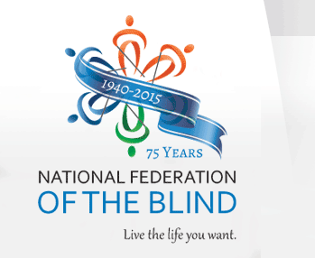

“The National Federation of the Blind knows that blindness is not the characteristic that defines you or your future. Every day we raise the expectations of blind people, because low expectations create obstacles between blind people and our dreams. You can live the life you want; blindness is not what holds you back.” Please visit our website: NFB.org

