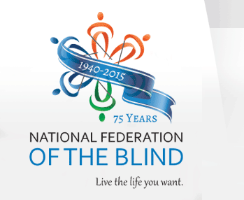
THE NFB CINCINNATI CHAPTER PRESENTS:
2nd ANNUAL BRAILLE-A-THON
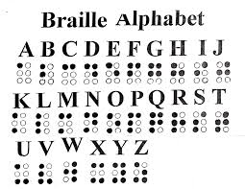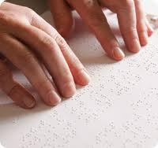
WHERE: North College Hill Kroger
7132 Hamilton Ave Cincinnati, OH 45231
WHEN: Saturday July 18, 2015 10:00 AM – 2:00 PM
Promote Braille Literacy and Awareness…Learn About Braille...
Try Your “Hand” At Braille!
Programs supported by the National Federation of the Blind:
BELL Program – summer camp for kids, ages 4 – 12, who may not be getting adequate Braille instruction in school.
State and National Conventions – opportunity for new and current members for education, networking and having life changing experiences.
Washington Seminar – members meet with Congress to advocate for the equality, as well as, the quality of life for all blind people.
For more information, email Sheri at salbers1@twc.com. Please visit our website: www.nfbohio.org

