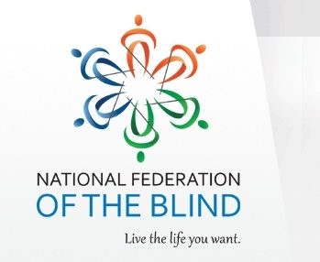
Special Fundraising Event to Support the National Federation of the blind

Where: Buffalo Wild Wings, Norwood #10, 2692 Madison Rd, St A7, Cincinnati, OH 45208
When: Wednesday, June 7th from 11:00 A.M. to 11:00 P.M.; dine in or carry out, orders can be done by phone or via the website for pick-up. The ticket listed below must be presented with your payment in order for credit to be given to The National Federation of the blind.
Purpose: The National Federation of the Blind of Ohio, Cincinnati chapter will utilize these funds to educate, advocate and support the blind community of Cincinnati. A portion of the funds will support Our Braillle Enrichment for Literacy and Learning (BELL) program. This program provides intense education of braille and blindness techniques to children from the ages of 4 to 12. The education provided is skills that would not be provided within a school's regular curriculum.
For more information about the National Federation of the Blind, please visit nfb.org or nfbohio.org
To request a ticket to support this event, please call Walter Mitchell (513) 334-9000. Please write on your bill “NFB of Cincinnati” to ensure that the organization receives credit.

EAT WINGS. RAISE FUNDS.
On the day listed below, present this ticket to your server and Buffalo Wild Wings® will donate 10%* of your total bill (not including tax, gratuity or promotional discounts) to our organization.
Buffalo Wild Wings strives to support our community and the organizations and sports teams within it. Together we can make a positive impact and help keep our community working and playing together.
(Show this ticket to your server on the date & time listed below.)
NATIONAL FEDERATION OF THE BLIND
June 7, 2017 • 11:00 AM-11:00 PM 2692 Madison Rd. A7 Rookwood Pavilion • Cincinnati, OH •
513-351-9464

"•The 10% donation is contingent on the organization raising at least $300 of pre-tax sales during the promotion (subject to change in our discretion).
Other restrictions may apply. Please see participating location for details. ®2015 Buffalo Wild Wings. Inc.

