Italian Dinner Fundraiser

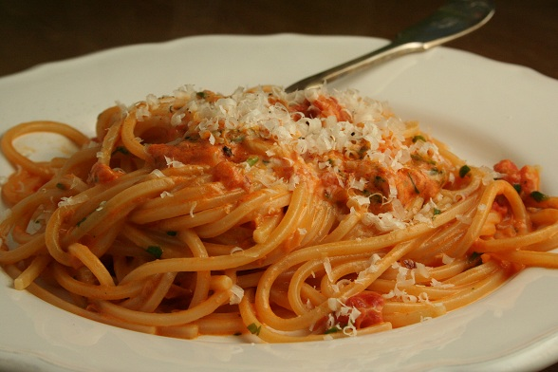
Join us for our Italian Dinner to help raise money for the Cincinnati Chapter of the National Federation of the Blind
Be sure to check out our great raffle items and door prizes!

Date: Saturday, June 16
Time: 11:00 AM-3:00 PM
Location: Clovernook Center for the Blind and Visually Impaired
7000 Hamilton Ave.
North College Hill, Ohio 45231
The festivities will take place at the Clovernook Procter Center (the two-story building on your right as you enter the driveway) Please enter at the Lower Level.
The cost of dinner will be $5. Dinner includes spaghetti or lasagna, garlic bread, salad, drink, and dessert.
If you have any questions please contact the Cincinnati NFB President, Sheri Albers at (513) 886-8697; or if you would like to make a donation to our cause, you can contact our Treasurer, Emily Pennington at 513-668-6866.
Thank you in advance for your support!

