National Federation of the Blind of Colorado Presents
2014 Day at the Capitol
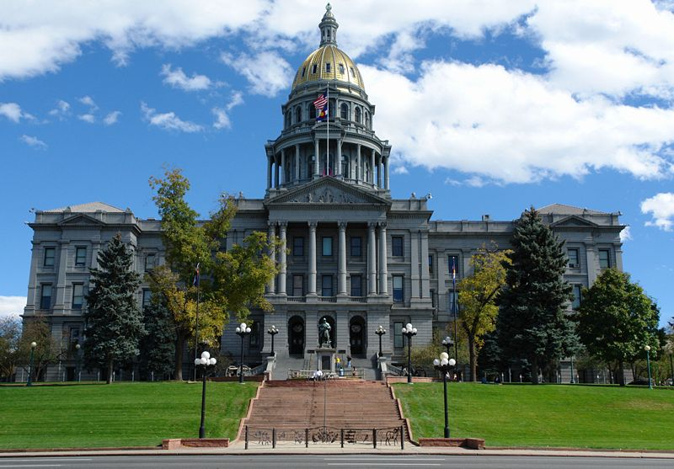
Friday, February 28
8:00am-12:00pm

Meet the NFB of Colorado at 8:00am in the Old Supreme Court Chambers for a fun and effective opportunity to make a difference! Experience the sound of nearly 100 cane tips tapping on the marble floor of the Capitol as energetic and dynamic blind people take over the halls to promote meaningful change for the blind of Colorado! Enjoy breakfast, shake hands, and rub elbows with the people who represent you and me in the Colorado State legislature!

Improving the education of blind children, demanding equality for Coloradans with disabilities, and insuring continuity and growth of NFB NEWSLINE® and Audio Information Network of Colorado are just a few of the ways that your efforts on the Friday, February 28 will help blind people throughout Colorado.

We need YOU! Participants from across the state are invited and encouraged to join together as we knock on the doors of EACH and EVERY Colorado representative. This year, we are committed to bringing a BIGGER and BOLDER force than ever before! If we have 100 people in attendance the name of each participant will be entered for a chance to win an AWESOME prize courtesy of NFBCO so BRING A FRIEND!

If you need transportation or any kind of assistance in order to attend PLEASE let us know. Email Lisa Bonderson at lbonderson@labarrelaw.com

Make plans to stick around for our NFBCO Friday afternoon in-person board meeting! For more information email Scott LaBarre at slabarre@labarrelaw.com

