SAVE THE DATE!
MAKING A DIFFERENCE IN LIVING THE LIVES WE WANT!

THE NATIONAL FEDERATION OF THE BLIND
OF COLORADO

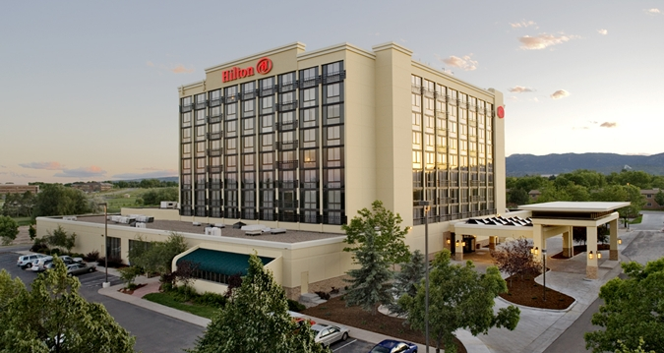

63rd ANNUAL STATE CONVENTION
October 26 through October 29

The 63rd Annual State Convention will kick off Thursday October 26 in Fort Collins, Colorado. Convention activities will continue all weekend long with exhibitors, informative presentations, seminars, and much more! Join the largest gathering of blind men, women and youth in Colorado to make a difference in the lives of the blind across the state!

NOTE: Exhibitors will be demonstrating their products on Friday and Saturday.
Look for information about our vendors times and location.

THE NFBCO CONVENTION HOTEL: Our 2017 convention will be held at the Fort Collins Hilton, nestled in the foothills of the Rocky Mountains at 425 West Prospect Road, Fort Collins, Colorado 80526.

HOTEL ROOM RATES: The NFBCO room rate is $99 a night for singles and doubles; $109 a night for triples and $119 a night for quads. Reservations MUST be made by Monday, September 25. You must get your reservations in by the deadline, as we will not be granted any extensions.

To reserve your room by phone call: 970-482-2626 and mention that you are with the National Federation of the Blind of Colorado.

Click here to reserve your room online.

Pre-registration fees: BEFORE October 16
$20 registration
$20 Friday luncheon
$20 Saturday luncheon
$35 Saturday banquet
Total: $95.00

Registration fees AFTER October 16
$25 registration
$25 Friday luncheon
$25 Saturday luncheon
$40 Saturday banquet
Total: 115.00 (Save $20.00 and pre-register!)

Stay tuned to your email and check our website at www.nfbco.org for more information about convention registration. OR Contact Lisa Bonderson at lkb@labarrelaw.com.

FOR MORE CONVENTION INFORMATION CONTACT:
Scott C. LaBarre, President
Phone: (303) 504-5979
slabarre@labarrelaw.com

