**Introduction to the Guide Dog Lifestyle**

**A Hands-On Workshop for Persons Considering a Guide Dog for Mobility**

**Presented by:**



**Thursday October 25th, 2018**

**Time: 9:00am – 12:30pm**

**Location:** **Larimer County Workforce Center, Lily Lake Room**

**200 West Oak Street, Suite 5000**

**Fort Collins, CO 80522**

***Please join us for a complementary lunch following the workshop!***

**Have you ever wondered what it would be like to work with a Guide Dog? Now is your chance! Students and their family members, O&Ms and TVI’s are welcome to attend.**

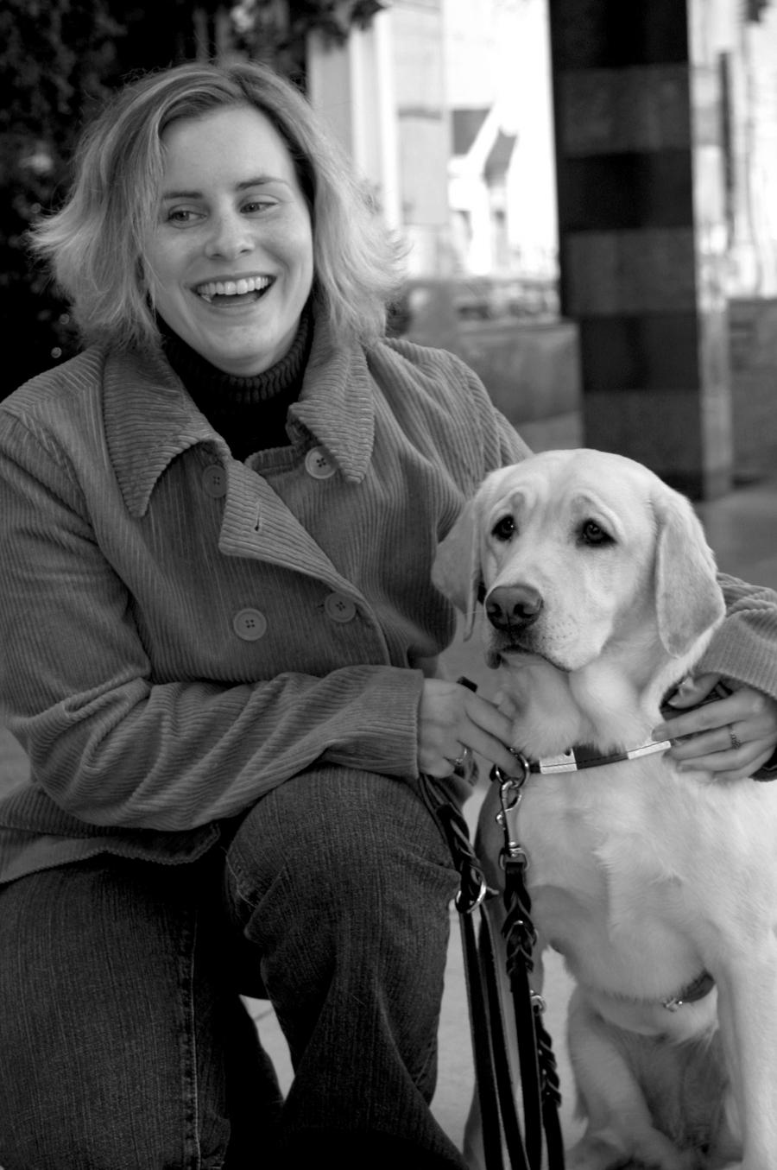What you will learn:

* How do you know if you are ready to train and work with a Guide Dog?
* What the eligibility criteria are to qualify to train with a Guide Dog?
* What does the application process and two week training class entail?
* How will Guide Dogs for the Blind support you once you leave the training program?
* What would it feel like to walk with a Guide Dog, experience a simulated walk.
* Please RSVP by October 8th to Jane Flower Outreach Manager at [jflower@guidedogs.com](mailto:jflower@guidedogs.com)