
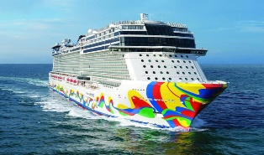
NFBCO Spectacular Spring Caribbean Cruise

The National Federation of the Blind of Colorado cordially invites you to join us for a fun filled week aboard the Norwegian Encore March 7th through 14th, 2026 (round trip Miami) as we escape the snow and cold, and jump start our Spectacular Spring with a western Caribbean cruise fundraiser.

Itinerary:
Harvest Caye, Belize, Roatán (Bay Islands), Honduras, Costa Maya, Mexico, and Cozumel, Mexico

Prices Include Taxes and Port Fees:
Balcony Single occupancy: $2358.92, Balcony Double occupancy: $2559.64
Balcony 3rd and 4th passengers: $688.82 each

Interior Single occupancy: $1908.82, Interior Double occupancy: $2109.54
Interior 3rd and 4th passengers: $718.77 each

The prices listed for thirds and fourths are subject to change.
Norwegian is offering buy one, get one free on airfare for the first two passengers in each cabin.

Make Your Reservations.
Initial payment: $125 per person. Final payment due: November 6, 2025
Call or text Cindy Kiper with Dream Vacations: 813-418-0647

For Cruise Questions:
Maryann Migliorelli, Cruise Coordinator National Federation of the Blind of Colorado
Phone: 720-284-2318, Email: maryannmigs@gmail.com

 Spectacular Spring Cruise Raffle

Join us by winning a balcony cabin for two.

https://nfbco.org/state-raffle

