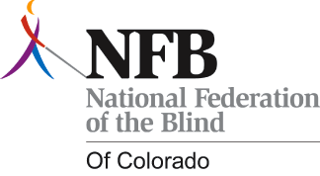

Meet the National Federation of the Blind of Colorado

The National Federation of the Blind of Colorado (NFBCO), Colorado’s oldest and largest organized group of blind people has worked since 1955 to make positive change in the lives of blind people. From teaching the simple how to’s of life to creating greater opportunity for employment, education, technology access, transportation and more. NFBCO makes a difference in the lives of blind and visually impaired people every day. We are excited to be coming to Grand Junction and we want to meet YOU!

Who is invited?
We want to meet people who are blind, low vision, or loosing vision. We also welcome family members, friends, blindness professionals, and others who want to learn more about blindness. We have lots of great resources including scholarships for students, assistance for seniors who are loosing vision, and resources for parents of blind children!

What will we do?
During our first informational meeting we will discuss the NFB of Colorado as well as other blindness related resources, answer questions, and do lots of networking. Of course there will be FREE FOOD!

When is this meeting?
Our initial meeting will take place on January 18 from 10:30am-1:30pm.

Where will the meeting of NFBCO be held?
We will meet at the Grand Junction Center for Independent Living, which is located at 740 Gunnison Ave. Grand Junction, CO 81501.

If you have questions or would like additional information contact Jessica Beecham at jbeecham@cocenter.org or call 720-440-2632.

