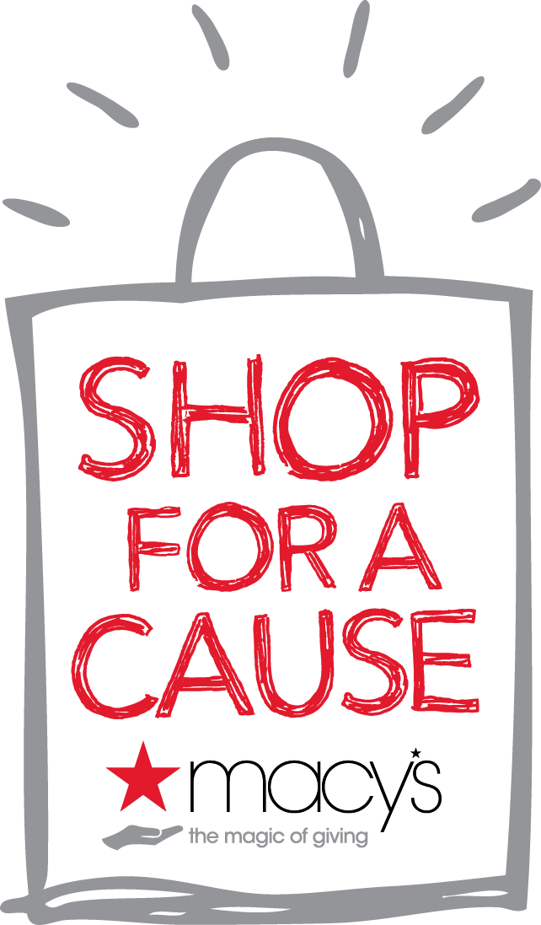
National Federation of the Blind

FOR IMMEDIATE RELEASE

CONTACT: Melissa Fishburn
Fundraising Chairperson
go.melsue@gmail.com

National Federation of the Blind Denver Chapter PARTNERS WITH MACY’S

FOR 10TH ANNUAL “SHOP FOR A CAUSE”

Macy’s helps local charity raise funds and awareness for important cause

through the national “Shop For A Cause” charity shopping event

Littleton, CO – August 9, 2015 - Macy’s will partner with National Federation of the Blind Denver Chapter to invite customers to participate in Macy’s 10th annual national “Shop For A Cause” charity shopping event on August 29, 2015. Customers can purchase shopping passes from NFB Denver chapter now. Macy’s “Shop For A Cause” is a unique one-day-only shopping event created to support local charities’ fundraising efforts. Since 2006, the program has helped raise tens of millions of dollars for charities across the country.

“Macy’s is proud to invite our customers to join us in giving back to causes that make a difference both locally and nationally,” said Martine Reardon, Macy’s chief marketing officer. “For the last nine years, Macy’s Shop For A Cause program has raised many millions of dollars for thousands of charities across the country. We look forward to offering our customers and associates an easy way to make a positive impact in our communities while enjoying great savings at Macy’s.”

Macy’s has provided NFB Denver chapter with shopping passes to sell for $5 each. (NFB Denver chapter will keep 100 percent of every shopping pass it sells. The more NFB Denver chapter sells, the more money it will raise!

By purchasing a shopping pass from NFB Denver chapter customers support members of the Blind community to achieve their full potential while enjoying a day of spectacular discounts, entertainment and special events at Macy’s. Pass holders will receive special discounts on most regular, sale and clearance purchases all day, but some exclusions apply.

Live the life you want.

For more information about Macy’s “Shop For A Cause,” visit macys.com/shopforacause. To purchase a shopping pass from National Federation of the Blind Denver Chapter, contact Melissa Fishburn; go.melsue@gmail.com

About Macy’s
Macy's, the largest retail brand of Macy's, Inc., delivers fashion and affordable luxury to customers at approximately 800 locations in 45 states, the District of Columbia, Puerto Rico and Guam, as well as to customers in the U.S. and more than 100 international destinations through its leading online store at macys.com. Via its stores, e-commerce site, mobile and social platforms, Macy's offers distinctive assortments including the most desired family of exclusive and fashion brands for him, her and home. Macy's is known for such epic events as Macy's 4th of July Fireworks® and the Macy's Thanksgiving Day Parade®, as well as spectacular fashion shows, culinary events, flower shows and celebrity appearances. Macy's flagship stores -- including Herald Square in New York City, Union Square in San Francisco, State Street in Chicago, and Dadeland in Miami and South Coast Plaza in southern California -- are known internationally and are leading destinations for visitors. Building on a more than 150-year tradition, and with the collective support of customers and employees, Macy's helps strengthen communities by supporting local and national charities giving more than $70 million each year to help make a difference in the lives of our customers.

For Macy’s media materials, including images and contacts, please visit our online pressroom at macys.com/pressroom.

# # #

